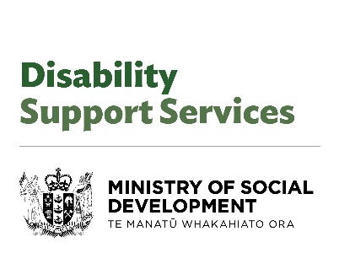

# Fact sheet for people receiving Disability Support Services

# As at: 23 August 2024

The Minister for Disability Issues, [Hon Louise Upston](https://www.beehive.govt.nz/minister/hon-louise-upston), commissioned an Independent Review of the Disability Support System to strengthen its long-term sustainability.

As the Ministry of Disabled People - Whaikaha was facing cost pressures, the Minister wanted a full picture of the situation before considering any changes to the system.

The Independent Review included seven recommendations, which have been accepted by Government.

Work on implementing the findings of the Independent Review began in August 2024, with initial report backs by the end of 2024.

You can find the details of each recommendation on the Ministry of Disabled People – Whaikaha website here: <https://www.whaikaha.govt.nz/news/independent-review/recommendations-1-7>

(Please note the information in the link above is not available in Alternate Formats)

## What does this mean now?

If you are a disabled person, family member, or carer of a disabled person, there is unlikely to be immediate change to the support you receive.

For now, you will continue to get the funding, equipment, care and the other disability support you are eligible for.

People do not need to go into MSD’s Work and Income office for disability support services.

Your point of contact will be your provider, NASC, or Enabling Good Lives site.

The changes made to Flexible Funding in March 2024 will remain.

The prioritisation for Equipment and Modification Services (EMS) put in place in March 2024 remains in place.

## What could this mean in the future?

People will be consulted as we move through the process.

We will work with providers and disability organisations, as more details are confirmed.

More information can be found on the Ministry of Disabled People - Whaikaha website.

**End of information | Fact sheet for people receiving Disability Support Services (as at 23 August 2024)**

This Large Print document was adapted by Blind Citizens NZ from the standard document provided by the Ministry of Disabled People – Whaikaha