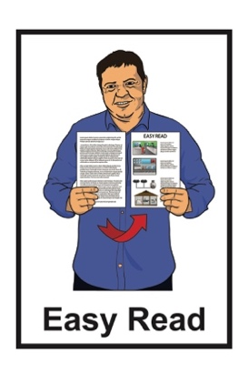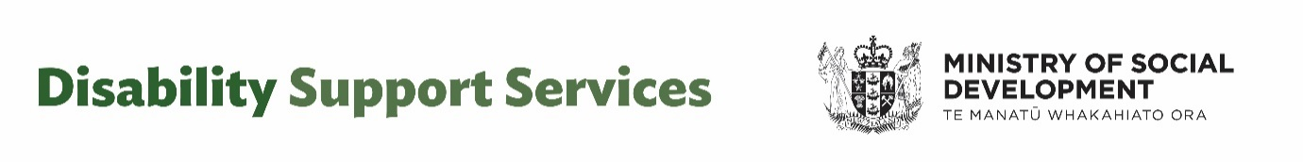

Fact sheet for people getting Disability Support Services



23 August 2024 – Fact sheet 1

# What this document is about



This Easy Read fact sheet is from the

DSS unit at the Ministry of Social Development.



It is information for people who are getting Disability Support Services.

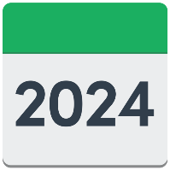

The information in this fact sheet is true as of 23 August 2024.



Some of the information in this fact sheet may change in the future.

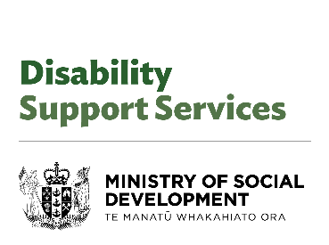

When you see the words **we / us** in this fact sheet it means the

DSS unit at the Ministry of Social Development.

.

# About the independent review of the Disability Support System



The Minister for Disability

Issues is Louise Upston.

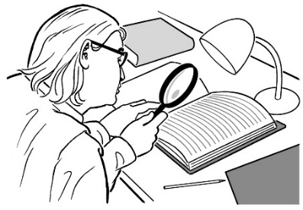Minister Upston asked for an **independent review** to be done to look at how well the Disability Support System was working.



A **review** is when someone looks at what things have happened.

An **independent review** means the review was done by people who do not work at the place being reviewed.

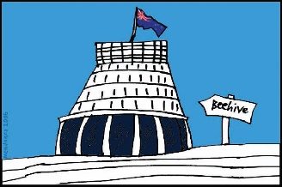

The review also looked at how well Ministry of Disabled People — Whaikaha was:

working

using the money it has.

The people who did the review made 7 **recommendations** that the Government have said yes to.



**Recommendations** are the changes that the people doing the review said should happen.

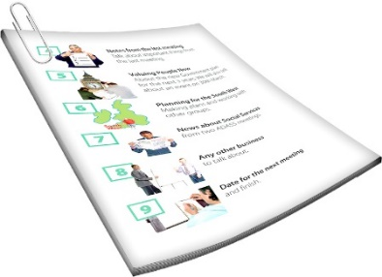You can read a **summary** of the 7 recommendations on **pages**   
**4 to 8** of this fact sheet.

A **summary** is a short version of a report / information.

## Recommendation 1:

## Budgets for disability service providers

A **budget** is the total amount of money an organisation / service has.

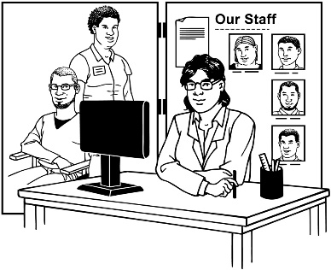

The budget changes will affect:

Needs Assessment and Service Coordination organisations / **NASCs**

Enabling Good Lives / **EGL**

Equipment and Modification Service / **EMS** providers.



The budget changes will mean that these services will need to think about how they spend their money.

## A group of people standing in front of a building Description automatically generatedRecommendation 2:

## Freeze funding for residential

## care



This means services who get funding for residential care will not get any extra money until after July 2025.

## Recommendation 3:

## 

## Take no action on a price increase for providers in 2024 / 2025

This means there will be no extra money for disability service / care providers from July 2024 to June 2025.

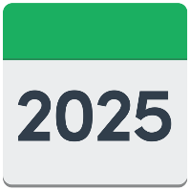

## Recommendation 4:

## 

## Monitor NASC and EGL sites

This means that a system will be put in place to watch over what some disability providers do including:

NASCs

EGL.

## Recommendation 5:



## Update assessment and allocation settings

This means that the amount of support that someone gets will be based on how much they need it.

## Recommendation 6:

## 

## Establish Flexible Funding criteria and review guidelines

This means that the way the Flexible Funding system works will be looked at so that it can be made better.

## Recommendation 7:

## 

## Strengthen how the Ministry of Disabled People - Whaikaha works with other agencies

This means the Ministry of Disabled People - Whaikaha will look at ways to work better with other government agencies.

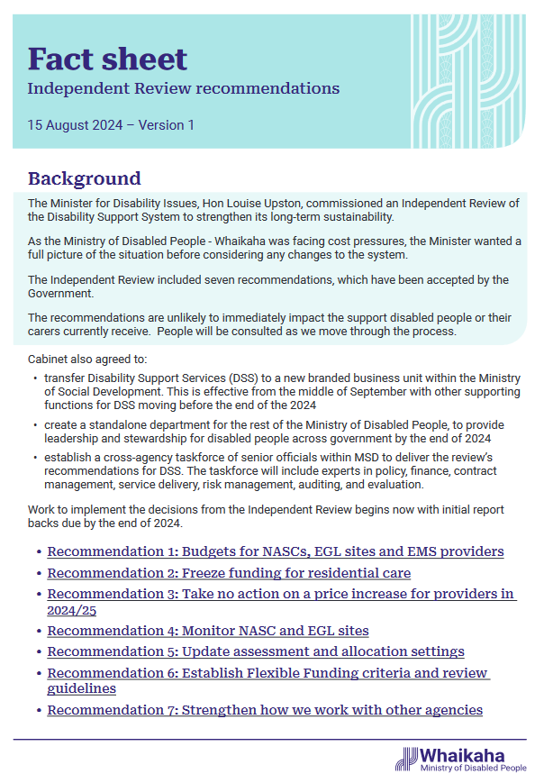You can read more about the 7 recommendations in the fact sheet called:

**Independent Review Recommendations**



You can find this fact sheet on the Ministry of Disabled People — Whaikaha **website** at:

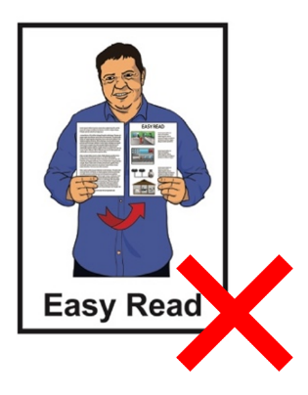**https://tinyurl.com/2y6tvhcj**

The fact sheet is **not** in Easy Read.

# What the changes mean now

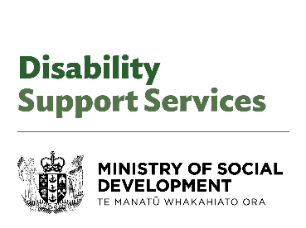

The DSS unit at the Ministry of Social Development supports people who are:

disabled

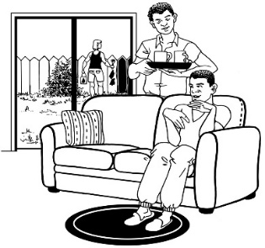the whānau / family member of a disabled person

the carer of a disabled person.



The kind of support you get might be:

funding

equipment

care

any other disability support.

You will carry on getting any support you get for now.

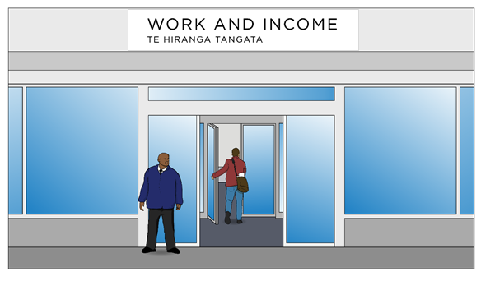

You do **not** need to go into your Work and Income office for disability support services.



You can talk to your:

* service provider
* NASC
* EGL site.

On 18 March 2024 changes were made to the rules for:

Flexible Funding

Equipment and Modification Service / EMS.

The changes to these rules will stay the same.

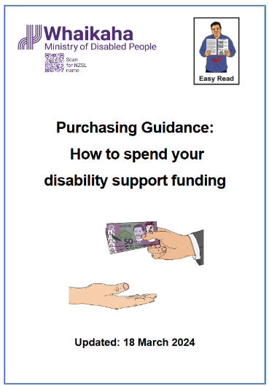

You can find Easy Read information about the rules in a document called:

**Purchasing Guidance:**

**How to spend your disability support funding**

****You can find this document on the Ministry of Disabled People — Whaikaha website at:

**https://tinyurl.com/yc5ncsku**

# What the changes could mean

# in the future

We will talk to disabled people about what will happen as things change.

We will work with other disability

organisations / providers when we know more about what will happen.



You can find out more information about the changes on the Ministry of Disabled People – Whaikaha **website** at:

**www.whaikaha.govt.nz**

This information was first written by Ministry of Disabled People — Whaikaha.

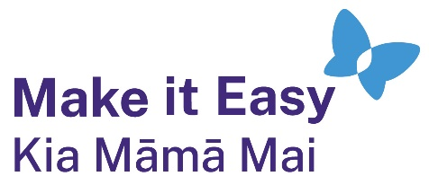It has been translated into Easy Read by the Make it Easy Kia Māmā Mai service of People First New Zealand Ngā Tāngata Tuatahi.



The ideas in this document are not the ideas of People First New Zealand Ngā Tāngata Tuatahi.

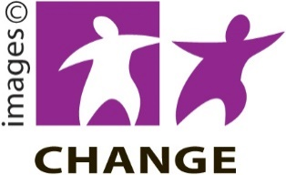

Make it Easy uses images from:

* Changepeople.org

Photo SymbolsPhotosymbols.com

* SGC Image Works
* Huriana Kopeke-Te Aho
* T. Wood.

  
All images used in this Easy Read document are subject to copyright rules and cannot be used without permission.