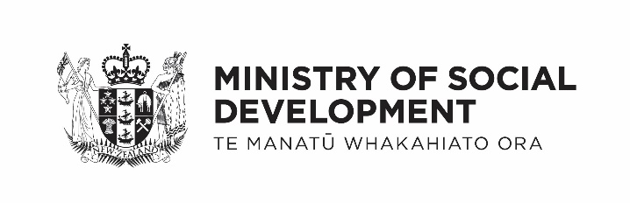
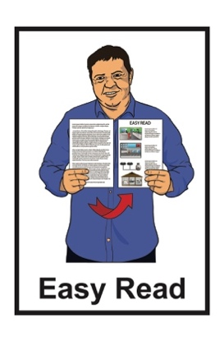

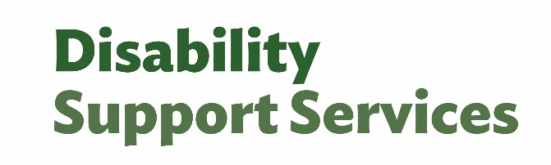

How Ministry of Social Development Disability Support Services checks

quality and safeguarding

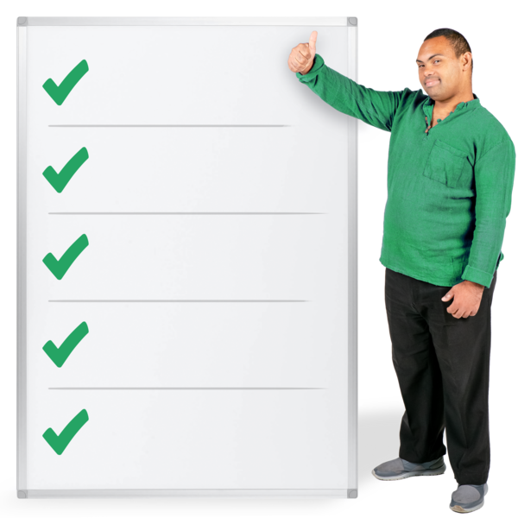

Published: March 2025

Before you begin


This document talks about abuse.

This information may upset some people when they are reading it.

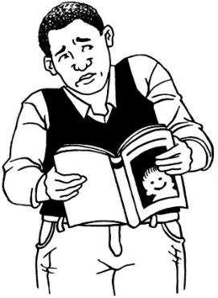

This information is not meant to scare anyone.

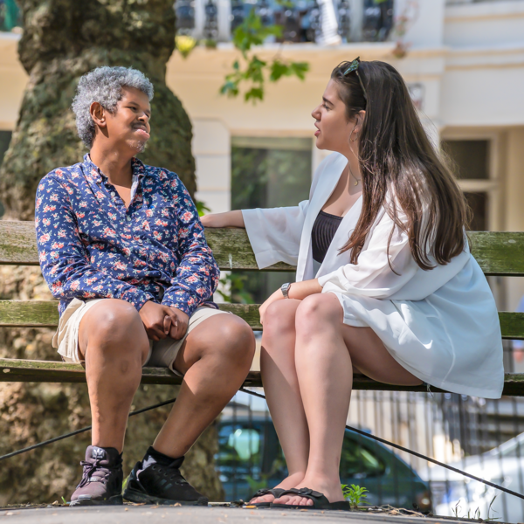
If you are upset after reading this document you can talk to your:
whānau / family
friends.

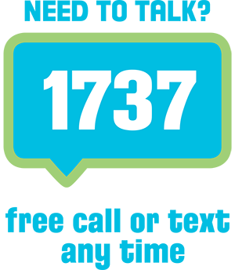
You can also contact Need to Talk by:
calling 1737
texting 1737


It does not cost any money to call / text 1737.

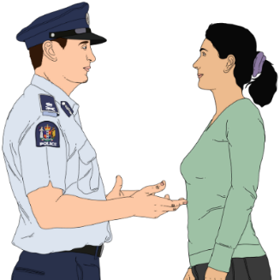
If you do not feel safe call the police on 111

What you will find in this document

Page number:

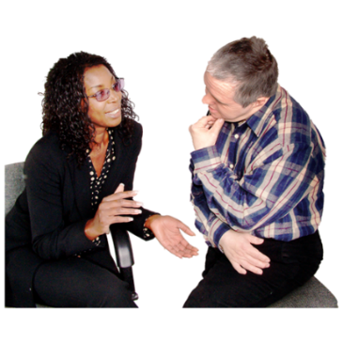
What is this document about? 5

People for Us 8

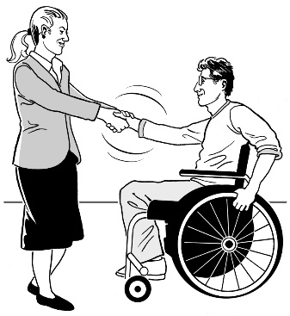
Assisting Change 11

Disability Abuse Prevention and Response 12

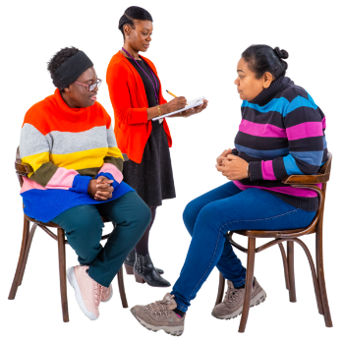
Evaluations and investigations 17

Complaints and feedback 20

Page number:

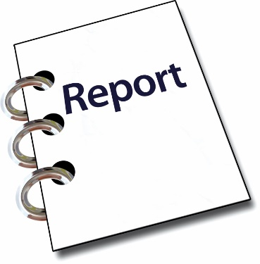

Critical incident reports 22

Death notifications 24

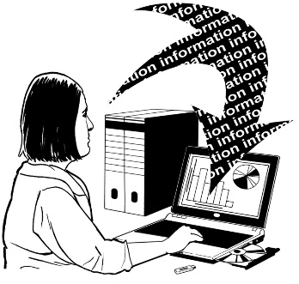
Getting and sharing data 26

Where to get more information 27

What is this document about?

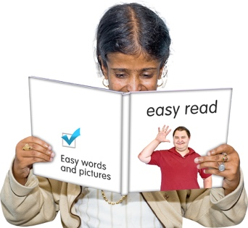
This Easy Read document is
from Ministry of Social Development.

In this document:
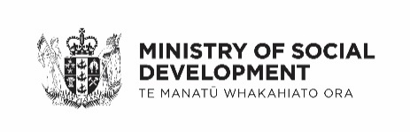
MSD means Ministry of Social Development
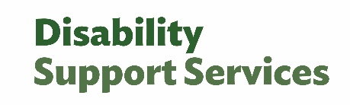
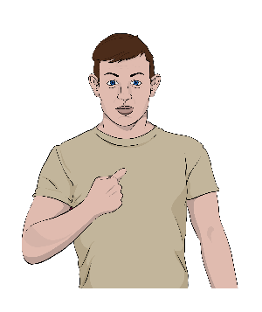
DSS means Disability Support Services
the words we / our mean Disability Support Services.

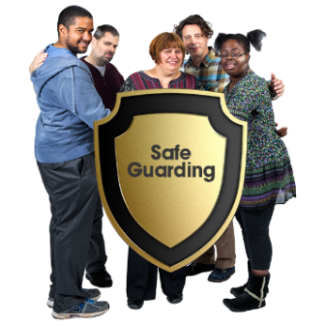
At DSS we do something called quality and safeguarding.

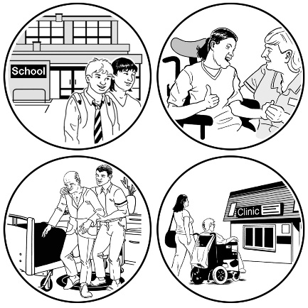
Quality and safeguarding is where we make sure disabled people:
get the best disability support services possible
are kept safe from harm.
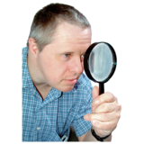

In this document we talk about how we check how quality and safeguarding is working.

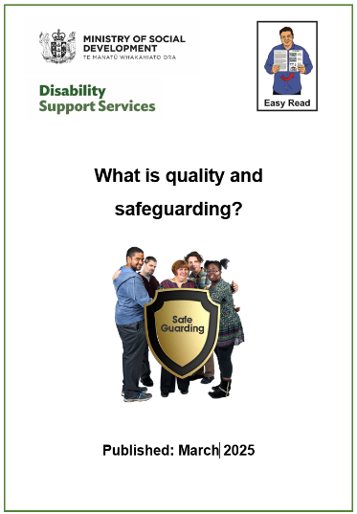
There are 2 other Easy Read documents about quality and safeguarding:
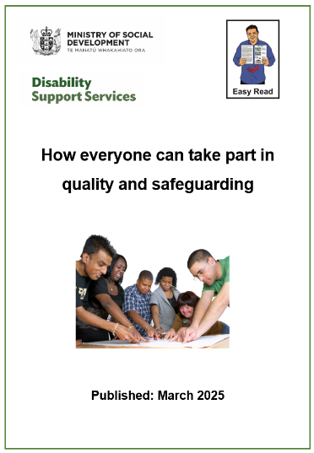
- What is quality and safeguarding?
- How everyone can take part in quality and safeguarding.


You can find the Easy Read documents on the Disability Support Services website at:

www.disabilitysupport.govt.nz

People for Us

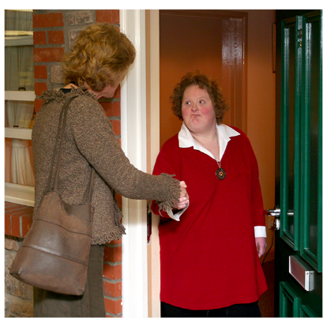
People for Us will be disabled people visiting other disabled people where they live to:
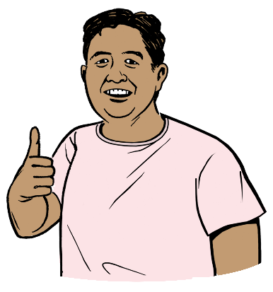
find out if they are safe
and
living a good life.


DSS will contract organisations to do the People for Us service.


To contract means to pay people from outside an organisation to do a job.

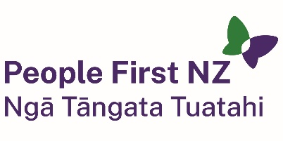
The organisations who will run
People for Us will be:

People First New Zealand Ngā Tāngata Tuatahi

Te Ahi Kaa Indigenous Solutions
Vaka Tautua.

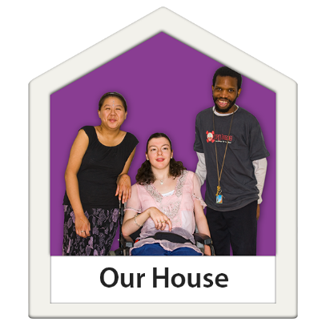
People for Us will work with disabled adults who live in residential services to find out if they are:
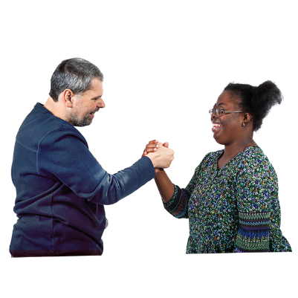
safe
living a good life
getting high quality:
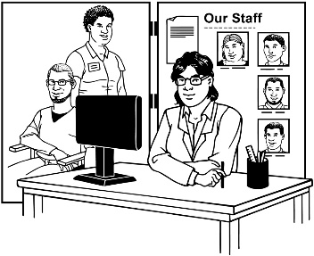

- support
- services.


Here quality means things are very good for a long time.

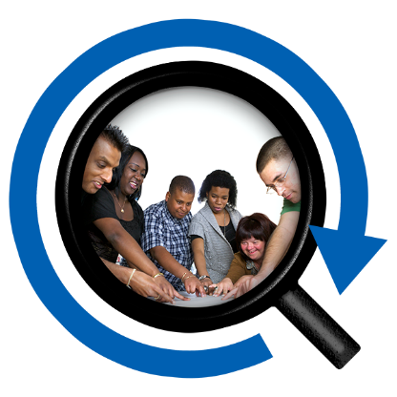
They will support people to find the right way to solve the problems they have with:
safety
wellbeing.

Assisting Change

Assisting Change is a service that supports disability service providers to make better quality services.


Assisting Change will be done by
Te Pou Wairoa.

Assisting Change will match a disability service provider with people who will give them advice.


This will support them to:
figure out what their quality problems are
fix their quality problems.

Disability Abuse Prevention and Response

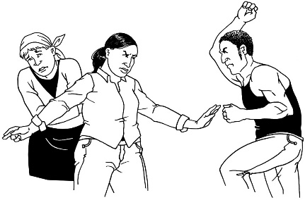
Disability Abuse Prevention and Response is also known as DAPAR.

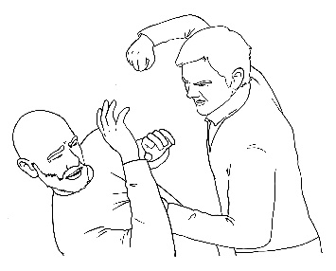
Abuse means things like:
hitting
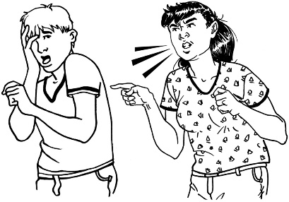
saying mean things
not giving people things they need like:
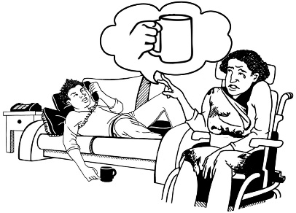
- food
- medication
- health care.


Prevention means to stop
something from happening.
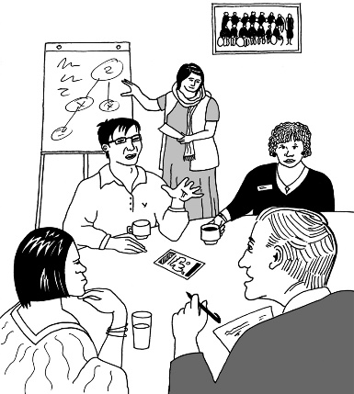
Here response means to do something about a problem like:
talking about it
making a plan to fix it.

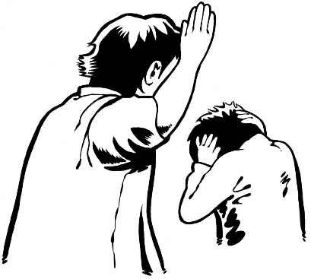
DAPAR is provided by a team of people who are specialists in dealing with:
family violence
sexual violence.

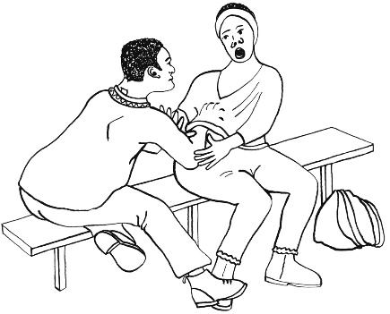
Sexual violence means making people do things with their body they do not want to like:
touching private parts
having sex – this is called rape.

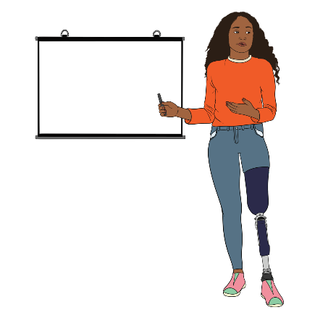
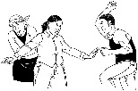
The DAPAR team will be led by:
disabled people
professionals.

A professional is a person who:
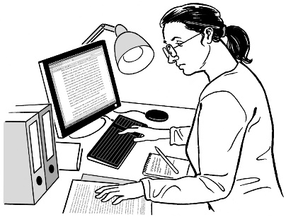
knows a lot about something
has done a lot of work in a type of job.

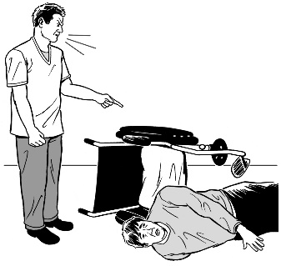
DAPAR will step in to support people when things happen like:
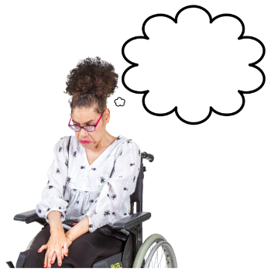

disabled adults are experiencing abuse
someone is worried there might be abuse happening.

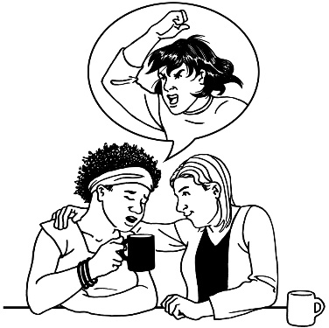
DAPAR:
will work with the disabled person
may bring in other organisations to support them.

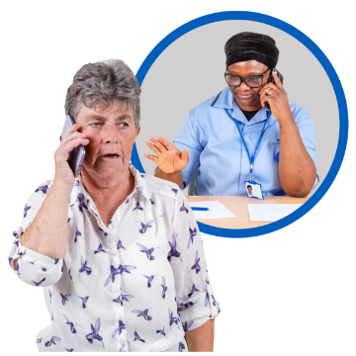
Anyone can make a referral to DAPAR.


Here a referral is when someone asks another person to do a job because they know how to do the job better.

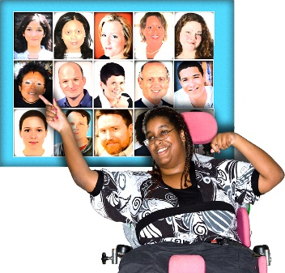
DAPAR will make sure:
there are people to do the jobs

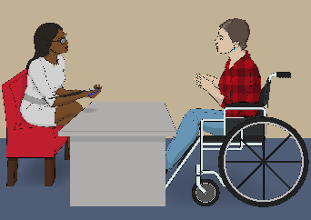
people have the right skills to do their jobs.

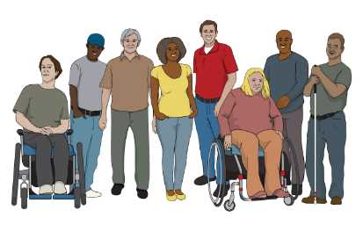
DAPAR will do this for:
disability communities
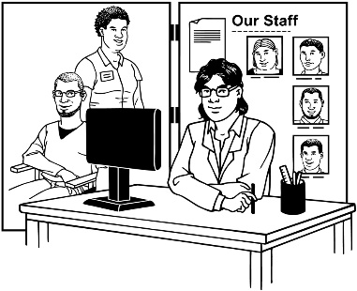
agencies working with disabled people
groups working in:
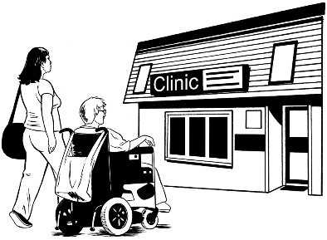
- disability
- stopping violence.

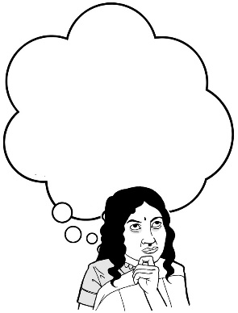
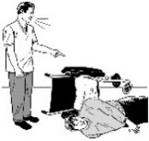
This will support them to:
figure out when abuse is happening
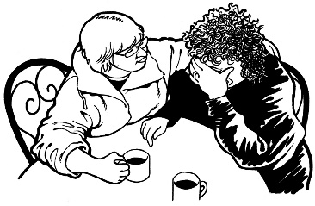
support those who are being abused.

Evaluations and investigations

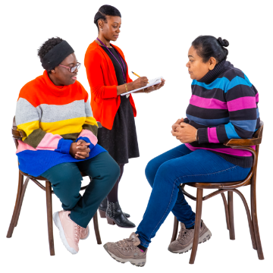
Each year DSS evaluates some of the providers we contract.

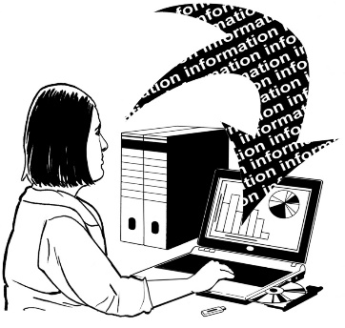
Here evaluate means to look at something to check how well the job is being done.

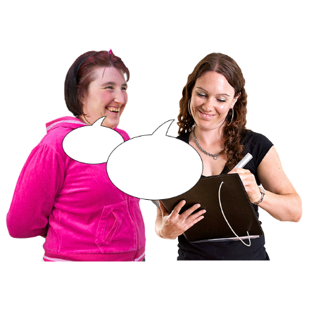

Evaluations check providers are doing what we have asked them to do.

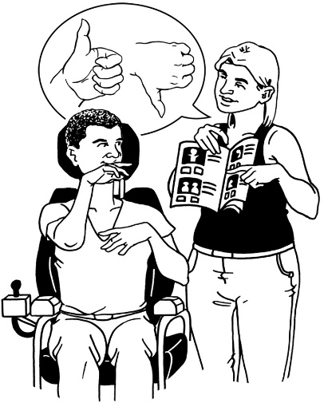
The people doing the evaluation will:
talk to the disabled people who the provider supports
to ask them what they think about the provider.
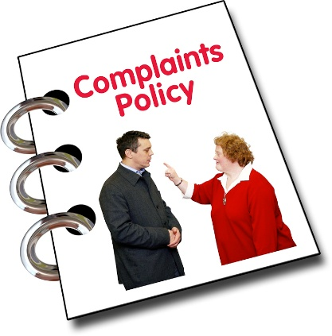
We do investigations when there are serious:
complaints
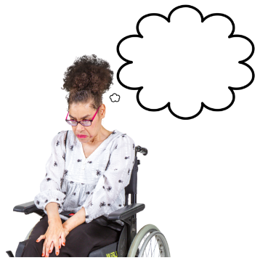
problems
deaths
worries.

An investigation is when we look into how something has happened.

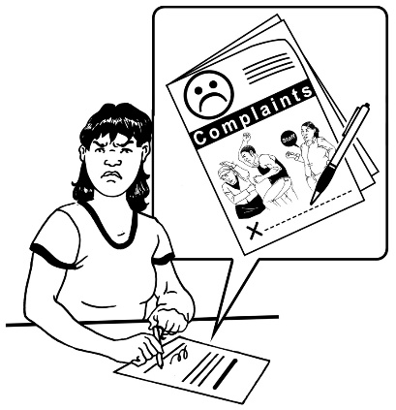
A complaint is when you tell someone:
something is wrong
and
how you want it to be fixed.


You can find out more about our evaluations and investigations at this website:

www.disabilitysupport.govt.nz/
providers/audits-and-evaluation

Complaints and feedback

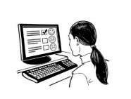
DSS takes care of:
complaints
feedback.

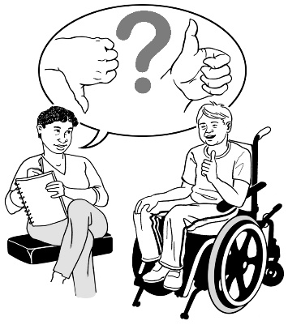
Feedback means saying what you think about something.

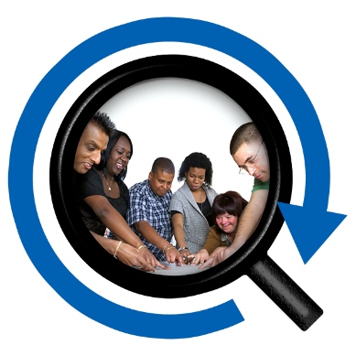
Looking at complaints and feedback is part of how we check the quality of our contracted disability:
supports
services.

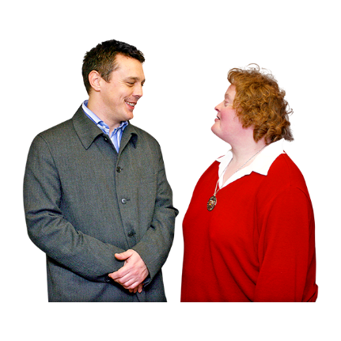
Anyone can tell DSS their complaint or feedback about a provider.


You can find out more information about how complaints and feedback are taken care of at this website:

www.disabilitysupport.govt.nz/
about-us/contact-us/complaints

Critical incident reports

DSS takes care of critical incident reports for all our contracted services.

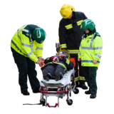
A critical incident report is a report that has been made about something very serious that has happened.


The provider:
fills in the critical incident report
and
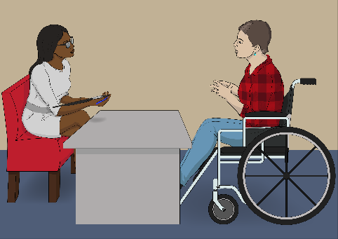
should ask the disabled person what they think about the incident.


You can find out more information about how we deal with critical incident reports at this website:

www.disabilitysupport.govt.nz/providers/
reporting-of-critical-incidents-and-deaths

Death notifications

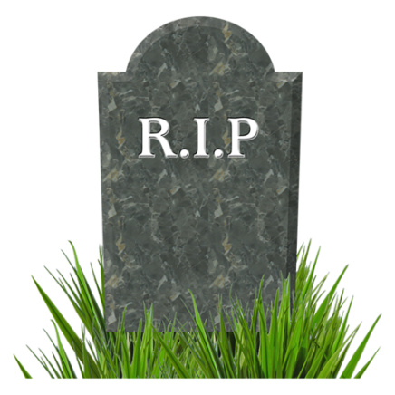
DSS deals with death notifications of disabled people who lived in residential care funded by us.

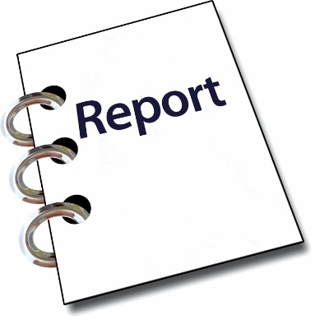
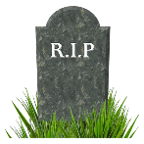
A death notification is information about:
how someone died
when someone died.


The provider:
fills in the death notification
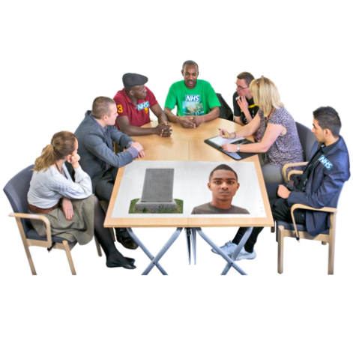
and
should ask the whānau / family of the person who died what they think about the death.

You can find out more information about how we deal with death notifications at this website:

www.disabilitysupport.govt.nz/providers/
reporting-of-critical-incidents-and-deaths

Getting and sharing data


DSS is making our systems better by:
collecting data
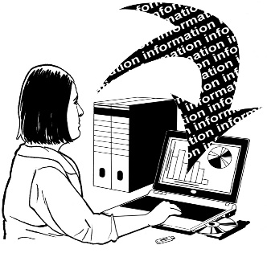
and
figuring out what the data means.

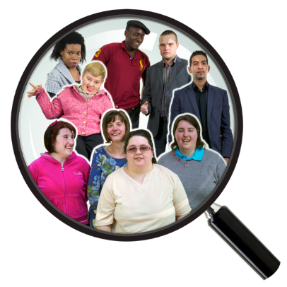
Data is information that shows what groups of people:
are doing
need.


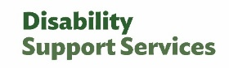
When we have looked at the data we will share what we know on the DSS website.

Where to get more information


If you would like to know more about the quality and safeguarding framework you can email:

quality@msd.govt.nz


You can contact us at this website:

www.disabilitysupport.govt.nz/
about-us/contact-us/

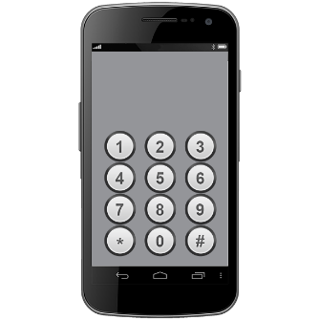
You can phone us on:

0800 566 601


If you find it hard to use the phone the New Zealand Relay service is for people who are:

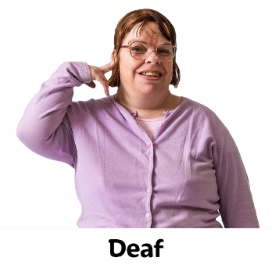
Deaf / hard of hearing
deafblind
speech impaired / find it hard to talk.


You can find out more about the New Zealand Relay service at:

www.nzrelay.co.nz

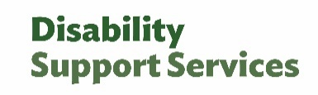
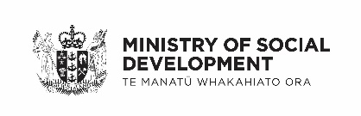
This information has been written by Ministry of Social Development Disability Support Services.

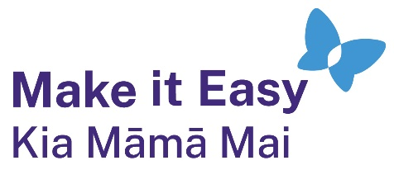
It has been translated into Easy Read by the Make it Easy Kia Māmā Mai service of People First New Zealand Ngā Tāngata Tuatahi.
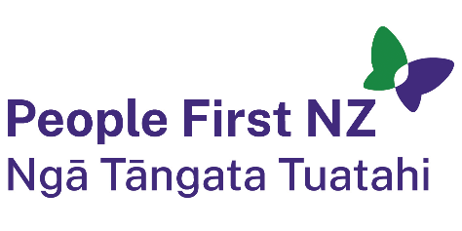
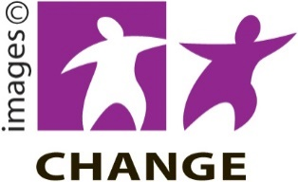
The ideas in this document are not the ideas of People First New Zealand Ngā Tāngata Tuatahi.

Make it Easy uses images from:


- Changepeople.org


            - Photosymbols.com

- SGC Image Works
- Huriana Kopeke-Te Aho
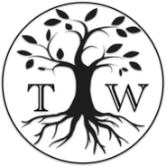
- T.Wood.

All images used in this Easy Read document are subject to copyright rules and cannot be used without permission.

