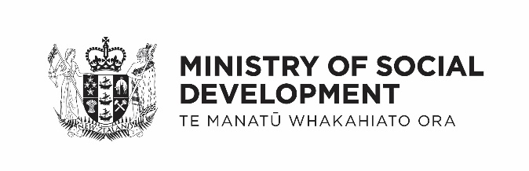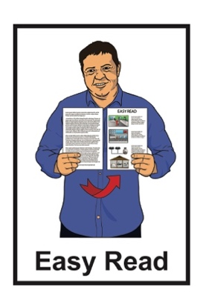

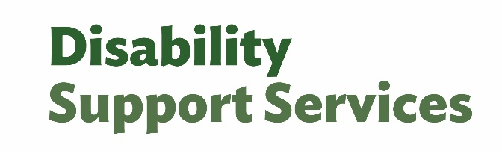

How everyone can take part in quality and safeguarding



Published: March 2025

# What is this document about?

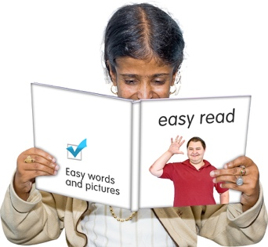This Easy Read document is   
from Ministry of Social Development.

In this document:

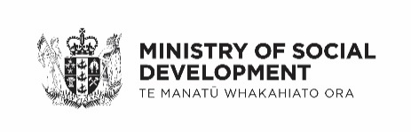MSD means Ministry of Social Development

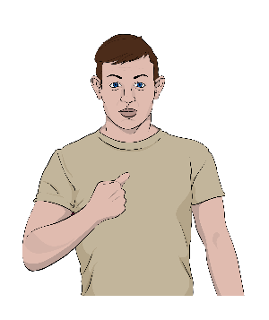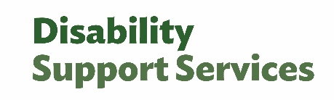DSS means Disability Support Services

the words we / ourmean Disability Support Services.

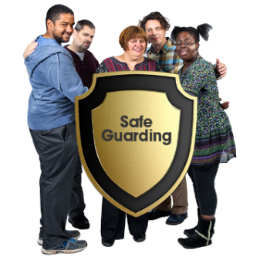At DSS we do something called **quality and safeguarding**.

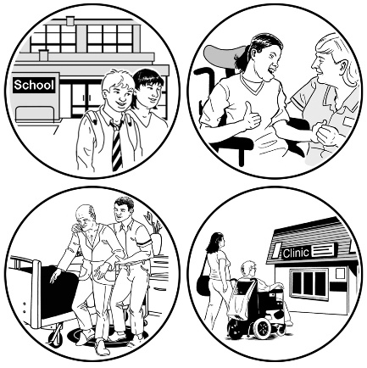**Quality and safeguarding** is where we make sure disabled people:

get the best disability support services possible

are kept safe from harm.

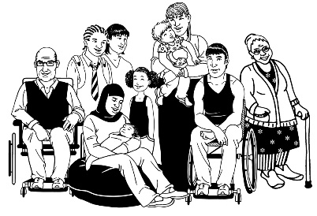In this document we talk about how everyone can take part in quality and safeguarding work including:

disabled people and their whānau / family

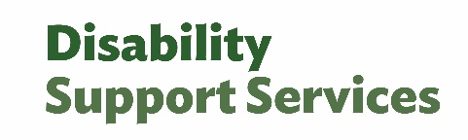DSS

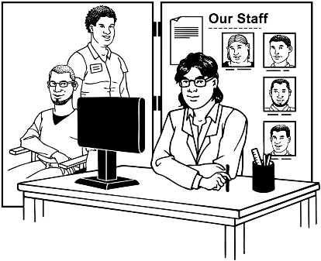disability support organisations

Needs Assesment Service Coordination / NASC

Enabling Good Lives / EGL

other government agencies.

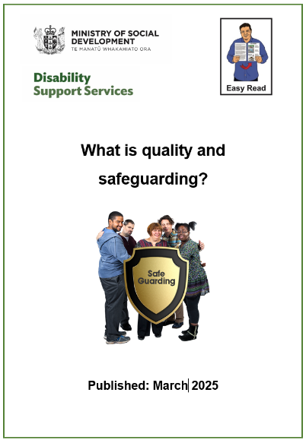There are 2 other Easy Read documents about quality and safeguarding:

* **What is quality and safeguarding?**
* 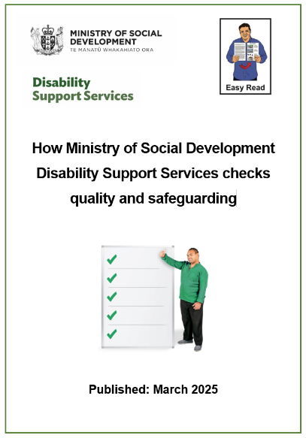**How Ministry of Social Development checks quality and safety**

You can find the Easy Read documents on the DSS website at:

[**www.disabilitysupport.govt.nz**](https://www.disabilitysupport.govt.nz)

# How can people take part in quality and safeguarding?

## Disabled people and whānau / family

You can share with us:

your experiences of living with your disability

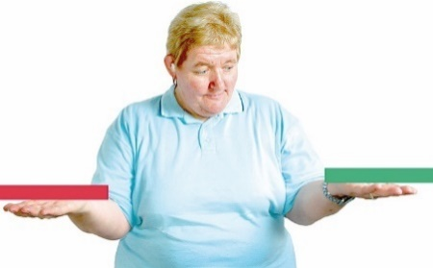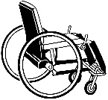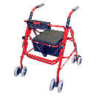

what you want from service.

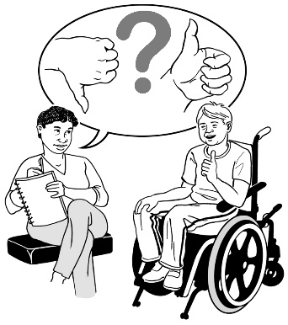You can talk to your disability provider or connector about things:

that work well

you want to make better.

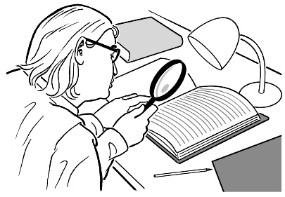It is up to you to check how good the supports you get are if you use:

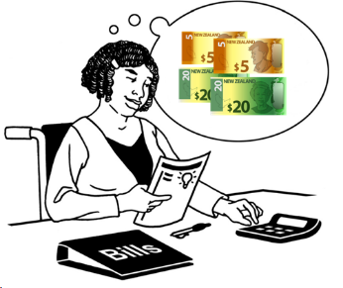Personal Budgets

Individualised Funding.

## Ministry of Social Development

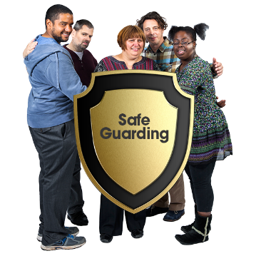We are responsible for checking the services we fund are:

high **quality**

safe.



Here **quality** means things are very good for a long time.

How we do this is set out in:

**contracts**

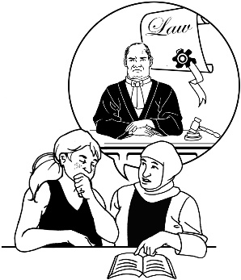**legislation**

**regulation**

**policies**.



Here **contracts** mean the agreements we have with disability support providers.

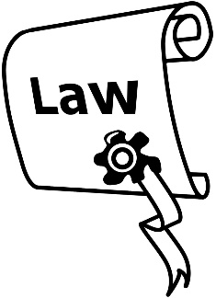

**Legislation** is the laws the government makes in Parliament.

**Regulation** are systems made by the government to:

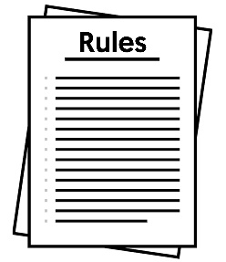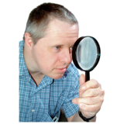

watch what is going on

make sure the rules are followed.

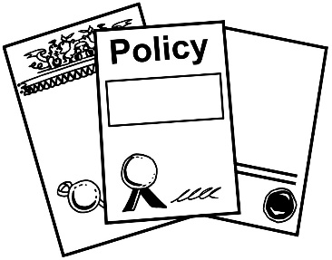**Policies** are a set of guidelines that show what the government wants to do about something.

## Disability support organisations

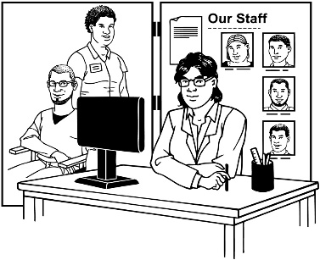

These organisations are responsible for giving disability supports that are of high quality.



They have said yes to doing this in the contracts they have with us.

## Needs Assessment Service Coordination and Enabling Good Lives

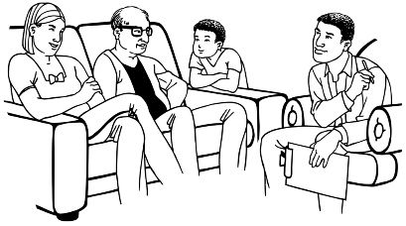These organisations work with disabled people and   
whānau / families to access disability supports to make sure they can have a good life.



This includes checking disability supports if there are   
concerns / worries about quality and safeguarding.

## Other government agencies

Other government agencies are responsible for things they do that we do not check on.

Some examples are:

the Health and Disability Commissioner looks after complaints made under the the **Code of Health and Disability Services Consumers’ Rights.**

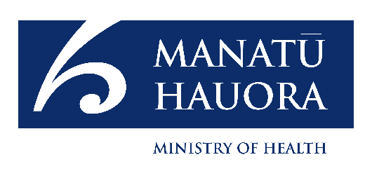the Ministry of Health checks some residential providers using **Ngā Paerewa** rules

the Police look into crimes.

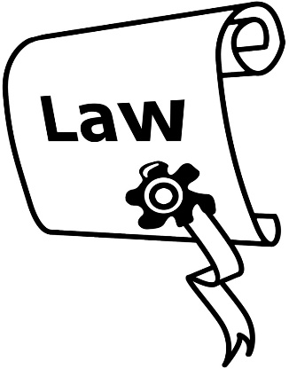The **Code of Health and Disability Services Consumers’ Rights** is the 10 rights people have under Aotearoa New Zealand law when using:

health services

disability services.

**Ngā Paerewa** is a set of rules that providers need to do that supports people to make choices about their:

health care

disability care.

# How we want our staff and providers to behave

## Quality management principles

**Principles** are rules that tell people how things should be done.

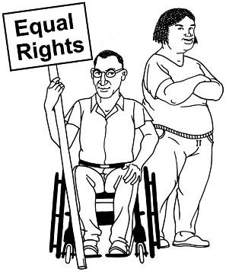At DSS we:

support the rights of disabled people

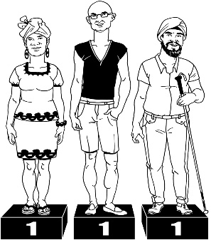respond to what people need

treat everyone fairly.

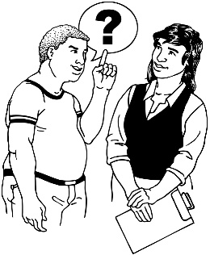At DSS we also:

are responsible for what we do

learn things which means we can get better at what we do.

## Te Tiriti o Waitangi / Treaty of Waitangi

We use **Te Tiriti o Waitangi / Treaty of Waitangi** in everything we do.

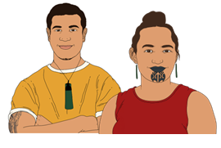**Te Tiriti o Waitangi / Treaty of Waitangi** is an important agreement between Māori and the Crown.

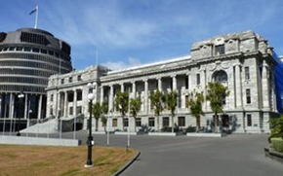It is about Māori and the New Zealand Government making decisions together.

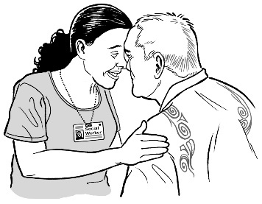We use kawanatanga which is:

working together

and

making decisions together.

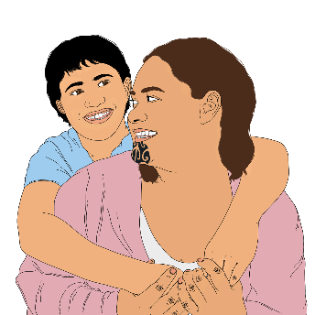

We use tino rangatiratanga which is supporting tāngata whaikaha Māori and their whānau / families to have in their lives greater:

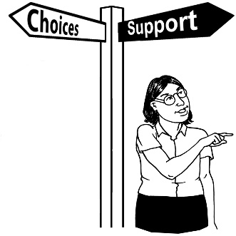choice

control.

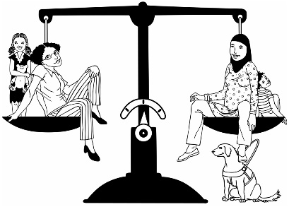We use ōritetanga which is making sure what we do for Māori:

is fair

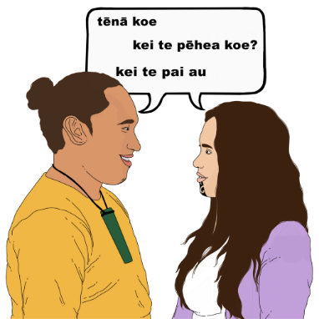responds to their **cultural** **needs**

does not **discriminate** against them.

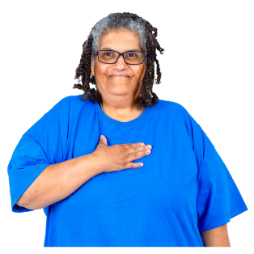

Here **cultural needs** means something that is important to the way you do things:

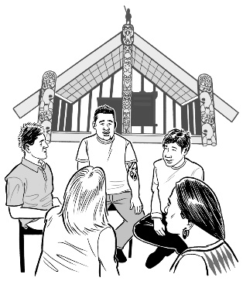in your life

with other people in your   
culture / group.

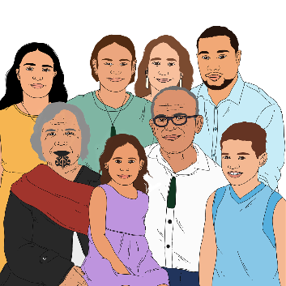

A cultural need might be having your whānau / family supporting you to make a decision.

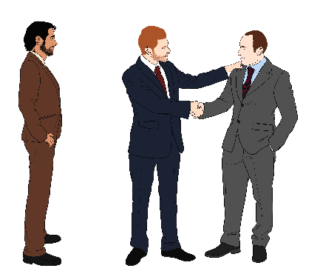**Discrimination** is when people are treated unfairly because of things like their:

race

disability.

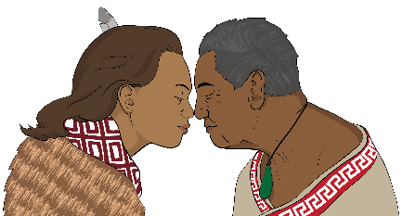

We use wairuatanga which is knowing how important it is that a person may have:

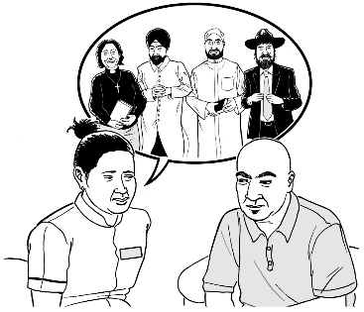cultural **values**

**spiritual beliefs**.

**Values** are beliefs that a person uses to decide how to:

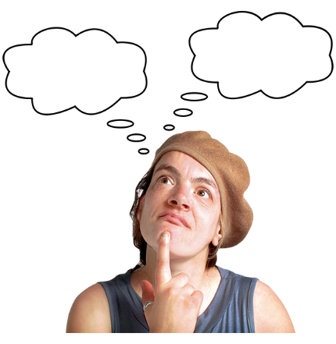

☹

😊

behave

live.

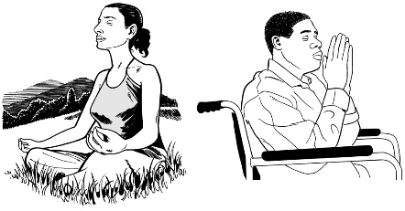**Spiritual beliefs** are ideas a person uses to live by that come from a:

religion

culture.

## Enabling Good Lives principles

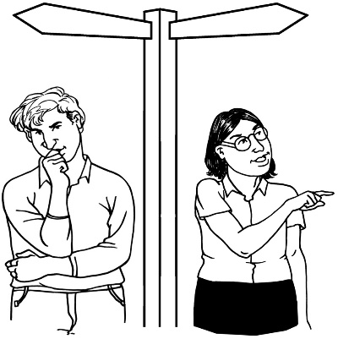The principles of Enabling Good Lives we use for quality and safeguarding are:

self determination – we respect the choices disabled people make

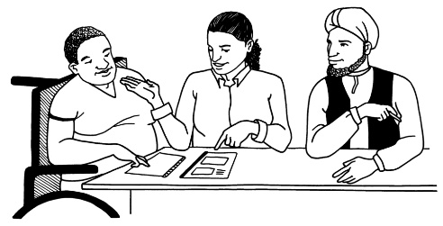beginning early – we act quickly when people have concerns

being easy to use.

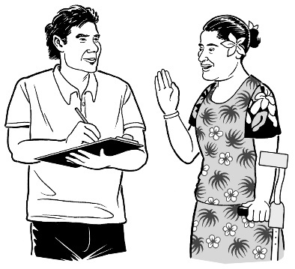Other principles of Enabling Good Lives we use for quality and safeguarding are:

being person centred – we understand what disabled people know about their lives

ordinary life outcomes – we support disabled people to live a good life

mainstream first – we make sure everyone can use:

* services
* communities.

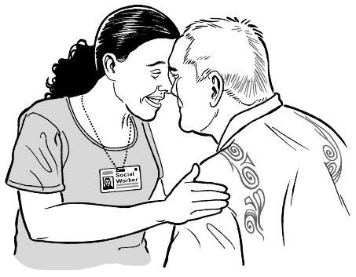Other principles of Enabling Good Lives we use for quality and safeguarding are:

mana enhancing which means:

* 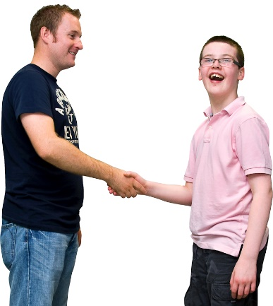we respect the people we work with
* we take concerns seriously

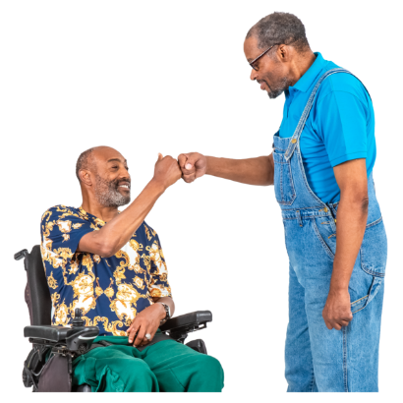**relationship** building – we build trust with everyone to work on:

* quality and safeguarding concerns
* making relationships better again.

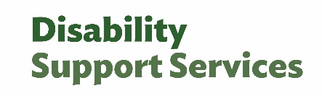Here **relationship** means how people get along in all the things we do.

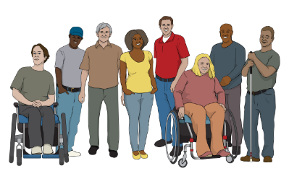

This includes:

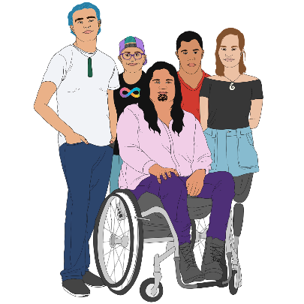disabled people

tāngata whaikaha Māori

whānau / families

DSS

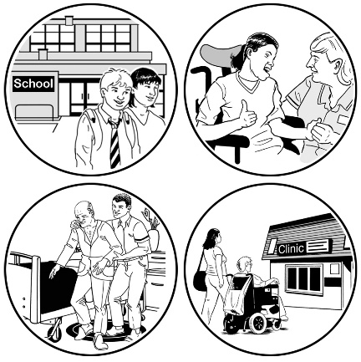disability support providers

disability organisations

other government agencies.

# Where to get more information

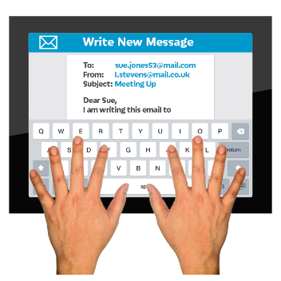If you would like to know more about the quality and safeguarding framework you can **email**:

**quality@msd.govt.nz**



You can contact us at this **website**:

[**www.disabilitysupport.govt.nz/  
about-us/contact-us/**](https://www.disabilitysupport.govt.nz/about-us/contact-us/complaints)

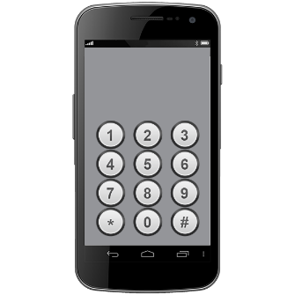You can **phone** us on:

**0800 566 601**

If you find it hard to use the phone the **New Zealand Relay** service is for people who are:

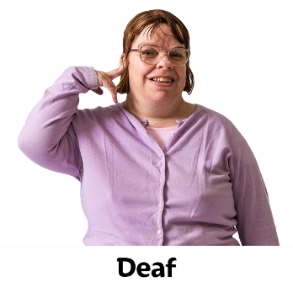Deaf / hard of hearing

deafblind

speech impaired / find it hard to talk.

You can find out more about the New Zealand Relay service at:

[**www.nzrelay.co.nz**](https://www.nzrelay.co.nz)

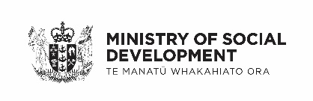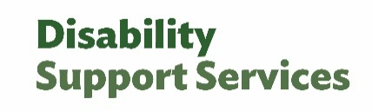This information has been written by Ministry of Social Development Disability Support Services.

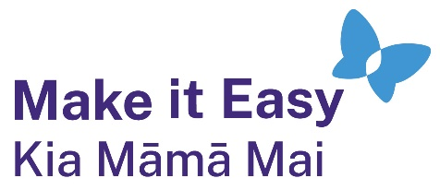It has been translated into Easy Read by the Make it Easy Kia Māmā Mai service of People First New Zealand Ngā Tāngata Tuatahi.

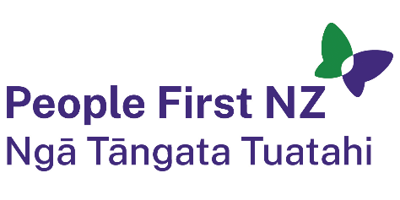

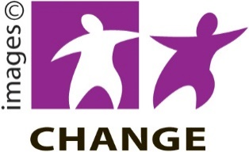The ideas in this document are not the ideas of People First New Zealand Ngā Tāngata Tuatahi.

Make it Easy uses images from:

* Photo SymbolsChangepeople.org

Photosymbols.com

* SGC Image Works
* Huriana Kopeke-Te Aho
* T.Wood.

  
All images used in this Easy Read document are subject to copyright rules and cannot be used without permission.