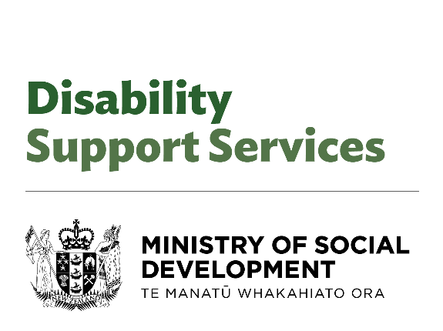

**Clarifications on Purchasing Rules for Flexible Funding**

Adapted in 2024 by Accessible Formats Service,   
Blind Low Vision NZ, Auckland

**TN**: The logo on the top of the page is DSS at Ministry of Social Development

# Clarifications on Purchasing Rules for Flexible Funding

Whaikaha – Ministry of Disabled People is provided clarifications to support disabled people, tāngata whaikaha Māori and whānau to apply the Purchasing Rules for flexible funding supports.

The clarifications have been informed by the feedback received from our community and providers.

Whaikaha recognised it had a lot to learn from the announcement on March 18, 2024.

It acknowledged the changes have been distressing and caused confusion for the community, and for the service providers who support disabled people.

The clarifications are:

1. Ride and driver services can be used to support a disabled person to access services or engage with the community, where this is a reasonable and cost-effective option
2. The following items can be purchased for a disabled person to assist self-management, on a one-off basis within a flexible funding allocation period:
3. Electronic tablet devices
4. Noise-cancelling headphones
5. Sensory toys, fidget spinners, etc
6. Weighted blankets
7. Household support arrangements in place through Choice in Community Living or a personal budget can continue, where these arrangements are an alternative to residential care that enables people to live in the community
8. Existing support arrangements can continue where:
9. the disabled person has committed to employment, a course of study, therapy, or a timebound programme; and
10. they have relied on the availability of flexibility under the previous Purchase Rules to support them to participate in those commitments; and
11. that commitment was made before 18 March 2024.

Every person and every situation is different. If you have specific questions about how these changes relate to you, please contact your Needs Assessment and Service Co-ordination service (NASC)/Host or Enabling Good Lives site in the first instance. This information has been shared with them.

The DSS unit at MSD is committed to working with disabled people, tāngata whaikaha Māori and whānau to develop longer-term settings aligned with the Enabling Good Lives vision and principles, UNCRPD and Te Tiriti o Waitangi.

## Key links for more information:

* Purchasing Rules at [www.whaikaha.govt.nz/rules](http://www.whaikaha.govt.nz/rules)
* We have produced guidance for the Sector, more information on the clarifications can be found at [www.whaikaha.govt.nz/clar-info](http://www.whaikaha.govt.nz/clar-info)

End of Clarifications on Purchasing Rules for Flexible Funding