

Purchasing Guidance:

How to spend your

disability support funding



Updated: 18 March 2024

# What you will find in here

**Page number:**

About the Purchasing Guidance 3



What disability funding is for 7

How Government disability

funding works 10



[Rules for spending disability   
funding](#_Rules_for_spending) 18



Making a plan 26

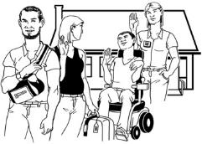

Examples of how the funding

can be used 28

**Page number:**



What you cannot use the

funding for 34

Employing support workers 38



Where to find more information 39

# About the Purchasing Guidance



This Easy Read information is from **the DSS unit at the Ministry of Social Development**.

In this Easy Read guide:

when you see the words **we / us** it means the DSS unit at the Ministry of Social Development

**disability community** means:

* disabled people
* tāngata whaikaha Māori
* whānau / family
* carers.

From **18 March 2024** changes were made to the **Purchasing Guidance.**

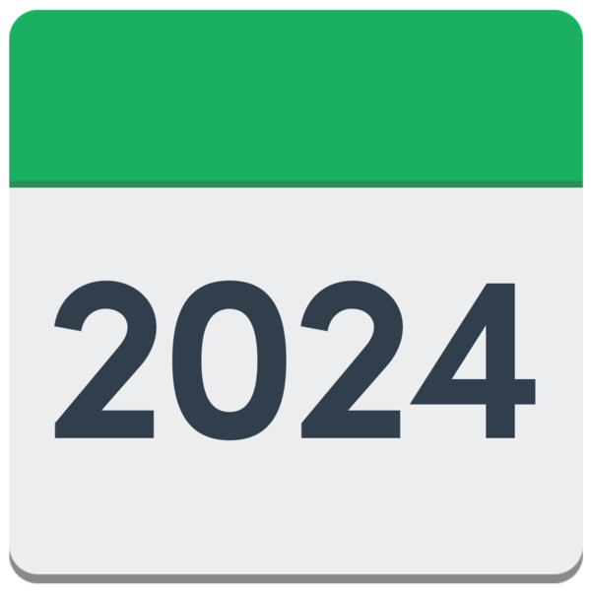



**Purchasing Guidance** is about the rules on what people can buy with disability support funding.



**Purchase** means to buy something.



The changes were made so that the rules about how people can use their disability support funding are clearer.

There are 4 rules that must be followed when purchasing / using disability support funding.

The 4 rules are for the following disability support funding:

Carer Support

Individualised Funding / IF

Enhanced Individualised Funding / EIF

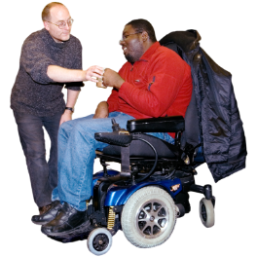

Choice in Community Living or Enabling Good Lives / EGL

Personal Budgets.

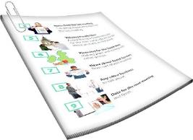

We will look at these 4 rules on **pages 18 to 25**.

We needed to change the rules to make sure that funding is being spent where it is needed most.

The rule changes will be in place until after we have talked to the disability community.

The rule changes are needed so that we can:

* work with the disability community
* work out some rules for using the funding going forward.

# What disability funding is for

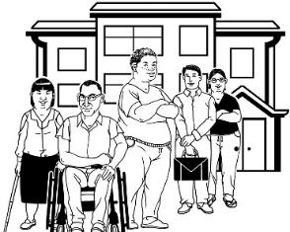Disability funding is for some:

disabled people

tāngata whaikaha / Māori disabled people.

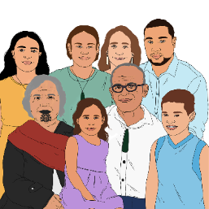

Disability funding can also be used to support the families / whānau of disabled people.



The funding can be used to:

give you more chances to live a good life

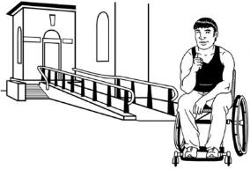

take away **barriers** that stop you from being able to do the things you want.

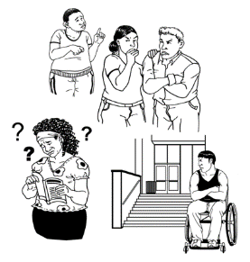**Barriers** are things that make it harder for disabled people to live a good life like:

buildings that they cannot use / get into

information that is hard to understand

not being able to get the things / support they need to have a good life.

Disability funding can also be used for **respite.**

**Respite** is a way to give whānau / family a break from caring for someone.

****You can find out more about respite on our website:

[**https://tinyurl.com/2vku3vpc**](https://tinyurl.com/2vku3vpc)



This information is not in Easy Read.

# How Government disability support funding works



The Government disability support funding pays only for costs that are about your disability.

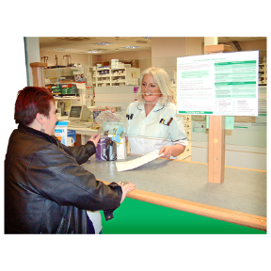Disability support funding does not:

* replace other ways of paying for things that support your life
* pay for other types of support that are not part of your disability.

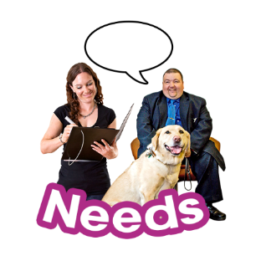

Your disability support funding has been given to you to manage / use to meet your disability support needs only.

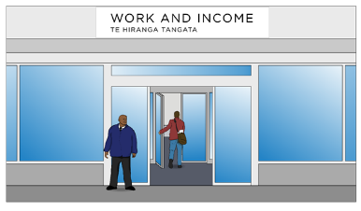This is different to getting a **benefit or allowance** from the Government.

A **benefit or allowance** is money you may be able to get to pay for some of your living costs.



Disability support funding cannot be used to pay for day to day costs like:

* 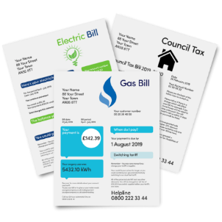**recreational** **costs**
* **living costs / expenses**.

**Recreational costs** means the cost of doing things you enjoy like:

* exercising
* gaming like Xbox or PlayStation
* entertainment like movies / shows.

**Living expenses** are things like:

food

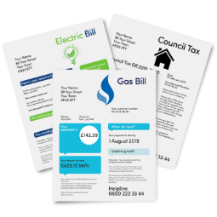rent / housing costs

power / electricity bills.

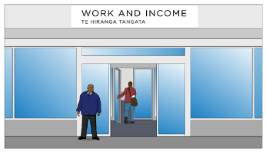

You can talk to Work and Income at the Ministry of Social Development if you need money for living expenses.



When you talk to Work and Income you can find out if there are any benefits or allowances that you can get.

You can find more information about support from Work and Income at this **website**:

[**www.workandincome.govt.nz**](https://aus01.safelinks.protection.outlook.com/?url=http%3A%2F%2Fwww.workandincome.govt.nz%2F&data=05%7C02%7CRebecca.Haig007%40whaikaha.govt.nz%7C56b7733414074172975a08dc48af236f%7Ce40c4f5299bd4d4fbf7ed001a2ca6556%7C0%7C0%7C638465165397863230%7CUnknown%7CTWFpbGZsb3d8eyJWIjoiMC4wLjAwMDAiLCJQIjoiV2luMzIiLCJBTiI6Ik1haWwiLCJXVCI6Mn0%3D%7C0%7C%7C%7C&sdata=JQ71ENEVpLJdQxIdDiJYFHmCoVuMUudkdnERJCLggz0%3D&reserved=0)

You can ask for assistance from Work and Income:

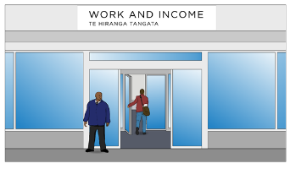online using My MSD

in person

by phone.

**Online using My MSD**

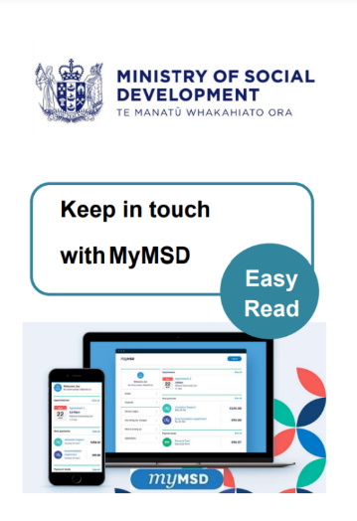You can find Easy Read information about using My MSD in a document called:

**Keep in touch with MyMSD**

You can find this document here:

**shorturl.at/kuFMR**

## In person

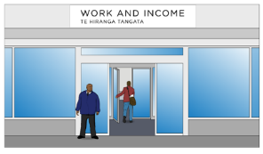

You can visit the Work and Income centre which is closest to where you live.

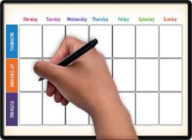

It is best to make an appointment before you go.

You can find the Work and Income centre closest to you on this **website**:

**www.workandincome.govt.nz/findus**

## By phone

You can apply / ask for assistance over the phone.

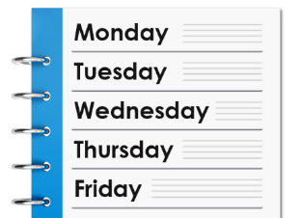You can call Work and Income at these times:

* Monday to Friday from:
* 7 am in the morning

to



* 6 pm in the evening
* Saturday from:
* 8 am in the morning

to

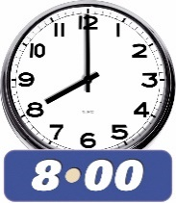

* 1 pm in the afternoon.

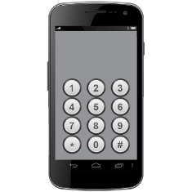If you are **working age** phone:

**0800 559 009**

**Working age** means you are a person aged between:

18 years

and

65 years.

If you are a student phone:

**0800 88 99 00**

If you are a **senior citizen** phone:

**0800 552 002**



A **senior citizen** is a person aged 65 or over.

If you find it hard to use the phone the **New Zealand Relay** service is for people who are:

* Deaf / hard of hearing

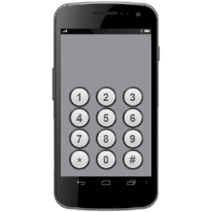

* deafblind
* speech impaired / find it hard to talk.

You can find out more about the New Zealand Relay service at:

**www.nzrelay.co.nz**

# Rules for spending

# disability support funding



There are 4 rules that tell you how you can spend disability support funding.

The 4 rules are the same for:

Carer Support

Individualised Funding / IF

Enhanced Individualised Funding / EIF

Choice in Community Living or Enabling Good Lives

Personal Budgets.

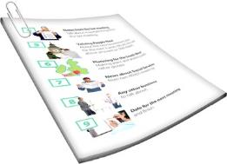You must make sure the thing you want to buy fits the Purchasing Guidance before you buy it.

The changes to the Purchasing Guidance do not change the rules about other disability government funding.

## Rule 1: The funding / purchase:

**helps you live a good life**

**makes your life better.**

The funding has been given to you to use in a specific way.

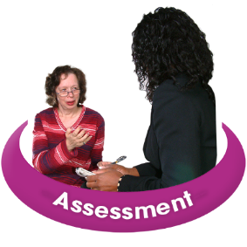You will have discussed the way you use your funding / purchase with your:

* Needs Assessment Service Coordinator / NASC Coordinator
* Individualised Funding Host
* 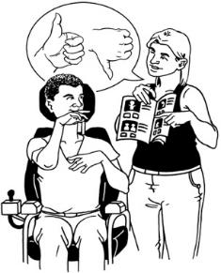Choice in Community Living provider
* Flexible Disability Funding providers
* Enabling Good Lives Team / EGL Team.

**Question: Does this purchase fit with the way the funding is to be used?**

## Rule 2: The purchase is a disability support

The purchase is being used for something that you need because of your disability.



You cannot use the funding for something that you would still need if you were not disabled.

**Question: Is this purchase needed for my disability?**

## Rule 3: The purchase must be:

**reasonable**

**cost effective.**



**Reasonable** means that:

the cost is what you would expect

the item is a good use of the money.

**Cost effective** means:

* it is a good use of the funding / money
* the purchase will mean good outcomes / support for you.

Cost effective does not mean that the thing you buy must be cheap.

Sometimes it is better to buy something that will last a long time even if it costs more.

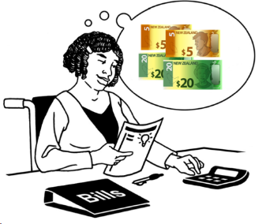The purchase must fit your **budget**.

A **budget** tells you how much funding you have to spend on purchases.

**Question: Does this purchase make good use of your funding on something that will make a lasting impact?**

**Lasting impact** means something will have good outcomes for a good amount of time.

## Rule 4: The purchase is not subject to a limit or exclusion



This rule means that your purchase:

* is something you are allowed to buy



* is not against the law like drugs



is something you have enough funding to buy

is something you cannot get other funding to pay for



follows the way you are supposed to do things like paying people to support you.

**Question: Is this the best way to fund your purchase?**

You can find more information about the purchasing rules on our **website**:

[**www.whaikaha.govt.nz/rules**](http://www.whaikaha.govt.nz/rules)

# Making a plan

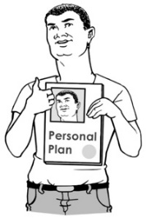Having a plan will support you to:

* make good purchases
* have good conversations / talks with your **Host** or **Connector** about how to use the funding.



If you get IF or EIF funding your **Host** is the organisation that:

* works with you to look after your funding
* checks that your funding is spent in a way that meets the purchasing rules
* works with you to write an Individual Service Plan / ISP.

Your **Host** will also:

* support you to relook at your plan when your needs change
* give you advice / support.

If you manage your EGL personal budget your **Connector** will work with you to write a plan.

If you do not already have a plan then discuss this with your Connector.

You can find more information on our **website** about working with a Connector to write a plan:

[**https://tinyurl.com/5cmfud9y**](https://tinyurl.com/5cmfud9y)

# Examples of how the funding can be used

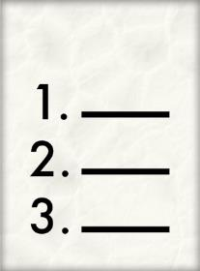

A good way to understand the rules is to read some examples of how the funding might be used.

## Example 1:

Example 1 talks about a disabled person called Joelene.

Joelene has funding for:

personal care

respite.

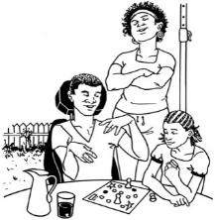Joelene lives with her whānau / family.

Joelene has a support team which she pays for using her funding.

Joelene purchased technology to manage the booking of her support team.

Joelene has a plan that she has worked out with her Host.

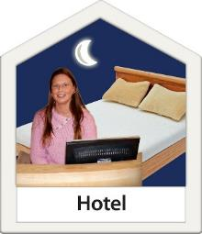

In her plan Joelene says she wants to spend 1 weekend in every month away at an Airbnb / hotel.



Joelene plans to use her respite funding to pay for the cost of her support worker to stay with her.

Joelene will have to use her own money to pay for other costs of going away like paying for:

* 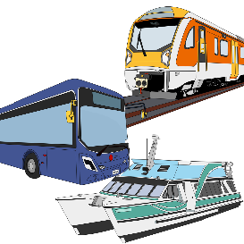accommodation costs – the cost of the Airbnb / hotel where they stay
* her own travel costs between the Airbnb and home.



Joelene can use her funding to pay for the paid support workers travel costs.

This way of using her funding fits with the rules because it:

is individual which means it fits with what Joelene wants to do

means Joelene can spend time away from her family.

This way of using her funding also fits with the rules because it:

is included in her plan

fits with why she has funding.

## Example 2:

Billie has a sight disability.

Billie has a goal in her plan about becoming a photographer.

Billie goes to photography classes.

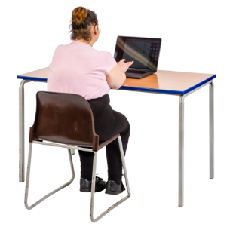Billie needs to buy some computer software to support her to take part in the photography class.

Billie uses her EGL Personal Budget – Community Participation funding to purchase the software.

Billie can use Rule 2 to purchase the software because it makes it possible for her to take part in a recreational activity she enjoys **independently**.



**Independently** means Billie can do the class without the need for a support person.

This way of using the funding fits with the rules because:

the software will make it possible for Billie to access information she needs

it makes it possible for Billie to take part in the class like everyone else

the software is an extra cost because of her disability.

# What you cannot use the funding for



You cannot use the funding for:

anything that is against the law

alcohol like beer or wine



tobacco / smoking products / vaping



gambling like buying a lottery ticket

things that are not a cost of disability

money for yourself



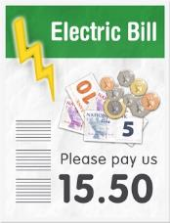things that everyone else has to pay for like bills unless they are related to your disability.

What you cannot buy with your funding depends on the funding stream your money comes from.



To know what you can use your funding for you should talk to your:

* IF Host
* Service Coordinator at the NASC
* Connector.

You cannot use the IF Respite or Carer Support funding to pay for respite related costs such as:

* accommodation like hotel or Airbnb costs
* **domestic travel** which is travel to:
  + different parts of New Zealand to another
  + different towns or cities in New Zealand
* overseas travel
* food
* costs that come from respite but are not part of supporting the disabled person like entertainment costs.



These rules about how funding for respite can be used apply to:

* disabled people
* 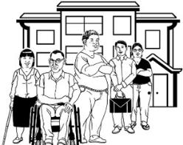whānau / family
* the person / people providing respite.

You also cannot use the funding to buy a support:

* when funding for that support has been turned down by another government agency

**or**

* where you may have to wait to be able to access / get a service – for example if there is a waiting list.

# Employing support workers



If you use the funding to **employ** support workers you must:

follow the laws about employment

be a good employer.



**Employ** means you pay someone for work they do.



You can talk to your Host about how to do this properly.

# Where to find more information

If you have any questions about disability funding you can ask your:

IF Host

EGL team

Service coordinator at the NASC.

They will be able to support you by:

understanding your needs

working with you to decide what is best for you

changing your plan with you

checking that the choices you make fit with the Purchasing Guidiance.

A full list of Hosts can be found at the bottom of this website page:

**<https://tinyurl.com/mxzbtksa>**

Carers New Zealand can also answer any questions you have about disability funding.

****You can contact Carers New Zealand by:

phone on:

**0800 777 797**

going to their website at:

**https://carers.net.nz**

Enable NZ has a website called Firstport that has lots of information about disability funding.

You can find the Firstport website at:   
  
[**https://firstport.co.nz**](https://firstport.co.nz/)



The phone number for Firstport is:

**0800 171 981**



You can find information about the

**New Zealand Relay** service on

**page 17**.

This information was originally written by Whaikaha – Ministry of Disabled People.

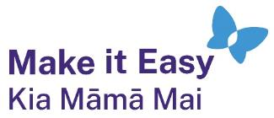It has been translated into Easy Read by the Make it Easy Kia Māmā Mai service of People First New Zealand Ngā Tāngata Tuatahi.



The ideas in this document are not the ideas of People First New Zealand Ngā Tāngata Tuatahi.



Make it Easy uses images from:

* Changepeople.org

Photosymbols.com

* SGC Image Works
* Huriana Kopeke-Te Aho
* T. Wood.

  
All images used in this Easy Read document are subject to copyright rules and cannot be used without permission.