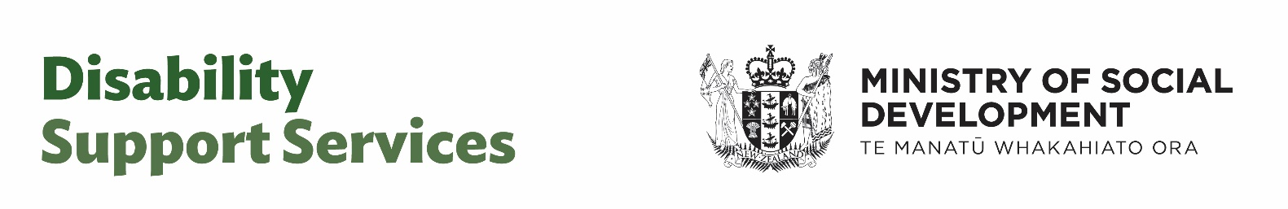

Have your say:

How should disability support

services work in the future?
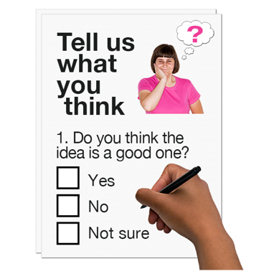

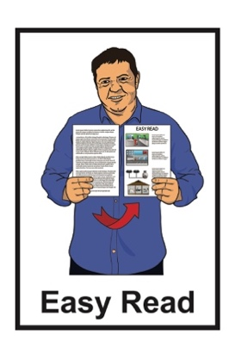
Survey open 29 October 2024 to 22 November 2024

About this Easy Read survey

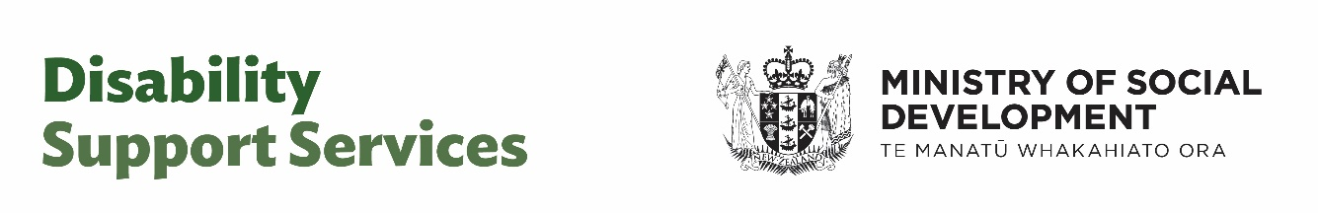
This is an Easy Read survey from the Disability Support Services Taskforce.

A survey is a way to get information by getting people to answer questions.

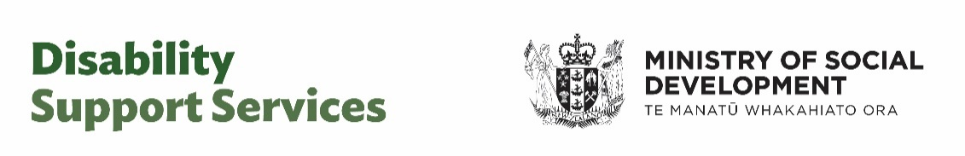
The Disability Support Services Taskforce is:

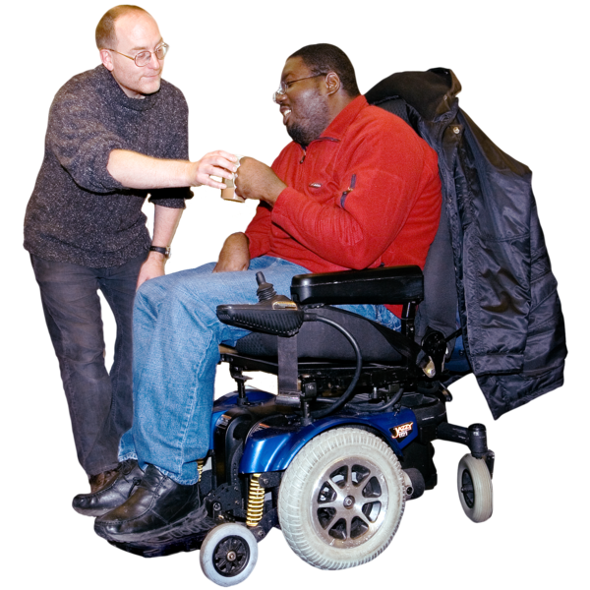
- a part of the Ministry of Social Development

- working to set up how disability support services will work in the future.


Future means in the months / years ahead.
When you see the words we / us this means the Disability Support Services Taskforce.

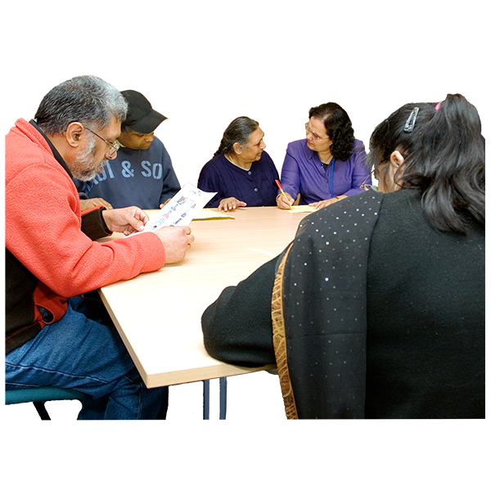
Your survey answers will assist us to better understand what is important when it comes to disability support services.
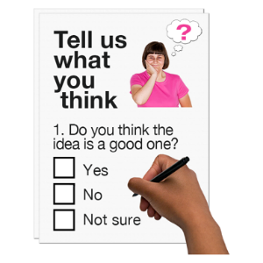


Please complete 1 survey per person.


The survey is 1 way people can have their say about the future of disability support services.

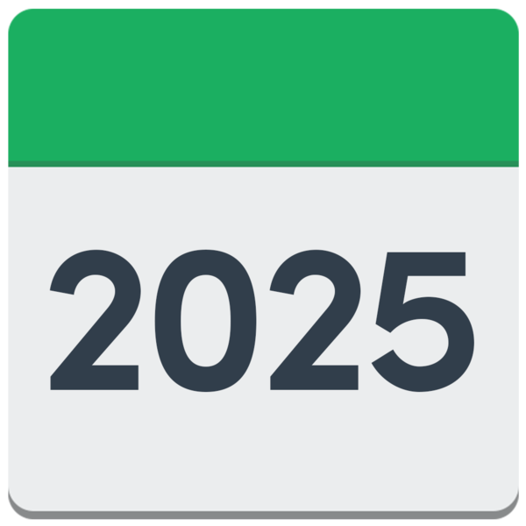
There will be more ways to have your say in early 2025.

The answers you give in this survey are anonymous.


Anonymous means no one will know:

- that you answered the survey

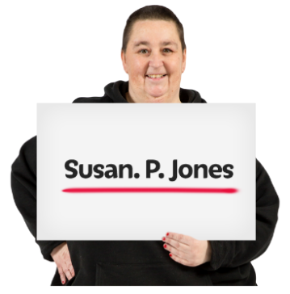
- which answers are yours.

Please do not give your name or any contact details in the survey.

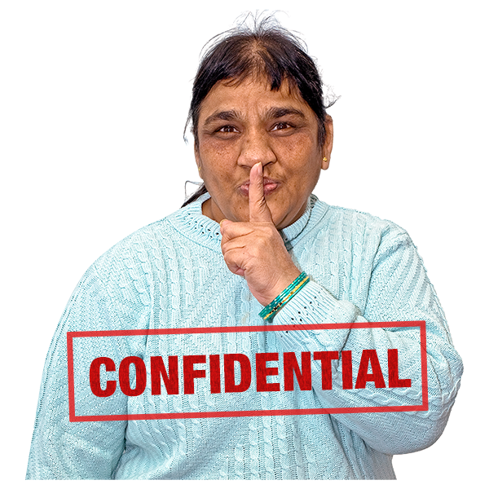
We will not give your survey answers to anyone outside the Disability Support Services Taskforce.

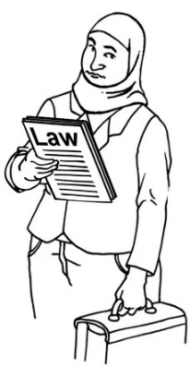
The only time we might need to tell someone is if we have to by law.

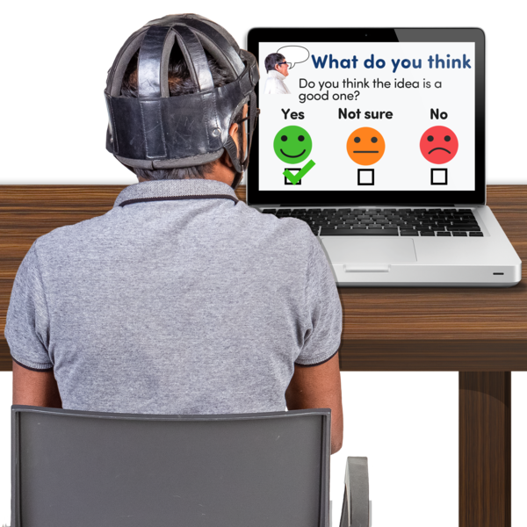
You can find the survey online at this website:

www.disabilitysupport.govt.nz
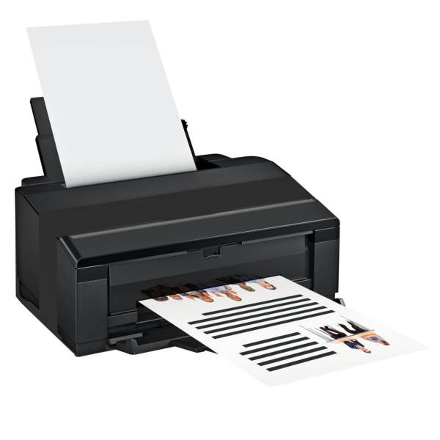

You may find it easier to print the survey to fill in.

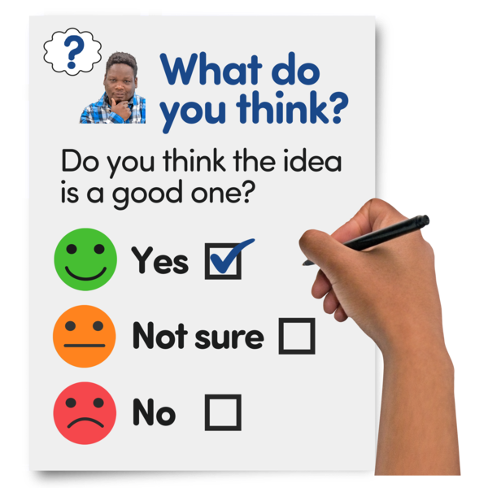
There are 4 parts to the Easy Read survey.

You do not have to answer all the questions if you do not want to.


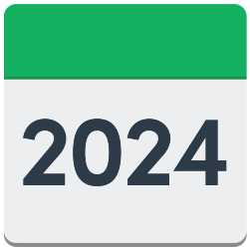
You have until Friday 22 November 2024 to send us your survey answers.


You can email your survey answers to:

dss_submissions@msd.govt.nz

You can post your survey answers to:
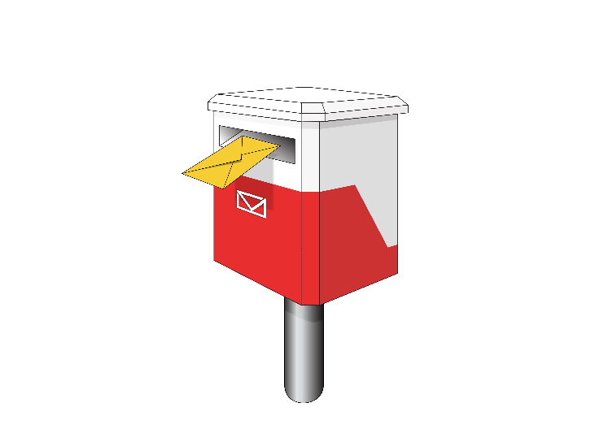
DSS Submissions – Disability Support Services Taskforce

Ministry of Social Development
PO Box 1556
Wellington 6140

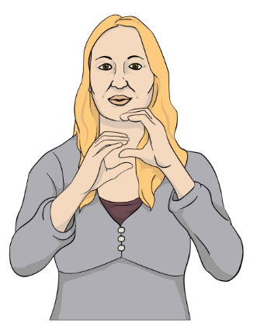
If you want to answer the survey using New Zealand Sign Language you can email:

DSS_NZSLsubmissions@msd.govt.nz

Survey questions – Part 1


Please tick 1 box to show your answer.

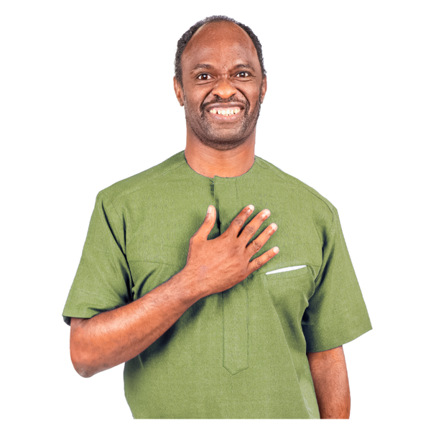
- You are filling in this survey as a:
- disabled person
- whānau / aiga / family
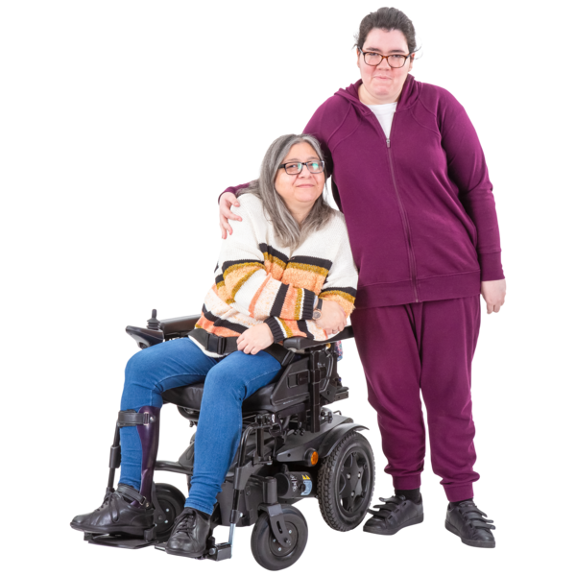
- carer
- service provider

- Needs Assessment Service Coordination Service / NASC
- Enabling Good Lives site
- community group.
Please tick 1 box to show your answer.

- You live in:
- Northland
- Auckland

- Waikato
- Bay of Plenty
- Taranaki
- East Coast
- Central North Island
- Wellington.

There are more answers on the next page.
Please tick 1 box to show your answer.

- You live in:

- Nelson / Marlborough / West Coast
- Canterbury
- Southern.

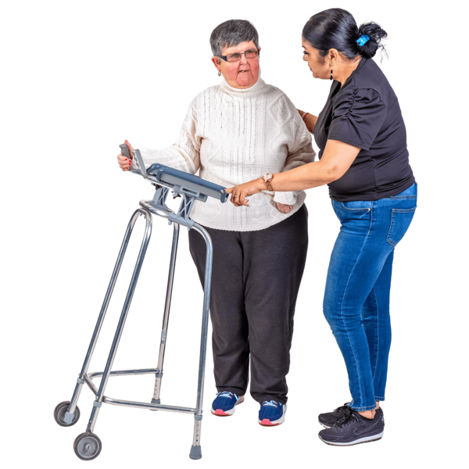
- What disability services and support do you get?

Please write your answer here:



- If you are a provider – what disability services and support do you provide?

Please write your answer here:

Survey questions – Part 2
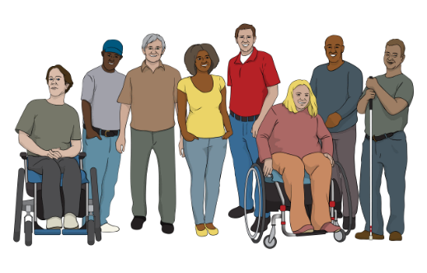
- What do you think is the role / job of disability support services?

Please write your answer here:

Tick this box if you are not sure / do not want to say.
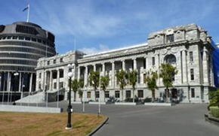
- Is it clear what the role / job of Government is in supporting disabled people?



Please tick 1 box to show your answer:
- Yes
- No
- Not sure / do not want to say.

- If your answer to Question 2 was No please give us some examples:

Please write your answer here:


- How do you find navigating between different parts of Government?

Navigating means finding the information / services you need.

Please tick 1 box to show your answer:

- 1. Very hard
- 2. Hard
- 3. Neutral – not hard / not easy
- 4. Easy
- 5. Very easy
- Not sure / do not want to say.

- What supports would make navigating different parts of Government easier?

Please write your answer here:

Tick this box if you are not sure / do not want to say.
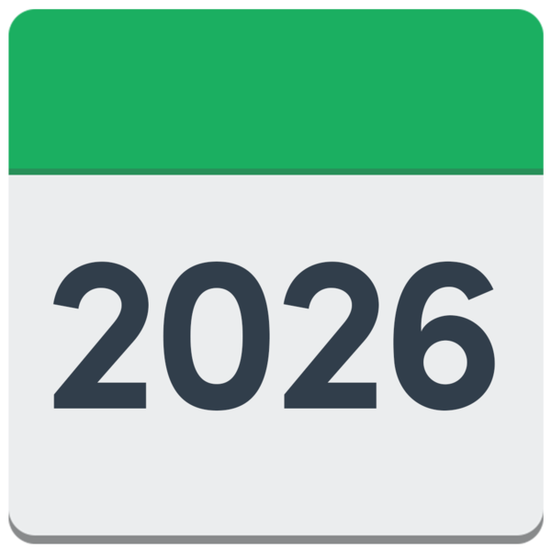
- What do you think can be done over the next 1 to 2 years to make disability support services better?

Please write your answer here:

Tick this box if you are not sure / do not want to say.
- What do you think can be done over the next 1 to 2 years to better manage / look after the cost of disability support services?

Please write your answer here:

Tick this box if you are not sure / do not want to say.
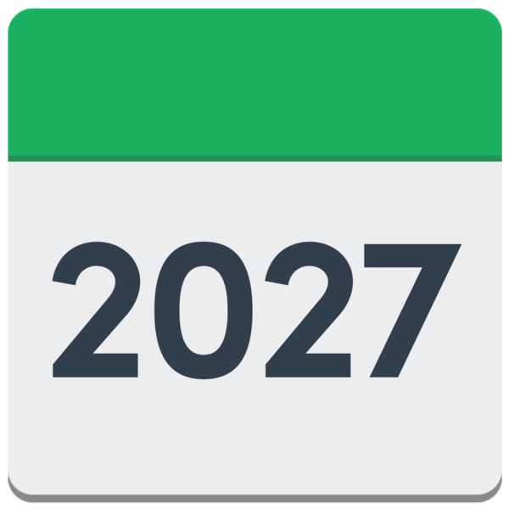
- What do you think can be done longer term to improve disability support services?
2034

Longer term means the next
3 to 10 years.

Please write your answer here:

Tick this box if you are not sure / do not want to say.

- What changes do you think would make disability support services more fair?

Please write your answer here:

Tick this box if you are not sure / do not want to say.

Survey questions – Part 3

The questions in Part 3 are about:
- your needs assessments which look at what support needs you have
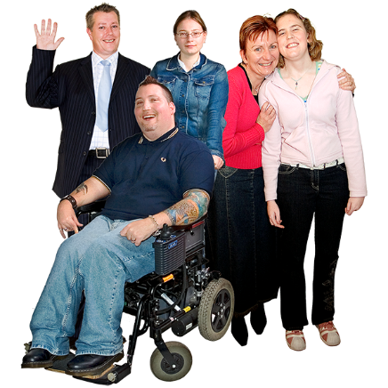
- putting in place your support services.

These assessments / services may have been done by your:
          - Needs Assessment Service Coordination service / NASC service
          - Enabling Good Lives site / EGL site.

- Did the needs assessment do a good job of quickly finding out what supports you need?

Please tick 1 box to show your answer:
- Yes
- No
- Not sure / do not want to say.

- If your answer to Question 1 on page 19 was Yes:
How well did the services put in place match your assessed needs?

Please write your answer here:

Tick this box if you are not sure / do not want to say.
- If your answer to Question 1 on page 19 was No:
What could be done better with the:
- coordination / putting in place of services to match your needs?
- needs assessment to work out the supports needed?

Please write your answer here:

Tick this box if you are not sure / do not want to say.

- Is it clear how the reassessment of services / needs is done?


A reassessment is when there is a review of your support:

- needs

- services.

Please tick 1 box to show your answer:
- Yes
- No
- Not sure / do not want to say.

- If your answer to Question 4 on page 22 was No what would make it clearer?

Please write your answer here:

Tick this box if you are not sure / do not want to say.

Survey questions – Part 4


The questions in Part 4 are about the Disability Support Services flexible funding.


Flexible funding is support such as:
- Carer Support
- Individualised Funding / IF

- Enhanced Individualised Funding / EIF
- Choice in Community Living or Enabling Good Lives / EGL
- Personal Budgets.

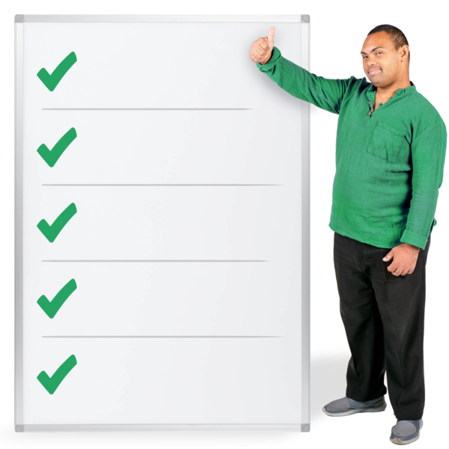
- What things need to be worked through in setting the eligibility criteria for flexible funding?

Eligibility criteria are used to decide who the services should be for.

Please write your answer here:

Tick this box if you are not sure / do not want to say.

- Are there things / support that you can only get using your flexible funding?

Please tick 1 box to show your answer:
- Yes
- No
- Not sure / do not want to say.
If you answered Yes to Question 2 above what are some examples of the things / support you can only get using flexible funding?

Please write your answer here:

Tick this box if you are not sure / do not want to say.

- Are you clear what the flexible funding can be used for?

Please tick 1 box to show your answer:
- Yes
- No
- Not sure / do not want to say.

- What ideas do you have to make flexible funding simpler / easier to use?

Please write your answer here:

Tick this box if you are not sure / do not want to say.

- Are the Purchasing Guidelines clear / easy to understand?

Purchasing Guidelines are rules about how you can use your funding.

Please tick 1 box to show your answer:
- Yes
- No
- Not sure / do not want to say.

If your answer to Question 5 on page 28 was No:

What ideas do you have to make the Purchasing Guidelines easier to understand?

Please write your answer here:

Tick this box if you are not sure / do not want to say.

Where to find more information


You can find more information about the survey on the Disability Support Services Taskforce website:

www.disabilitysupport.govt.nz

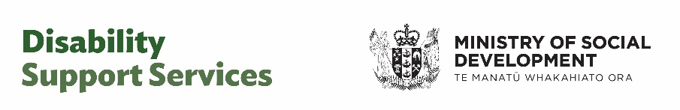
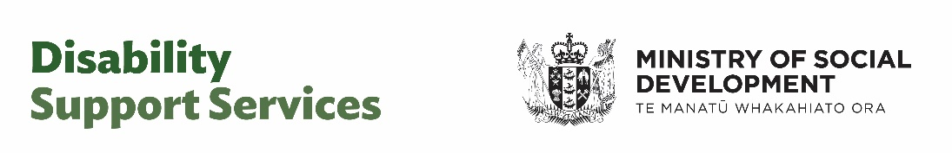
This information has been written by the Disability Support Services Taskforce, Ministry of Social Development.

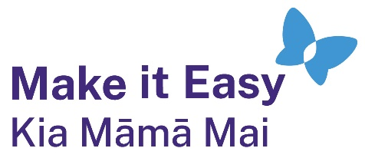
It has been translated into Easy Read by the Make it Easy Kia Māmā Mai service of People First New Zealand Ngā Tāngata Tuatahi.


The ideas in this document are not the ideas of People First New Zealand
Ngā Tāngata Tuatahi.

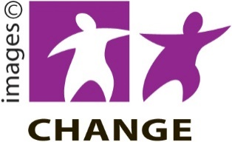
Make it Easy uses images from:
- Changepeople.org

            - Photosymbols.com


- SGC Image Works
- Huriana Kopeke-Te Aho
- T. Wood.


All images used in this Easy Read document are subject to copyright rules and cannot be used without permission.

