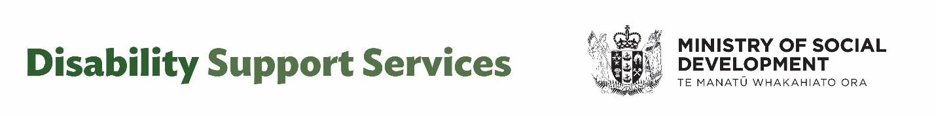
Survey Questions
Are you responding to this survey as a: (please select one)

- disabled person
- family / whānau member
- carer
- service provider
- NASC
- EGL site
- community group

Which region do you live in most of the time? (please select one)

- Northland
- Auckland
- Waikato
- Bay of Plenty
- Taranaki
- East Coast
- Central
- Wellington
- Nelson/Marlborough/West Coast
- Canterbury (including Chatham Islands)
- Southern

What services and supports do you receive?

What services and supports do you provide?

Overall response to the Independent Review
These questions are about the future state of the Disability Support Services system.

- What is the role and purpose of Disability Support Services in disabled people’s and their whānau / families’, aiga and carers lives?

- Prefer not to say/skip

- Is the role of government agencies in supporting disabled people clear?

- Yes
- No
- Prefer not to say

(If “no” in Q2)
- If no, please provide examples.

- How do you find navigating between different parts of government?

- 1 = Very hard
- 2 = Hard
- 3 = Neutral – not hard, not easy
- 4 = Easy
- 5 = Very Easy
- Not sure/Prefer not to say

- What supports would help make this easier?

- Not sure/ Prefer not to say

- What short-term actions, over the next one to two years, do you think would improve disability support services?

- Not sure/ Prefer not to say

- What short-term actions, over the next one to two years, do you think would help better manage the cost of disability support services to the Government?

- Not sure/ Prefer not to say

- Longer term, what changes do you think would help improve disability support services?

Not sure/ Prefer not to say

- What changes do you think would make disability support services fairer?

Not sure/ Prefer not to say

Recommendation Five
The following questions are about needs assessment and services coordinated at your NASC or EGL site for disability support services you receive. We are especially interested in the views of disabled people whānau / families’, aiga and carers.
- When you had your needs assessment done (or for the person you support), did the assessment do a good job of establishing the support required? (for example, identification of support or reasonable timeframes to determine those supports)

- 1 = Yes
- 2 = No
- Not sure/ Prefer not to say

- If “Yes” to Rec Five, Q1
How well did the services coordinated to you (or the person you support), match the needs identified?

If ‘no’ to Q 1. A
- What could improve the coordination of services to match your identified needs?

- Not sure/ Prefer not to say

- What can be done to improve assessments to establish the support required?

- Not sure/ Prefer not to say

- Is it clear what the process of reassessment of services and needs is, and how it works?

- = Yes
- = No
- Not sure/ prefer not to say

- If “no” to Q2
What could be done to make it easier to understand?

- Not sure/ Prefer not to say
Recommendation Six
The following questions are about criteria and flexible funding of Disability Support Services.
- What things need to be worked through in setting eligibility for flexible funding?

- Not sure/ Prefer not to say

2. Are there situations where you can only access what you need through flexible funding, support that would otherwise be unavailable?
- = Yes
- = No
- Not sure / prefer not to say

- If “yes” to Q. 2
What are some examples?

Not sure/ prefer not to say
3. Are you clear what flexible funding can be used for?
- 1 = Yes
- 2 = No
- Not sure / prefer not to say

4. What suggestions do you have to make flexible funding simpler?

- Not sure / Prefer not to say

5. Are the purchasing rules and guidelines clear and easy to understand?
- 1 = Yes
- 2 = No
- Not Sure/ Prefer not to say

- If “no” to Q 5
What suggestions do you have to make the purchasing rules or guidelines easier to understand?

- Not sure/ prefer not to say

Ways to submit your written response:

Email
DSS_submissions@msd.govt.nz

Post
Disability Support Services
Ministry of Social Development
PO Box 1556
Wellington 6140
New Zealand

