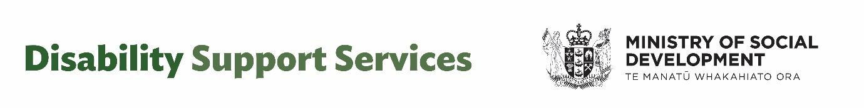

Video transcript: Survey on future disability support services
Kia ora koutou. I'm Chris Bunny, the head of the Disability Support Services Taskforce. We're working on how disability support services should best be provided into the future. We want to acknowledge many of you have given feedback throughout the year on disability support services, and we want to thank you for that.
This next survey will build on what you have already told us. We would really appreciate your feedback on some key questions to help us better understand and consider these very important supports and services, both in the short and longer term. The survey is anonymous, and we are not collecting personal information through it.
We do not provide information about your survey responses to any other individual, company, or government body, except as required by law. Any identifiable information provided by you will be treated in confidence. This survey is only the first round of input into this work. Further community engagement and consultation will be held in early 2025.
This initial survey will help us develop policy options to come back to you early next year. And after that, Cabinet will make decisions. The background to this work is that in August, an independent review found there was unsustainable spending increases and a lack of fairness and transparency around what support disabled people can access.
The government wants to put disability support services on a sustainable basis longer term. The Government also wants to better manage cost pressures and improve consistency, fairness and transparency. For this survey, we are seeking feedback on three main topics. The first, where we would value your input, is more general questions on future disability support services.
The second is about flexible funding and eligibility and what funding can be used for. The third area is about needs assessments and the allocation of support. These topics relate to the recommendations of the independent review and will inform longer term planning to improve disability services. We really hope you are able to take part.
Ka kite.

