
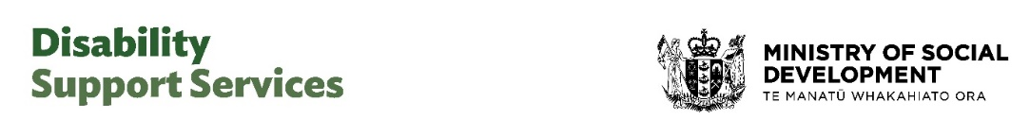

Community consultation on
Disability Support Services:
Discussion document – summary


Published: February 2025

What you will find in this Easy Read

Page number:
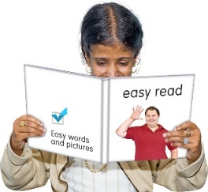

About this Easy Read 2


Information about the online
survey 6

Other ways of giving your answers 8

Consultation Topic 1: Questions 10


Consultation Topic 2: Questions 20

Where to find more information 29

About this Easy Read

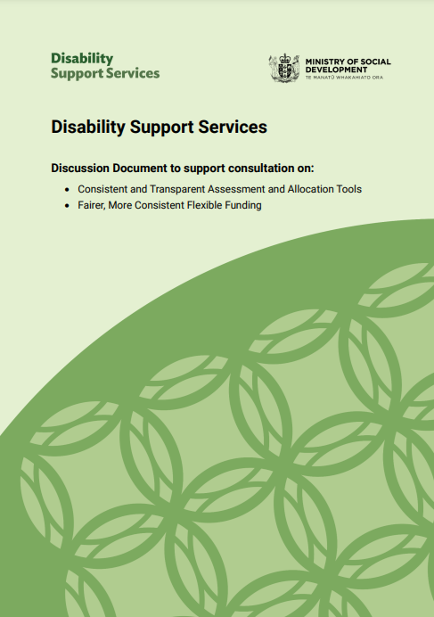
The information / questions in this Easy Read document are from a document called:

Disability Support Services - Discussion Document to support consultation on:
- Consistent and Transparent Assessment and Allocation Tools
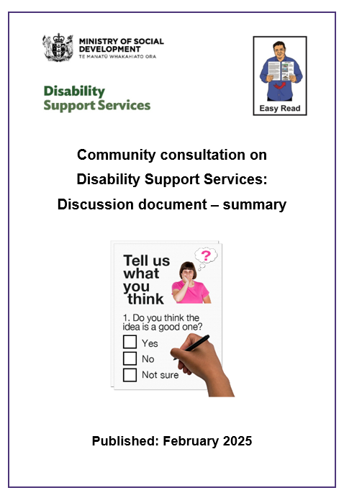
- Fairer, More Consistent Flexible Funding.

This Easy Read is a summary of some of the information from this Discussion Document.


A summary is:
- shorter than the main document
- tells you the main ideas.


The full Discussion Document is not in Easy Read.


You can find the full Discussion Document at this website:

https://tinyurl.com/mr3mwxr3


The Discussion Document is part of making Disability Support Services better.
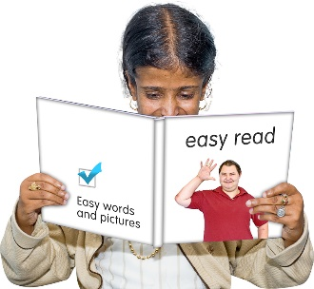

In this document Disability Support Services will be written as DSS.


This survey has 2 main consultation topics.


Consultation topics are the ideas that were talked about in the Discussion Document.

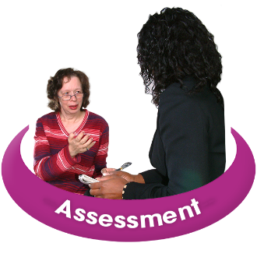
Consultation Topic 1 is about making the way the needs of disabled people are assessed better.

Assessed means how NASC checks the needs of disabled people.

There are 8 questions in Consultation Topic 1.

Consultation Topic 2 is about looking at:
disabled people accessing flexible funding
how flexible funding can be used.

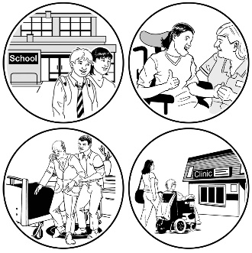
Flexible funding pays for the support some disabled people need.

Flexible funding gives disabled people more control over how the money is spent.

There are 5 questions in Consultation Topic 2.

There are 13 questions in total.

Information about the online survey

There is an online survey with the questions being asked as part of the consultation.

You can answer as many questions as you want.


You can find the online survey at this website:

consultations.msd.govt.nz

The online survey is not in Easy Read.

This Easy Read document has the questions that are being asked in the online survey.

You can use this Easy Read to better understand the questions being asked.



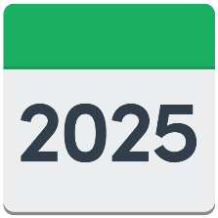
The online survey is closes on:

Monday 24 March 2025 at 5 pm.

Other ways to giving your answers

There are also other ways you can send in your answers.

You can send your answers by:
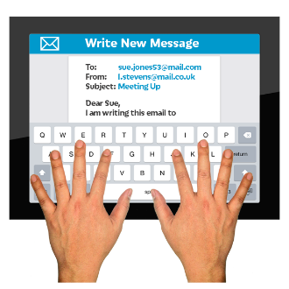
- Email:
DSS_submissions@msd.govt.nz


- Video / audio recording to email:

NZSL_submissions@msd.govt.nz

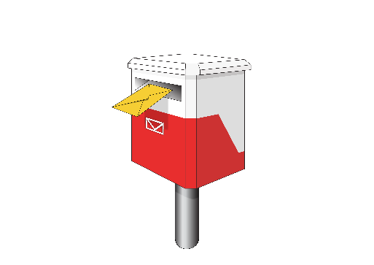
- Posting your answers to:
Disability Support Services
Ministry of Social Development
PO Box 1556
Wellington 6140

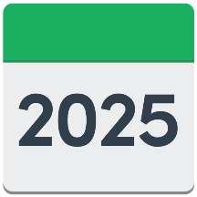
You have until Monday 24 March 2025 to send us your answers.

Consultation Topic 1: Questions


Consultation Topic 1 is about ideas on how to change:

- the way the needs of people are assessed
- how decisions are made about what supports they get.

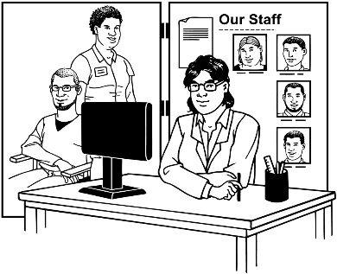
This includes assessments by the Needs Assessment Service Coordination.

In this Easy Read document
Needs Assessment Service Coordination is written as NASC.

NASCs work with disabled people to find out what support services they can get.


Enabling Good Lives assessments are not included.

Make sure there is a consistent approach to needs assessment.
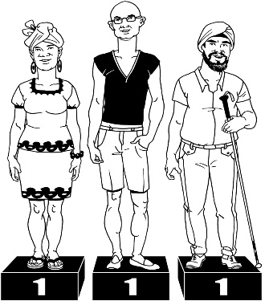

Consistent approach means that the way needs are assessed is the same for everyone.

Question 1:
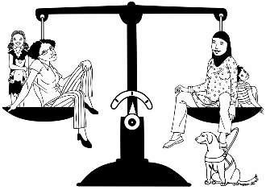
What changes do you think would make sure the way people are assessed are:

- fair
- the same for everyone
- clear for people to understand.


For example you might think the assessment should be:
- done online
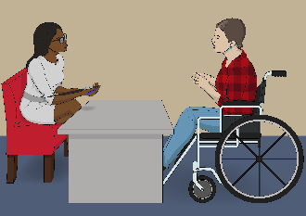
- done in:
- person
- a different place.

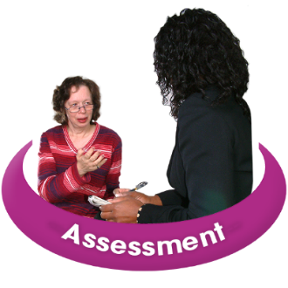
Improve how the way assessments are done fits with the diversity of disability.

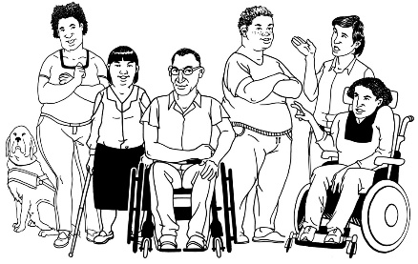
The diversity of disability means:

- all the different ways people are disabled
- all the ways disabled people and their lives are different.


Question 2:

What information do we need to know about you / your life to make sure we understand what support you need?

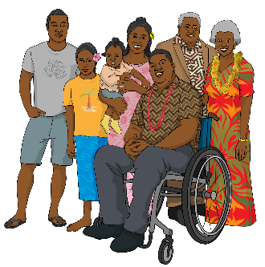
Assess the needs of
whānau / family and carers.

Assess means to ask questions to find out information.

Question 3:

Do you support the idea that the needs of carers should be assessed when the needs of disabled people are?

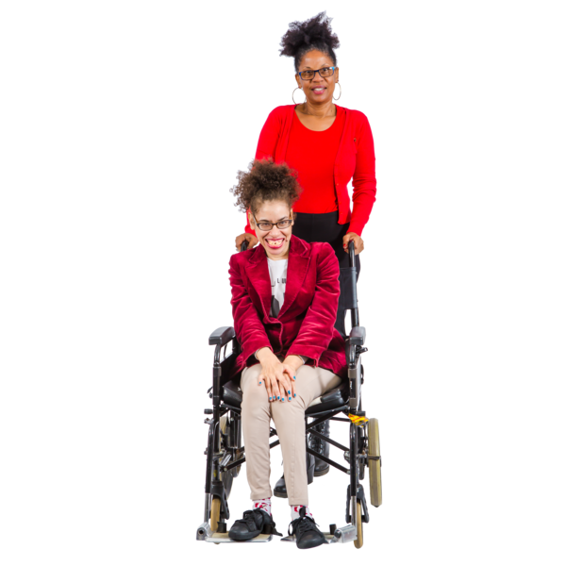

Question 4:

What questions should carers be asked about the support they need?

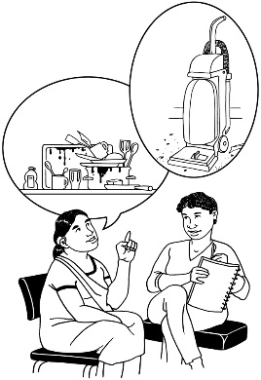
Make sure the services /

support a person gets keep meeting their needs.


Question 5:

How often do reviews happen about your:
- needs?
- services?
- support?


Reviews are when you:
- check how things are going
- decide if anything needs to be changed.
Question 6:


Sometimes things happen that mean our support needs change.

What are some changes that would mean people should have their support needs reviewed?

Question 7:

How often do you think your services / support should be reviewed?

For example every:
- year
- 2 years
- 3 years
- 5 years.


Assisting you to access support that you cannot get through DSS.

We suggest that NASCs:
- find out about other support agencies
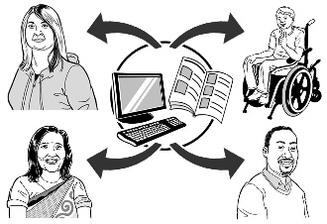
- give information on how to access other support agencies.

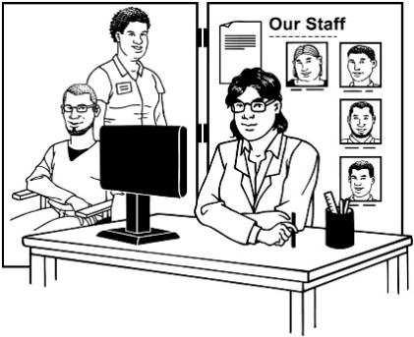
This means DSS is only used for supports that are not available somewhere else.


Question 8:

What should NASCs do that will help you access services?

For example you might think NASCs should give:
- information
- support.

Consultation Topic 2: Questions


Consultation Topic 2 has questions about flexible funding.

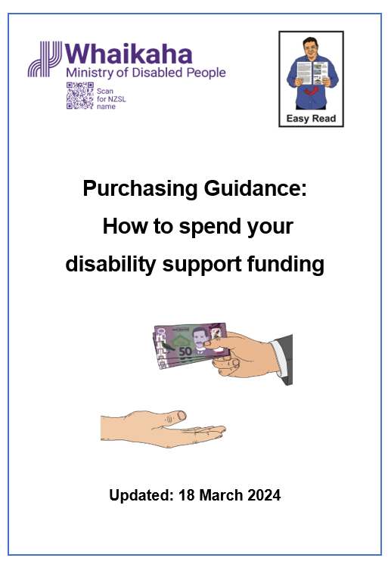
You can find more information about what flexible funding is in an Easy Read document called:

Purchasing Guidance: How to spend your disability support funding.

You can find this Easy Read at this website:

https://tinyurl.com/4asuc755


There are 2 options / ways for changing how flexible funding can be used.

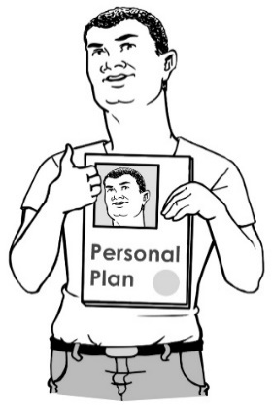
Option 1:

Link flexible funding to a plan while keeping track of how it is used.

Option 2:

Change:
- what can be paid for using flexible funding

- what can not be funded using flexible funding.

Question 9:

Which of the 2 options do you think is better?


Why you think that option is better?

Question 10:

Do you have any suggestions on how flexible funding can be used to allow
disabled people / carers as much:
- choice as possible
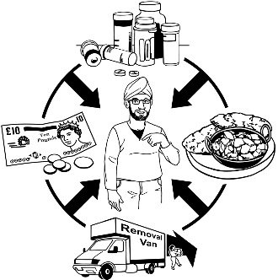
- control as possible
- flexibility as possible - this means being able to change as the needs of someone changes.

Your answer needs to make sure that the funding is:

- being used in the most supportive way possible
- supporting what needs to be done.


Introduce criteria to access flexible funding.

Criteria is like a list of rules about who can get flexible funding.


Question 11:

Do you support the idea that people need to meet the criteria for getting flexible funding?


Please say:
- why if you think yes
- why not if you think no.

Question 12:
There are 6 suggestions of what should be part of the criteria for getting flexible funding:

Which of the following suggestions do you agree with?
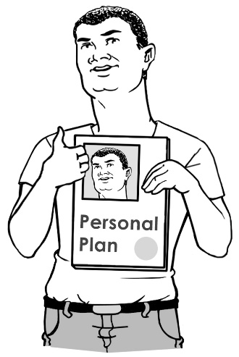
- Flexible funding should be:

- part of an agreed plan

- connected to a specific need.

- The responsibilities of flexible funding can be managed by:
- disabled people

- whānau / family of disabled people
- carers.
Some more suggestions for the flexible funding criteria are:

- The cost of the support / service that will be funded will not cost more than other ways to get that support.

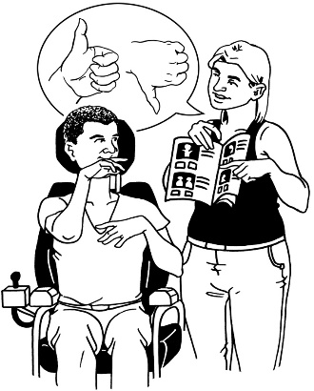
- Flexible funding is a better way of buying service / support that the DSS provides.
This is because it also allows for things like finding services / support close to where someone lives.


- Flexible funding will be able to provide a service that is not available anywhere else


Some more suggestions for the flexible funding criteria are:

- Flexible funding will support someone to buy / access a service that should mean they need support less in the future.

When you answer question 12 please say:

- the number of which suggestions you agree with
- why you agree to these suggestions


- the number of which suggestions you disagree with
- why you disagree with these suggestions.


Question 13:

Please tell us what you think should be part of the criteria for people to access flexible funding.

Please say why you think your ideas will be useful for someone accessing flexible funding.

Where to find more information

You can find more information about DSS on our website:

www.disabilitysupport.govt.nz


The DSS phone number is:

0800 566 601



The phone line is open 8 am in the morning to 5 pm in the evening on:
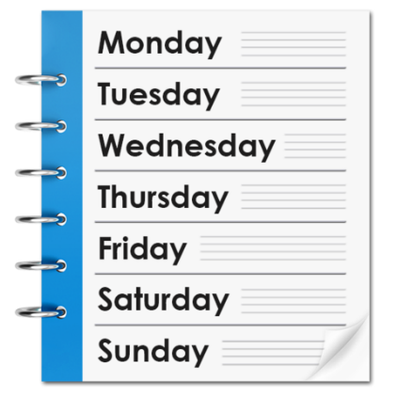
- Monday
- Tuesday
- Thursday
- Friday.


The DSS phone line is open 9.30 am in the morning to 5 pm in the evening on:
- Wednesday.


If you find it hard to use the phone the New Zealand Relay service is for people who are:

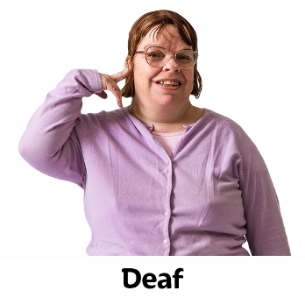
- Deaf / hard of hearing

- deafblind

- speech impaired / find it hard to talk.


You can find out more about the New Zealand Relay service at:

www.nzrelay.co.nz

This information has been written by Ministry of Social Development –
Disability Support Services.
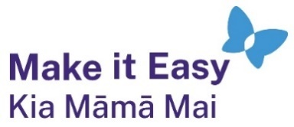
It has been translated into Easy Read by the Make it Easy Kia Māmā Mai service of People First New Zealand Ngā Tāngata Tuatahi.

The ideas in this document are not the ideas of People First New Zealand Ngā Tāngata Tuatahi.


All images used in this Easy Read document are subject to copyright rules and cannot be used without permission.

Make it Easy uses images from:

- Photosymbols

- Change Images



- Huriana Kopeke-Te Aho

- SGC Image Works

- T Wood


- Studio Rebeko.

