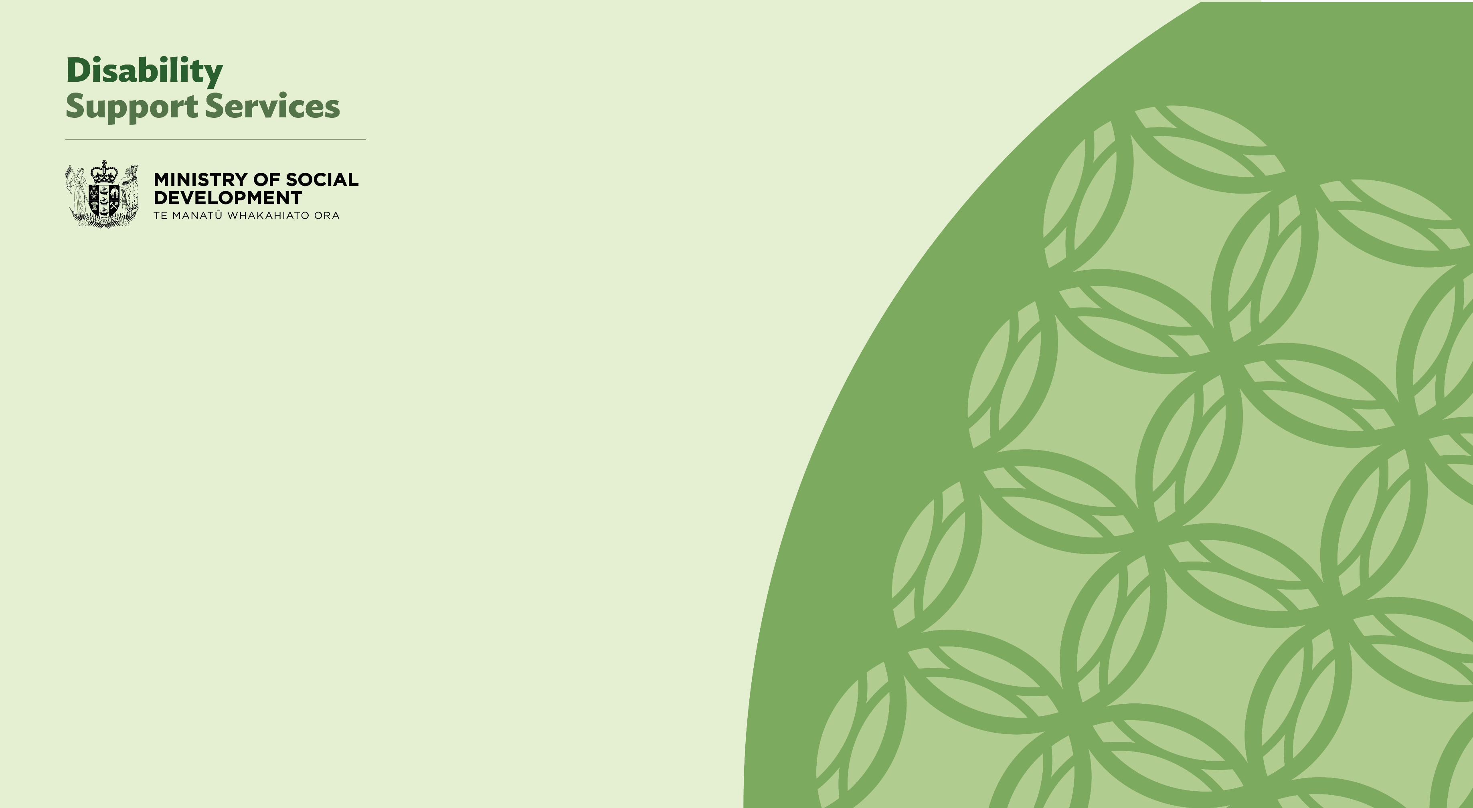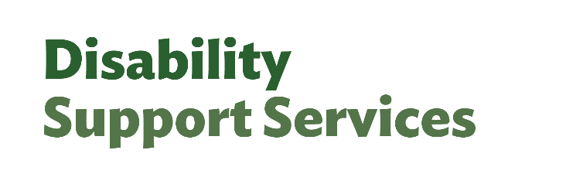

**Disability Support Services issues engagement findings**

October/November 2024

Contents

Acknowledgements 2

Background 2

Who we heard from 3

Written submissions 3

Hui 3

Online Survey 3

Connection to the disability community 4

Regional distribution 5

Section 1: overview of DSS 6

The role and purpose of DSS 6

Clarity of government’s role 8

Opportunities to improve navigation 10

Improving DSS in the short term 13

Short-term actions to help better manage the cost of disability support services to the Government 17

Improving DSS in the longer term 19

Making DSS fairer 22

Section 2: assessment settings 25

Matching services to need 25

Opportunities to improve coordination of services 29

Improving assessments 31

Making reassessments easier to understand 34

Section 3: flexible funding 38

Setting eligibility for flexible funding 38

Flexible funding was a critical method to access supports 40

Simplifying flexible funding 43

Making purchasing rules easier to understand 45

Methodology 48

Privacy 48

Limitations 48

# Acknowledgements

The Ministry of Social Development (MSD) would like to thank all the people who took time to share their views, insights and experiences with us as part of the consultation on issues experienced by disabled people and whānau using MSD’s Disability Support Services.

We sincerely hope that when those who participated in the issues consultation read this report, they will feel that we have provided a balanced representation of the range of different viewpoints.

We would also like to acknowledge and thank those individuals and organisations who helped us to publicise and promote the consultation. Without their help we would not have received such a high number of responses.

# Background

Disability Support Services (DSS) is responsible for providing essential disability support to around 50,000 disabled people and their whānau, as well as environmental supports, including equipment and modification services, for approximately 100,000 New Zealanders.

Following an Independent Review of DSS in 2024, the Disability Support Services Taskforce was established to implement the Independent Review's recommendations. The report of the Independent Review (including alternate formats) is available here: [Independent Review Report | Whaikaha - Ministry of Disabled People](https://www.whaikaha.govt.nz/news/independent-review/independent-review-report)

The current priority of the Taskforce is to stabilise DSS by making it fairer, more transparent, easier to understand and more consistent for disabled people within current funding levels.

Engagement on the issues experienced by disabled people and whānau using MSD’s Disability Support Services took place between 29 October 2024 and 22 November 2024. In this consultation over 1,500 people told us their views on the future of DSS.

This document provides a summary of the findings from this consultation and do not represent the views of MSD. Throughout this document we have included verbatim quotes to illustrate respondents' views. Quotes have not been changed or corrected for spelling and grammar.

The findings from this, and from upcoming consultation in early 2025, will support and inform the development of options for Government to stabilise disability support services so they are fairer, more consistent, more transparent, and sustainable into the future.

Our next community consultation will take place from 10 February until 24 March 2025 and builds on the responses we received in our first round of consultation as summarised below.

# Who we heard from

Engagement on the issues experienced by disabled people and whānau using MSD’s Disability Support Services (DSS) took place between 29 October 2024 and 22 November 2024.  This included written submissions, an online survey, and hui with organisations representing disabled people and carers.

## Written submissions

We received written submissions by email. Hard copies were also received. Some people emailed their completed online survey responses to us directly to provide long form answers.

Alternate formats were also emailed to the DSS consultation inbox. If submissions followed the online survey template, they were included in the analysis of online survey responses.

55 people emailed free form written submissions. These were analysed by theme. Where the submissions were relevant to residential care they were included in the analysis for recommendation 2 engagement – this is reported on separately.

## Hui

Consultation hui focused on recommendations 5 & 6 of the Independent Review. These recommendations were focused on needs assessment and allocation settings and flexible funding. There were 9 online meetings with peak bodies and community groups.

As part of the hui, participants and officials discussed the Independent Review, the timelines for the Taskforce, and the questions in the online survey.

Participants were also given the opportunity to discuss any additional issues they felt were important for us to understand. Notes taken from these hui were analysed by theme, providing greater detail on the issues identified from the survey analysis.

## Online Survey

The survey was launched on 29 October 2024 and was promoted on the DSS website, and by peak bodies and community groups, including in the Disabled People’s Organisations Coalition (DPOC) newsletter.

By the close of the survey on 22 November 2024, 1501 people had engaged with the survey, either online or by emailing or delivering hard copies of the survey to us.

The survey had 3 parts. The first part asked participants to respond to the Independent Review of Disability Support Services (Independent Review), with questions focusing on the role of disability support services, navigation of the system, and suggestions for short and longer-term actions to improve the system.

The second part of the survey focused on recommendation 5 of the Independent Review, and sought insight into needs assessment, service coordination, and reassessment processes.

The third part of the survey asked questions about recommendation 6 of the Independent Review and sought insight into flexible funding, including examples where flexible funding was used, and how to improve the rules around its use.

The survey featured a mixture of yes/no questions. There were also some options to indicate the level of agreement with each question, and the option to provide more detailed responses in the open comment boxes.

To protect privacy, we decided not to ask for demographic information, as this risked identifying individuals. However, respondents were asked to select their region and their connection to the disability community from a list of options.

## Connection to the disability community

Half of the respondents identified as a family/whānau member of a disabled person. 30% of respondents identified as a disabled person.

Respondents could only opt into 1 group. However, many indicated they had multiple connections to the disability community, for example having a disability and being a family member/carer of a disabled person.  There were 1,493 responses to this question.

## Regional distribution

68% of the respondents who provided regional data were from the 4 main regions (Auckland, Wellington, Waikato, and Canterbury - including Chatham Islands). There were 1,483 responses to this question.

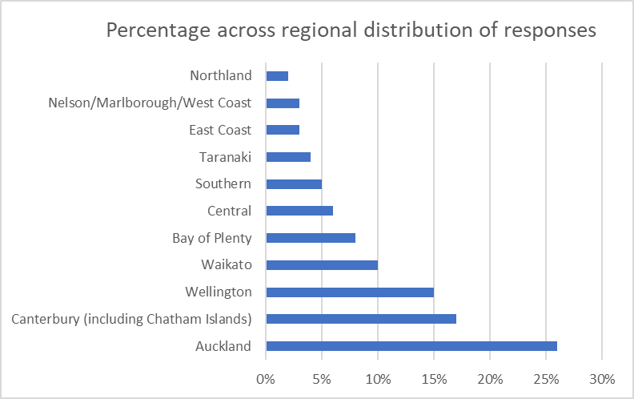

# Section 1: overview of DSS

The questions in this section focused on the role and purpose of DSS, challenges in navigating services, and short and longer-term actions to improve disability support services.

## The role and purpose of DSS

There were 1,317 responses to the question ‘What is the role and purpose of Disability Support Services in disabled people’s and their whānau/families’ aiga and carers lives?’ Views on the role and purpose of DSS varied substantially between respondents, with many people thinking DSS held multiple roles.

8% of respondents explicitly mentioned Enabling Good Lives (EGL), system transformation, or the United Nations Convention on the Rights of Person’s with Disabilities (UNCRPD) as the underpinning principles of the system or the aspiration and commitment the system is moving towards. 4% of respondents provided feedback relating to stewardship of the system, advocating at the government level to build inclusion and acceptance of disabilities within society.

Enabling good lives. That is what the role should be and what we have come to understand as a community already after years of work. I really don't think it needs to be redefined or investigated - the work and understanding exists. – Disabled Person, Southern

To help people with disabilities and neurodiversity be accepted and understood. – Disabled Person, Auckland

15% of respondents highlighted the role DSS has in providing communication on available support and how to access it, including the services provided by other agencies and parts of society (such as community groups).

4% of respondents referenced the application of eligibility criteria and needs assessments. Some gave feedback on the importance of individualisation in assessments.

5% of respondents provided feedback on the safeguarding role of DSS to ensure there are sufficient services, delivered in a safe way to manage the risk of abuse and neglect.

ideally: To assess individual needs of people with disabilities and allocation and distribution of funds and other supports based on these assessments. - Disabled person, Canterbury (including Chatham Islands)

I need support to ensure I am safe.....Since having support I am safe, happier and more able to do things - I am supported and have more control of my life and a lot more options. I am happy now. Please don't take away the support I have. I won't cope. - Disabled person, Auckland

Respondents provided feedback on the degree of involvement DSS should have in their lives. 43% of respondents felt DSS should make a partial contribution to disabled people to meet disability-related needs specifically.

20% of respondents thought DSS provided as good a life as possible to disabled people, providing individualised and fully comprehensive support. 17% of respondents thought DSS compensated for disability impact, ensuring disabled people have all the options available to non-disabled people.

8% of respondents thought DSS enabled access to community and mainstream supports.

3% of respondents shared their opinions that DSS replaced mainstream options, particularly where mainstream options were not suitable or available to disabled people.

To provide ANY kind of help a disabled person might need – Disabled person, Bay of Plenty

to support them to live meaningful lives and participate in society on an equal basis with non- disabled people – Disabled person, Bay of Plenty

Responses also varied in how much support people thought DSS should provide carers, family, and whānau.

37% of respondents felt DSS should provide care and supports to ensure carers were sustainable.

2% of respondents felt DSS provided support to enable family to participate in paid employment, similarly, 2% thought DSS was to compensate family carers for their work.

For my family, it is the provision of respite care. My wife and I have suffered extreme exhaustion, stress and mental health challenges while caring for our autistic/ADHD son who is primary school aged. The funding that we receive allows us to get breaks. Without it, I think we would break down. – Family/Whānau, Wellington

DSS should support carers to be able to live a good life too. We are often required to leave full time employment to look after our whanau and the stress of financial issues can be enormous. The amount of money carers save the Govt is enormous and we should be respected for this work – it is above and beyond what non-disabled children and takes a lot of time and energy to support. We also need to support our own health and wellbeing so that we can continue to provide quality support. – Disabled Person, Wellington

19% of respondents shared their understanding that DSS provided funding so that disabled people could buy the support they need, delivered in the way they need it. 24%of respondents mentioned the services delivered by providers and funded by DSS.

8% of respondents highlighted the role DSS plays in providing equipment and modifications to disabled people.

## Clarity of government’s role

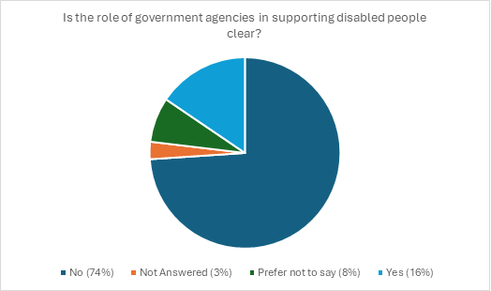

There were 1,343 responses to the question ‘Is the role of government agencies in supporting disabled people clear?’ 1,032 respondents then provided examples where they felt the role was not clear.

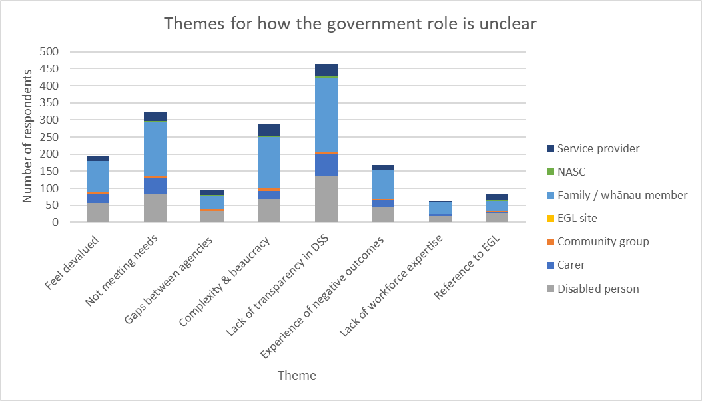

Respondents highlighted the lack of clarity around the role of government agencies in supporting disabled people.

28% of respondents felt there is unnecessary complexity and bureaucracy in the government DSS system, creating barriers to receiving support.

Some highlighted that navigating the system to identify which government agency leads each service is complex and confusing. There is a lack of communication between agencies. Disabled people and their families/whānau often go to multiple agencies to receive proper support due to the siloed nature of government.

9% of respondents discussed the gaps between agencies where DSS will not provide support as it is expected from another agency, but the other agency does not provide what is needed either.

Each government agency is siloed and doesn't communicate passed the walls they have created.  Splitting access to supports by label and not through human interaction – Community group, Wellington

Over the years I could give so many examples of my daughter and her needs falling through the cracks and being shuffled between health / education / MSD and other government agencies. It is soul destroying, and we are a highly functioning family with the ability to navigate systems – family member, Canterbury (including Chatham Islands)

45% of respondents felt that there was poor transparency within DSS resulting from a combination of issues. Information overload and the lack of consistent information made it difficult for disabled people and their family/whānau to find and access the supports they need.

This was compounded by regional variation in the availability, resourcing, and delivery of DSS. Poor communication and lack of consultation with the community on the recent government changes made to DSS and Whaikaha was also outlined.

The changes earlier in the 2024 year left disabled people and their families/whānau confused in a system that was already difficult to navigate and understand. A further 6% of respondents discussed the negative impact that untrained frontline and support staff can have on the lives of disabled people.

I have a PhD and yet I find it challenging to understand what is required – disabled person, Southern

Changes are made suddenly and not via appropriate channels. The changes aren’t articulated in a way that is easily understood by disabled people and their families. Changing governments shouldn’t mean changing everything about how the support is given and expecting that everyone will understand these changes without appropriate explanation or consultation – Family member, Central

32% of respondents believe DSS does not meet the needs of disabled people. Workforce shortages and financial constraints lead to long waitlists for support when it is needed more immediately. Inadequate and inflexible support plans decide what is ‘necessary’ support, while disregarding the disabled person and their family/whānau who know their situation best. This was seen as leading to needs not being met.

The cutting of travel and carer support to travel for work /voluntary work is a good example of cancelling a service that leaves the disabled person with no support rather like cutting their legs off therefore leaving them a very limited, narrow life. What difference does this make whether the funding is used for travelling support or other services such as meals etc? it is to help the disabled lead a normal life – Family member, Northland

19% of respondents felt disabled people are being devalued throughout society leading to inequitable outcomes. They felt undermined in their autonomy and dignity, particularly with the lack of consultation around changes to the system and restrictive funding models. A further 8% specifically reference or discuss wanting to see EGL put back into practice alongside the UNCRPD. 

There is rarely consultation with the community and good programmes have constantly been delayed or discontinued. Enabling Good Lives is a good example. It was rolled out to a few and there has been regular promises of extensions that have not happened and now it seems to be being restricted – family member, Canterbury (including Chatham Islands)

16% of respondents felt the current system had caused or contributed to their experiences of negative outcomes impacting their lives and wellbeing such as burnout, frustration, and inequity.

When you have a disabled baby there is so many different agencies to contact and be apart of that it’s overwhelming. In my experience I was grieving for my child and the life I wasn’t going to have. The constant pressure to get all of this “help” organised was too much for my own mental health and wellbeing... My life is hard and only getting harder. I’m scared to contact you to ask for help. You might say no, you might withdraw what funding we have, you might dismiss how hard it is to be a parent my children – Family member, Wellington .

## Opportunities to improve navigation

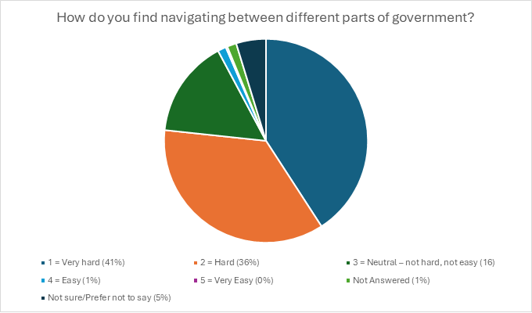

1,408 people responded to the question ‘How do you find navigating between different parts of government?’.

A further 1,247 people responded to the follow up question ‘What supports would help make this easier?’

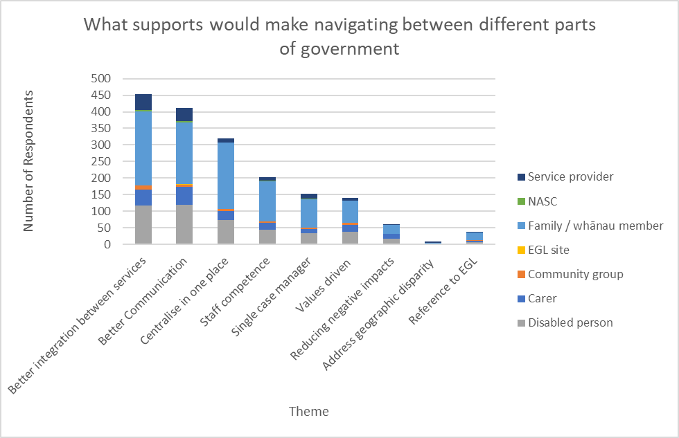

5% of respondents provided feedback on their negative experiences engaging with the system, including exhaustion, the need to advocate for themselves, and a lack of trust. 11% felt the system would be easier to navigate if greater value was placed on the lived experience of disabled people and their families/whānau.

Some felt this would lead to a system that embodies empathy, respect, and empowerment in a culturally sensitive way. This approach would also recognise the permanence of disability for many and the diversity of experience. It would encourage greater investment into disabled people and their families/ whānau through the systems that support them.

A further 3% of respondents explicitly discussed the value of EGL in supporting disabled people and their families to better navigate different parts of the government.

Let the client and their whanau be heard, let the egl principal be at the forefront of decisions – family member, Waikato

People who are kind, patient, and committed to helping. Systems and criteria that are not degrading, or hostile to users or implemented in degrading or hostile ways – disabled person, Canterbury (including Chatham Islands)

36% of respondents highlighted the need for better integration to improve navigation. Streamlining processes and greater agency coordination would improve the fragmentation experienced by many. Some respondents spoke of their experience with EGL pilot sites as exemplars in improved integration and shared data.

Personally I've had multiple funding streams over the years. The best has been EGL, they have coordinated a package so less need to use multiple departments. They also know families at a deeper level to gain a clearer picture of needs and support that suit the disabled person and supporting family carers, having a coordination person works. Other departments are not Individualised to needs, more a tick box system, and always different people when contact is required, so they have no idea our situation – Family member, Waikato

25% of respondents were in favour of centralisation to some degree. This varied from returning DSS to Whaikaha or the Ministry of Health (MoH), or centralising all disability supports into 1 agency.

Some respondents suggested a single point of information, such as a website or hotline, with a further 12% suggesting a dedicated case manager for each disabled person and their family/whānau who would be equipped to provide information to navigate the disability system and access services.

A centralized hub offering a one-stop shop for services would reduce confusion. Case managers or key workers could guide individuals through the system, while a unified application process would streamline access – Carer, Canterbury (including Chatham Islands)

Many respondents (32%) felt communication was key to improving navigation. People outlined that communication should be accessible, readily available in alternate formats, with interpreters available as needed.

Communication should also be adaptable and available in diverse formats that suit the preferences of disabled people and their families/whānau.

Get each Govt department to stop "passing the buck".  Services also do not overlap and many needs fall through the cracks. Also, tell people what they are entitled to in the way of help, don't continue to be gatekeepers of the Govt coffers. I have advocated in the disability world for over 30 years...simply because people generally find out what they are entitled to "by accident"....and always through other parents, not from the departments that are supposed to be there to help them. Facebook pages/advocates would not be necessary if you were doing your job of informing disabled people/families of their entitlements and how to use them – Carer, Northland

Some respondents highlighted the importance of the workforce in supporting disabled people and their families to navigate the system. They commented that staff should be trained to navigate the system and to inform disabled people and their families about their entitlements.

Their workloads should allow them to spend time supporting disabled people in a variety of adaptable ways (such as meeting in person, possibly in the home, calling, or emailing depending on the preferences of the individual).

Staff training in how to work with the disabled community in person and over the phone, how not to compare their own issues because its not the same. Personal experience of applying for SLP benefit was not great despite showing all documentation. - Disabled person, Canterbury (including Chatham Islands)

A team that understands disability and treats clients with dignity and respect. A system that respects the rights of disabled people and provides what they require. A team that is fully resourced and can provide what they are contracted to provide. People with lived experience working with disabled people. - Community group, Wellington

## Improving DSS in the short term

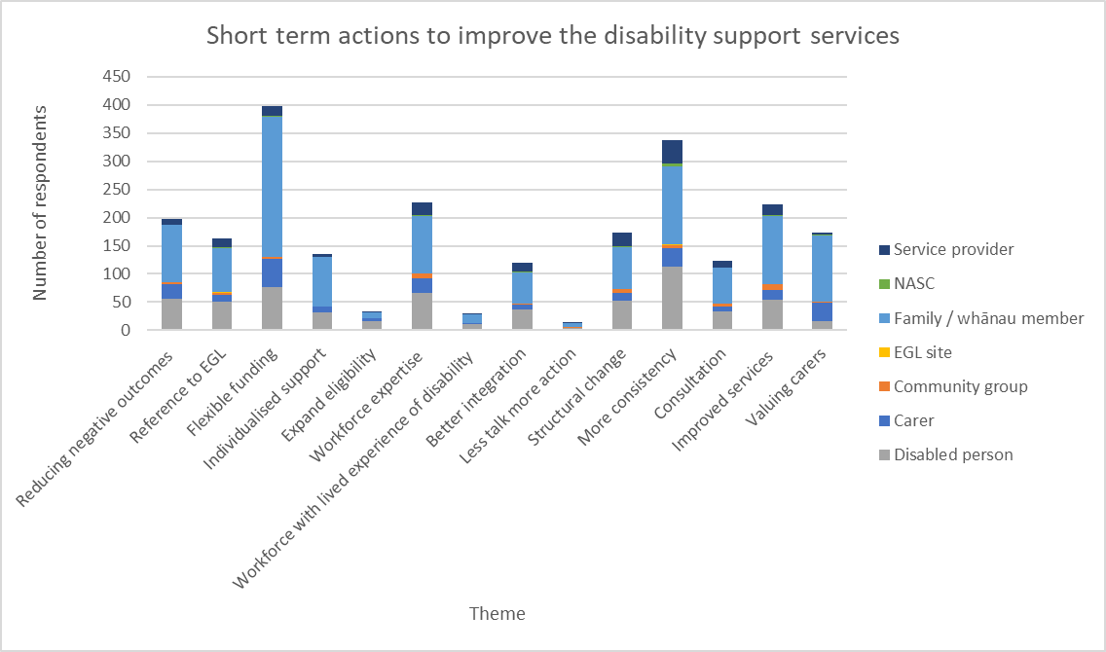

There were 1,356 responses to the question ‘What short-term actions, over the next 1-2 years, do you think would improve disability support services?’

Of these respondents, 21% outlined some of the negative outcomes associated with the current system, such as disabled people experiencing discrimination, feeling blamed or devalued, being forced into unsafe situations, and experiencing poor mental health.

Re-instate FLEXIBLE funding. In other words, using allocated funds in the best way that suits the disabled person and their whanau. To look after the carers who have been trashed on in recent months. Burn-out is not just a myth, and its getting worse.  - Family/ Whānau, Auckland

Whaikaha needs to prioritize their funding allocation with respect to getting disabled people out of hospital when they no longer need acute care. Some people are remaining in hospitals for hundreds of days. Invoicing Whaikaha for these inpatient stays might get action as the waste of tax payer dollars is inexcusable. - Service provider, Central

28% of respondents called for bipartisan support to provide additional funding and stronger planning for the system, more efficiency in the use of current funds, and a long-term commitment to the disability community.

Greater funding was seen as a method of valuing and respecting disabled people and families, enabling them greater certainty to be able to plan long term and reduce their stress. Many outlined that they have experienced shock and sometimes trauma with the sudden rollout of the March 2024 changes and have lost trust in DSS.

Making sure that the service is reaching the people who need it, and keep it simple. Efficiency matters. - Disabled person, Auckland

Increase funding to disability providers to provide consistent care investing in capable staff to increase the quality of service delivery. - Service provider, East Coast

9% of respondents felt that DSS could be improved through greater integration with other agencies and greater flexibility. Respondents felt disabled people should have fair outcomes and equity of funding, regardless of whether their support was covered by the Accident Compensation Corporation (ACC), MoH, or DSS.

3% of respondents felt eligibility for DSS needed to be reviewed so that people with fetal alcohol spectrum disorder (FASD), chronic fatigue syndrome (CFS), attention deficit hyperactivity disorder (ADHD), and other chronic and neurological illnesses and disabilities should be covered.

To improve disability support services in the short term, we should focus on making existing pathways more accessible, streamlined, and genuinely available. The pathways outlined in policy should be practical, easy to navigate, and responsive to the real needs of individuals seeking support. - Family/Whānau Auckland

More compassion for people with illness and disability approaching agencies, being aware a person may not understand what they are entitled too or understand what you even are giving them in the way of paperwork. Make a start fixing the inequity between acc and people with serious illness who are treated so differently in supports and entitlements no one wants to get sick or causes it just like an accident so why they are treated differently also people with serious conditions like motor neuron and Parkinson’s and multiple sclerosis should not have to reapply every two years for the supported living payment when it’s obvious and paper work is supplied from medical staff that they are only going to deteriorate it adds massive stress to them when they are so sick. - Carer, Auckland

13% of respondents felt that structural reform was required. A few suggested shifting the administration of DSS back to Whaikaha. A couple of people thought DSS should sit with the MoH or the ACC.

Respondents felt agencies and providers should be accountable for delivering value for money and needed to reduce the bureaucracy in the system. Respondents’ suggestions included increasing workforce capacity, providing an app/online platform, or a centralised hub/one stop shop.

Resinstate flexibility in purchasing. Increase child disability allowance. Move DSS back to whaikaha and properly fund Whaikaha. Make whaikaha the one stop support centre. - Family/Whānau, Wellington

Make sure ALL staff are trained to sing off the same song sheet. Employ people who live disability and understand families. Reduce fluffy ways of collecting date and reduce the number of appointments. Families are busy and don't want 4 appointments with a connector each year to roll over a funding allocation. When the home situation is NOT going to change then set the allocation roll over to 3 - 5 years like it used to be. Thus reducing expensive Funding staff time. Help families with the correct information when they need it. This will reduce unnecessary mistakes leading to overspending. So, the message is to set up streamline, accurate informed systems to reduce wasted staff hours. - Carer, Central

12% of respondents mentioned EGL and UNCRPD as important guides in improving the system.

These respondents called for the continued rollout of system transformation and taking an outcomes-led approach to supporting disabled people and their families/whānau.

10% of respondents felt that DSS processes and services should have greater adaptability to be tailored to disabled people and their families/whānau and understand the diversity of disability.

Return control to us and put other checks and balances in place. Don't punish all of us when some either misunderstand or abuse the system. There will always be those. after all, you don't penalise all motorists just because some drink and drive. We absolutely must have control over our own lives. - Disabled person, Central

But for the most part, creating as much flexibility as possible and putting the funding directly into the hands of disabled people and caregivers of disabled people, would give decision making and responsibility to the service users, allowing them to overcome as many barriers as possible whilst also saving the DSS an enormous amount of money. - Disabled person, Auckland

13% of respondents felt that family carers should receive better support through dedicated funding (separated from support for the disabled person), more respite providers, and flexibility around respite supports.

Flexibility with respite should extend into how respite can take place, where respite should happen, and making additional forms of respite available. For example, increasing in-home respite options through purchases to help the disabled person in ways that enable the carer to take a break.

The previous purchasing guidelines were seen as providing respite in ways that supported carers to continue their work sustainably.

A further 29% of respondents highlighted the value and empowerment of previous flexible funding rules. These rules were seen as demonstrating trust in disabled people and their families to know what was best for them and were adaptable enough to provide this. Respondents shared their frustration with the tightness of the new rules and highlighted that reintroducing the previous flexibility would improve DSS.

Respondents provided examples of supports they could no longer access through flexible funding, such as a wheelchair they could use outside their home and sensory items that had similar cost value to those on the approved list but better fitted their child’s needs.

Change your way of looking at a disabled person as an individual- they are woven within whānau who care for them but also need a break. Let's main carers get a night away in a hotel occasionally so they can sleep all night twice a year. Realise that we live complicated lives and a one size fits all approach does not work- coming from a mum of two kids with disabilities who are VERY different in need and what works. - Family/Whānau, Canterbury (including Chatham Islands)

Re-instate funding so that people with disabilities can live a full and happy life. Stop expecting families to be all and everthing. - Family/Whānau, Auckland

17% of respondents felt that, in addition to improving flexible funding, other services also need to be improved. There needs to be more availability and access to services contracted by DSS.

Poor access to quality residential spaces and lack of support in schools were of particular concern. Processes needed to be timelier from initial contact, to assessment, to outcome and delivery. Respondents also reference poor services provided by other agencies, such as long wait times for diagnosis, therapies, and specialists, which created negative and life altering outcomes.

More funding for Residential Care (housing and carers) - Family/Whānau, Auckland

Support needs to be more accessible, first and foremost. The amount of people struggling to get diagnosed is not okay, especially as adults when funding is not really there for neurodivergent diagnosis. This is urgent. - Disabled person, Waikato

17% of respondents felt the DSS workforce needed to have greater knowledge of disability and how to navigate DSS systems, with a further 2% wanting to see more disabled people working across all parts of DSS, including in leadership roles.

Some people wanted connector/navigator roles extended across the country, where case managers were assigned to be the single point of contact for disabled people and their families/whānau. Staff should support disabled people, instead of experiences where respondents felt staff were passing the buck or questioning the validity of the disability.

Improve accessibility for Deaf Community. Centralise and streamline services. Train staff continuously on Deaf Culture and basic sign language. increase awareness of Disability especially Deaf community- not enough awareness there. Always book at NZSL interpreter for a Deaf Person. - Disabled person, Auckland

25% of respondents wanted greater consistency across DSS through improved availability of information and greater transparency in entitlements and service provision. Open and accessible communication was suggested to create greater transparency.

Respondents felt equality was an important outcome which could be achieved through ensuring the application of the same clear system rules in all parts of the country. Some respondents felt the loudest people, or those who know how to navigate the system received support more than people who did not complain or know what they were entitled to.

More fairness in the support packages that are provided. Recently the loudest parents have received the biggest packages & the families that don’t want to complain about their disabled child, became invisible with very small packages. - Carer, Auckland

Clear transparency - what you can and cannot access. Clear communication - what funding can be used for. Inter-agency communication and sharing of information. Holistic approach. - Family/Whānau, Auckland

9% of respondents highlighted the need for genuine consultation with disabled people, family/whānau, and service providers. Longer timeframes are required for engagement, to enable wider reach.

Longer timeframes also provide more time for people to respond, with people with intellectual disabilities in particular benefiting from this. However, 1% of respondents expressed fatigue and frustration at the frequency of consultation in comparison to the lack of substantial system change.

put it back the way it was during covid, or even just before covid, give back the individual choice as each person's disability is different, bring back the enabling good lives to the community as it was working for us, see the not everyone who has a disability fits into one square or oblong box. they all have some similarities but live and daily struggles are different and living circumstances are all different. so go back to case by case and support us with dignity and compassion, and treat us as you'd like to be treated.- Family/Whānau/East Coast

More funding obviously, as the service and system is and has always been extremely under-funded. Why not continue to support the services that people need rather than watching them fall away with the lack of funding being made available. Don't bother talking anymore just do something positive for disabled people as a whole, not continue down these pathways to impoverished and lonely hell for many. - Disabled person, Auckland

## Short-term actions to help better manage the cost of disability support services to the Government

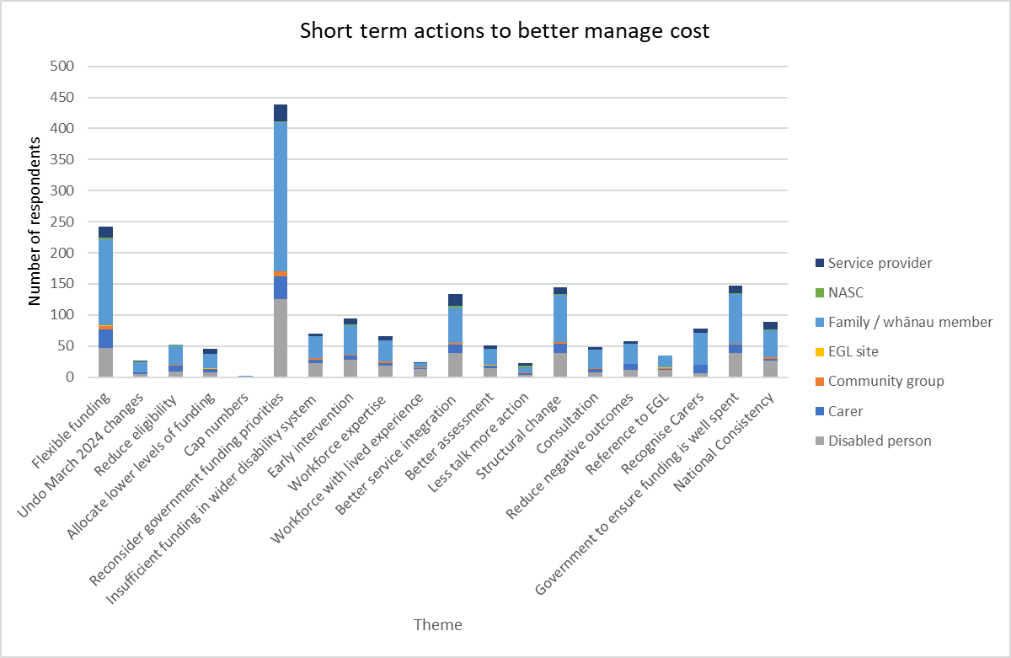

1,177 people responded to the question ‘What short-term actions, over the next 1-2 years, do you think would help better manage the cost of disability support services to the Government?’

Of these respondents, 21% recommended more flexible funding as an approach to help better manage the cost of DSS to the Government. It was emphasised that empowering disabled people and family can lead to more efficient, person driven use of funding.

Suggestions for this included increasing flexibility of funding, fewer rules, and reducing hosts’ power. 2% of respondents recommended undoing the March 2024 changes and bringing back respite for carers.

Increase flexible funding again. Let each disabled person decide how to use their funding. Better off having smaller allocated budgets than making it so restricted that the individual can't access the budget they have. I would much rather have less funding per annum and actually be able to access what I used to use my funding for. – Disabled person, Wellington

5% of respondents recommended ensuring high needs people are prioritised by reducing eligibility and creating stricter criteria for access to funding. A further 4% recommended lowering the levels of funding via approaches such as capping the funding in packages at a maximum amount or means testing/reducing funding based on income.

I could guarantee a decent portion of those receiving funding would happily take a cut just to be able to use their funding in a way that suits the needs of the disabled person and money is saved as people opt out of higher funding rates to access it. – Family /Whānau, Canterbury (including Chatham Islands)

In contrast, 37% of respondents recommended the Government re-evaluate its funding priorities. Respondents outlined how inadequate funding leads to inequities across the system and impacts negatively on the dignity of disabled people.

A further 6% believe current funding is insufficient for the wider disability system, e.g. mental health, and education services. A further 8% emphasised the importance of early intervention and early investment, including providing more funding to improve outcomes long-term.

The mark of a society is reflected in how we care and support our most vulnerable. The disabled community have historically always been at the margins and financially never truly supported. The government need to seriously reallocate funding to meet this need. If those affected by disability who receive ACC funding can access increased compensation, then we fundamentally have a huge discrepancy between those who are born disabled or become disabled through aging, etc. Many family carers (ourselves included) provide hours of unpaid and invisible support. I feel that this question in itself is very disrespectful. – Family / whānau, Auckland

6% of respondents recommended improving workforce knowledge and experience of staff within the DSS system and promoting the navigator role. A 2% recommended utilising a disabled workforce with lived experience of disability.

4% of respondents suggested better consultation characterised by genuine listening and transparency.

2% were disappointed with the lack of action following consultation. A further 3% specifically referenced EGL and/or UNCRPD.

Listening to disabled community groups and hiring disabled policy makers to ensure that the government is getting us what we need, not what able-bodied people think we need. – Disabled person, Wellington

11% of respondents recommended better integration across government of DSS and non-DSS services. A further 4% expressed the importance of assessments being connected to needs for both what is being assessed and frequency.

Better funding formulas - you can't manage a budget when the allocation of that budget is largely done on guess work and funding formulas that are decades old. – Service provider, Nelson/Marlborough/West Coast

Cut back on Needs assessments ONCE THE INITIAL ASSESSMENT IS COMPLETE. – Family / Whānau, Wellington

12% of respondents recommended structural reform by returning DSS to MoH or Whaikaha. Some felt that agencies delivering funding need to be value for money, reduce highly paid management, have less bureaucracy, and better use of technology to drive efficiency.

Return management to whaikaha and fund their budget appropriately. – Disabled person, Wellington

5% of respondents discussed negative outcomes where current DSS settings have led to disabled people in unsafe situations, discrimination, and burnt-out carers. A further 7% highlighted the need to value carers by providing better support, recognition, and respite.

Supporting families who are caring must be so much cheaper than putting people with disabilities into full time care. Remember this. When a family is coping and thriving the person with the disability has a natural support network with countless unpaid hours of relationships, support and activities. Funding can tip the balance between coping and not - coping. It's not designed to reimburse every hour! – Family / Whānau, Nelson/Marlborough/West Coast

Disabled people take a great deal of care, and all of that money goes back into the economy, paying people as carers, respite or activity providers. To save money - allow us to get the GST back on carer agency fees. – Family/Whānau, Auckland

## Improving DSS in the longer term

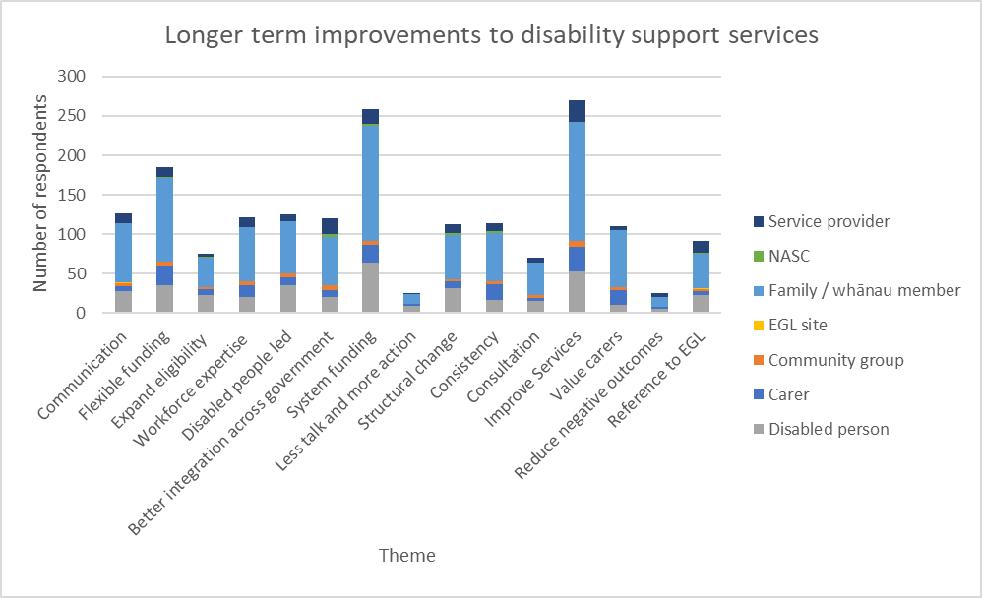

There were 1,222 responses to the question ‘Longer term, what changes do you think would help improve disability support services?’

11% of respondents explicitly mentioned EGL and the UNCRPD as the direction to move DSS in. Respondents also spoke about the Royal Inquiry into Abuse in State Care as a vital source of learning to prevent any risk of future abuse. Respondents emphasised the need to take a values-based approach underpinned by empathy, alongside evidence and embedding the social model of disability.

8% of respondents shared feedback on the need for genuine consultation with disabled people, family/whānau, and service providers. Disabled people needed to lead change and be consulted on definitions to ensure they are not ableist.

A further 2% of respondents mentioned their frustration at the poor consultation paired with inaction to resolve longstanding issues. 3% of respondents shared their experiences of discrimination, burnout, and living in unsafe situations due to DSS.

A full commitment to Enabling Good Lives. Better resources for auditing and monitoring – Family/Whānau, Canterbury (including Chatham Islands)

The recent apology from the Royal Commission means nothing if these people are not cared for in an appropriate manner. - Family/Whānau, Central

Nothing About Us Without Us! Inclusion and co-design in all areas concerning disability. - Disabled person, Waikato

Having consistently and really listening to the needs of the community and acting on it not just asking for feedback as a formality – Family/Whānau, Wellington

30% of respondents provided feedback on the need for further investment and improved efficiency within DSS and the wider disability system. Respondents highlighted growing populations and the critical need for system planning to prevent sudden disruptions to critical services. Respondents shared feedback on current government priorities, suggesting that DSS needed sustainable funding which enabled earlier intervention and equity with MoH and ACC, driven by better data collection and aligned budgets.

Building on improved equity between those supported by different agencies, 14% of respondents highlighted the need for DSS and non-DSS services to work together, where government understood the diversity of lived experience and was able to adapt services accordingly.

Suggestions included 1 assessment for multiple agencies’ services and delegating the authority to DSS to allocate other funds and services.

A further 13% of respondents mentioned the need for structural reform, suggesting DSS be returned to Whaikaha or, for a small number of respondents, ACC or MoH. Respondents suggested better legislation for DSS and learning from international examples such as the National Disability Insurance Scheme (NDIS) or Scandinavian countries.

Better access to the correct support. Assessments should be completed with the multidisciplinary team and across government departments to identify needs. Do not departmentalize. - Service provider, Nelson/Marlborough/West Coast

9% of respondents mentioned changing assessment and eligibility settings. Some wished to see an expansion of eligibility to cover disabilities, which are not covered and reflect the diversity of disability. Others requested changes to reassessment frequency or reducing allocations for some lower needs’ groups.

13% of respondents wanted to see greater value placed on carers both in considering carers and families in assessments and providing better supports (including respite) to enable carers to sustainably provide care to disabled people. 11% of respondents highlighted the need for greater consistency geographically, with funding, and with policy changes.

Expand support services to cover people with ALL disabling conditions. - Disabled person, Canterbury (including Chatham Islands)

If natural supports are relied upon, adequate respite is essential to prevent burnout and potential neglect. Reliable access to respite services ensures natural supports remain sustainable and available. Additionally, caregiver pay needs urgent reform – Family/Whānau, Auckland

16% of respondents mentioned the need for greater communication and transparency to improve understanding of DSS policies and processes. Guidelines and processes needed to be made clearer and easier to understand. Communication needed to be accessible and adaptable with respondents requesting closer interaction between staff and disabled people and their families/whānau.

Workforce knowledge and experience was seen as a key factor to improve communication and was mentioned by 13% of respondents. Respondents suggested staff needed a better understanding of DSS, disability knowledge, and the rights and needs of tāngata whaikaha and Māori. It was suggested a workforce development plan was needed to enact this.

13% of respondents recommended that DSS should be run by disabled people and those with lived experience of disability, emphasising nothing about us without us.

Clear communication!! Stop cutting funding but do a better job of management...take off Freezing residential care for younger disabled people – Disabled person, Taranaki

Closer interaction with family – Family/Whānau, Auckland

Get new people who know what they are doing. - Community Group, Wellington

28% of respondents shared feedback on the need to improve services contracted by DSS and honour the rights of disabled people and families. Suggestions included improving access to and quality of residential supports; culturally appropriate services; better utilisation of technology; and greater individualisation of services for disabled people and family/whānau.

Respondents mentioned poor wages and working conditions which contributed to workforce shortages and prevented access to services.

21% of respondents shared feedback on flexible funding, which was perceived to be empowering, efficient, and person driven prior to the March 2024 changes, with many suggesting a reversal of the purchasing guidelines. Some respondents emphasised the preference for choice and control over how they spent their allocation, even if it meant receiving less.

A change in mindset from seeing disabled people as a "cost" for the "government." Part of this is recognising the costs the government saves by families taking on caregiving burdens. Recognition of the extremely individualised nature of the support that families need. - Family/Whānau, Auckland

My health has improved, my connection to community has improved, I had freedom to recieve supports which benefited me the best ever, since purchases changes I feel very sad and more worried for my future, you scare me, I feel afraid about the future becuase of what is happening. The language being used, threats of cuts. Its terrifying to be vulnerable right now, leave our systems and flexibility in place – Disabled person, Northland

## Making DSS fairer

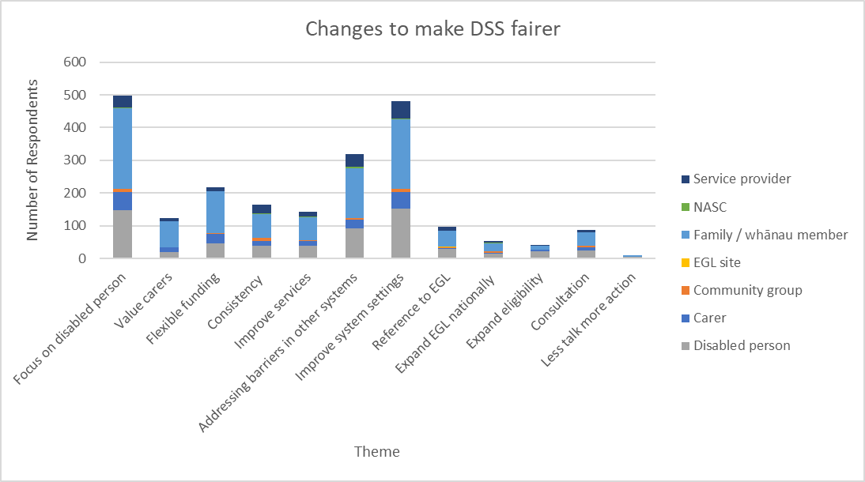

There were 1,237 responses to the question ‘What changes do you think would make disability support services fairer?’

Respondents emphasized the importance of focusing on the disabled person and their specific needs to make DSS fairer.

41% of respondents mentioned the focus of funding and support should be based on need, not diagnosis, catering to the diversity of disability. Increasing autonomy in decision making or supported decision making/representation was seen as instrumental in this.

Respondents emphasized that blanket rules do not work in this community where circumstances are highly individual and different for each family. Consistency with assessment practice is also very important as those with the greatest need may not be able to advocate for themselves as much as others.

A further 3% mentioned that eligibility for DSS should be expanded as disability is not black and white (e.g. including FASD, ADHD, etc.)

Egl in every Region and listening to what people need not just the diagnosis as everyone is so different with there needs. – Family/Whānau member, Canterbury (including Chatham Islands),

This may seem like it's not fair, but you can't make blanket decisions on something that really is highly individual. Fairness needs to come from empowerment of the person and their families, and accountability. – Carer, Bay of Plenty

7% of respondents recommended that consultation with disabled people, family/whānau, and service providers would be key in making DSS fairer.

A further 18% emphasised the need for flexible funding for both disabled people and their family/caregiver because they know what products and services will work best for them.

Consult with the disabled community and their carers more. Don’t think one rule fits all it does not. Slashing and burning funding rules to cut costs does not make anyone feel valued, rather more like criminals and not trusted. – Carer, Bay of Plenty

If the funding is flexible and can be used to purchase community based, uncontracted support options then the support can be tailored to the opportunities available in the community. – Service provider, Nelson/Marlborough/West Coast

13% of respondents emphasised the need for improved consistency across regions for services, NASCs, impairment types, and the overall ‘postcode lottery’ that currently exists. A further 12% specified the improvement of services in both availability and access nationally to services contracted by DSS.

All NASC staff to have appropriate training. Take away the postcode lottery which has become worse since some NASCs are adding in their own rules to manage within their budgets – Family / whānau member, Auckland

10% of respondents felt the validity and recognition of caregivers needs improvement, including providing more support for primary caregivers.

I feel whatever I say would be disregarded. All Full time care givers should be able to get the slp it's absolutely exhausting and degrading being broke and having no quality of life while giving your all to make sure your youth don't kill themselves. – Family / whānau member, Auckland

Respite for exhausted carers and an actually responsible wage for paying  someone to help.  Acknowledging that most parents of disabled kids can not work full time due to the extra care or kids need and perhaps some kind of tax break?  – Family / whānau member, Bay of Plenty

3% of respondents emphasized that interaction with the system should be simpler and more transparent, having clear guidelines that are easily referred to by disabled people, family/whānau, and providers alike.

Barriers to accessing DSS should also be addressed. Utilising connectors and advocates, particularly for Māori, Pasifika, immigrants, and those living rurally.

A further 8% referenced EGL and UNCRPD, focusing on easy-to-use services, person centered approaches, and relationship building.

I hated fighting for the budget we have now. I hated having to explain over and over that the disability is not going to go away and that it will get worse leading to death. Given that we deal with a very rare disease that there be understanding of the parents expertise and that be taken into account when being assessed. Having said that we have an amazing NASC person – Family / whānau member, Bay of Plenty

39% of respondents suggested making changes to the disability system itself. The system should have greater accountability, greater representation, and involvement of the disability community in policy making.

Others outlined the importance of more funding to the system, including a better funded and well-trained workforce.

Others suggested a focus on improving equitable outcomes and accessibility from various agencies, particularly with closing the gap between those receiving ACC support/funding and those receiving DSS.

A further 4% felt that EGL should be continued and rolled out nationally.

Remove the horrible barriers and chasm of difference of services between ACC and DSS, establish a level of need and support it appropriately -there should not be a system of "haves" and "have-nots" which is what currently exists.  EGL provides for the above if resourced appropriately -NDIS is how things should be done, equitably. Yes, there are costs, yes there is challenges, however we are people, not numbers. – Disabled person, Southern

Stopping the national roll-out of EGL is not about making disability support services fairer, it continues the inequity. The EGL needs to be rolled out nationally to make disability support services fairer. – Disabled person, Southern

# Section 2: assessment settings

Questions in this section focused on assessment and allocation settings, and the match between these and services.

## Matching services to need

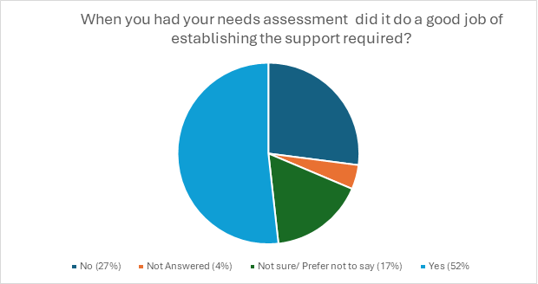

There were 1,183 responses to the question ‘When you had your needs assessment done (or for the person you support), did the assessment do a good job of establishing the support required?’

There were 752 responses to the follow up question ‘How well did the services coordinated to you (or the person you support), match the needs identified?’.

89% of respondents shared some degree of satisfaction with their service coordination.

Responses could be coded both positive and negative where they expressed satisfaction yet went on to describe a mismatch in their service coordination.

The reasons for this varied considerably and are detailed below.

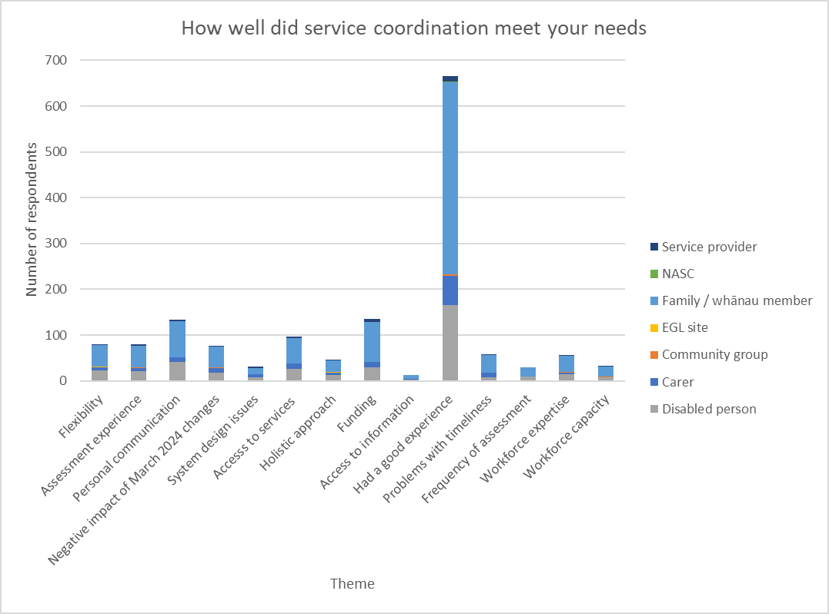

10% of respondents shared how the coordination of their services had been a good match, but this was no longer the case. For some this was because their circumstances had changed, for others it was because the supports had changed. This included the impact of the March 2024 changes to purchasing guidelines, but also because of the increasing cost or reduced availability of services.

Really well, prior to the March 18 changes. Now we are struggling with the lack of sensory purchases - which has ironically meant a significant change to behaviour from our disabled person. This led at our recent review to being assessed as needing a significant raise in our funding allocation, so we can employ caregivers for longer, to help with the significant behavioral changes. - Family/Carer, Canterbury (including Chatham Islands)

4% of respondents provided feedback on system level issues, such as regional inconsistencies, unfairness between different government agencies’ services and the impact of policy decisions.

Similarly at a high level, 6% of respondents highlighted the need for holistic approaches across processes, policies, and services which considered a disabled person and their family/whānau in their entirety, not siloed into parts. This reflected EGL principles.

Very poorly because the NASC couldn't arrange for all supports I needed. It was due to restrictions in their government contract. Due to this I had to go into care rather than continuing to live on my own. The NASC Assessor, their manager and other people involved with my care all pushed for it but it couldn't be  done. Even Whaikaha later said I 'fell through the cracks. - Disabled person, Waikato

Communication was raised by 18% of respondents as a critical component in matching needs to services.

Respondents stressed that they needed to be heard and have their input affect their outcomes. Information needed to be accessible, available via multiple mediums with a preference for in-person, relational communication, and follow-ups. Related to this was the ability for respondents to access information, a topic raised by 2% of respondents. Respondents highlighted the importance of transparency in rules and being able to make informed decisions upon receiving and understanding clear information.

NASC identified the needs of the disabled person/s and family to a reasonably level, this could have been improved by also providing information on and access to further servicers such as education, group support, peer support and counselling options for both the disabled person/s and family members. - Carer, Auckland

4% of respondents provided feedback on workforce shortages across regions, unavailability of skilled or specialist staff (and staff with NZ Sign Language (NZSL) proficiency).

A couple of respondents raised the additional burden on migrant workers, who experienced issues with Immigration NZ and poor pay, reducing their capacity and increasing staff turnover due to unsustainable employment conditions.

7% of respondents provided feedback on workforce capability: raising issues with language and cultural barriers; insufficient disability knowledge; or ableist attitudes and lack of understanding.

It would be good for assessors to be trained about and experienced with the experiences of the specific disability (autism in my partner’s case). This would enable them to pro-actively make appropriate suggestions and queries, especially in cases where a disabled person is newly assessed and may be unfamiliar with both their own needs and the types of support available. – Family member, Canterbury (including Chatham Islands)

People outlined how providing a service coordination that matched identified needs relied on an accurate understanding of the disabled person and their family’s/ whānau circumstances. 11% of respondents provided insights into how the assessment experience shaped their outcomes.

Respondents shared instances of inconsistencies between regions and between family members with the same disability; cultural appropriateness of assessments; and feeling overwhelmed and unsupported to understand the process.

4% of respondents shared their experience of reassessment and review frequency, including whether more or less assessments are required depending on their disability.

8% of respondents highlighted the challenges they experienced with assessment timelines, particularly where there were delayed follow ups and waitlists both to have an assessment and to access services following an assessment.

I think they did a good job but the problem was I just didn't understand so much of what I was told. There was so much to know. Some of the words and terms they used I did not understand. I now do understand and consider the services did match the needs. - Family/whānau, Canterbury (including Chatham Islands)

13% of respondents shared insights of issues they had with accessing services. Some respondents had not been allocated services which they needed, for some this was because the services were not funded through DSS (such as mental health support).

Some respondents had been allocated services but not been able to access these due to regional unavailability or long waitlists.

Others had been able to access services, but they did not meet their needs, either because of misalignment between staff and the disabled person and family/whānau, or because of the inflexibility of supports not meeting the identified needs.

Also, realistically, you can't employ someone else to do personal cares, at different times of the day, when you live rurally. You can't ask your disabled family member to use the toilet only at certain times of the day!! - Carer, Northland

11% of respondents felt that flexibility in service co-ordination was key to appropriately matching services to identified needs. This flexibility was visible where supports could be tailored and disabled people and their families could exercise choice and control.

However, poor flexibility in the allocation of services hindered the ability for services to meet identified needs.

Since the March 2024 changes to flexible funding, 18% of respondents found they have been unable to meet their assessed needs in the ways they had done previously.

EGL has been the most empowering funding I’ve ever had. I get to decide what support best suits my needs instead of having that decided by an organisation that decides what’s best for everyone, often by people who have no lived disability experience. EGL is easy to use and simple to account for and super empowering. - Disabled person

We have greater needs than that which we could be supported to achieve.  Even within the previous purchasing guidelines there were aspects of the support required that we would not be able to achieve - we need to be allowed to use the funding allocated in a truly individualised way and more funding not less.  There is also no proactivity within support services - we can't access services to enable us to sustainably care for our son so that we can continue to do so and make our situation the best it could be long term - it only looks at the short term. - Family/Whānau, Wellington

## Opportunities to improve coordination of services

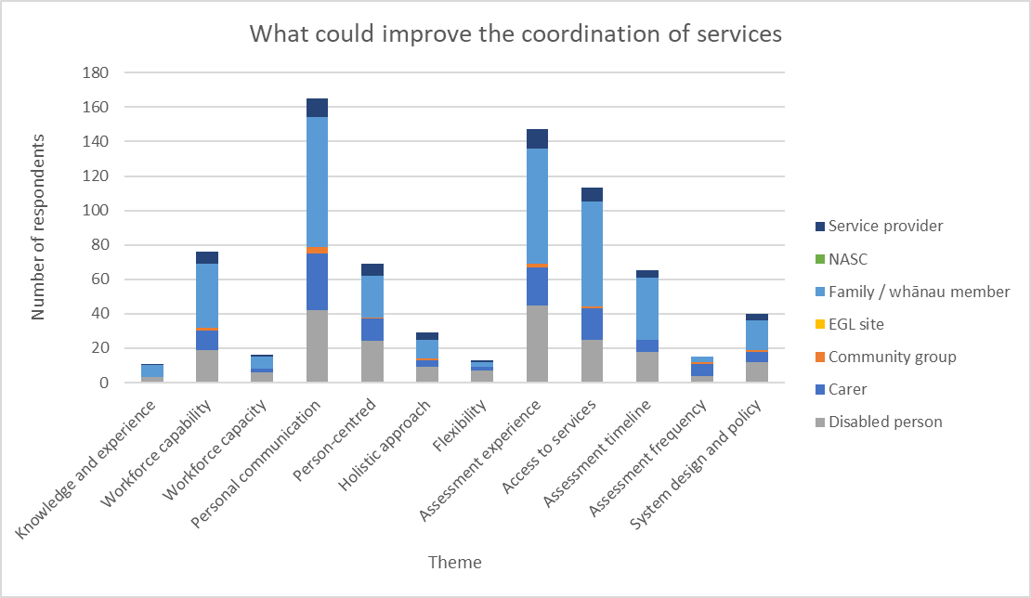

There were 403 responses to the question ‘What could improve the coordination of services to match your identifid needs?’ 3% of respondents highlighted the importance of disability knowledge and lived experience required to improve service coordination.

This knowledge was viewed as critical in shaping the policies and processes which facilitate service coordination, which 10% of respondents highlighted required improvement.

Respondents highlighted the need to improve end-to-end processes, improving coordination and addressing the current siloed approach.

Having it all on 1 place. So the knowledge base is there and people aren't having to run around services and wait literally years on lists to be told this service can't help you but they'll refer to xyz. - Family/Whānau, Canterbury (including Chatham Islands)

I cannot help but feel that the whole system is focussed on minimizing cost rather than maximizing wellbeing of disabled person. Supports are often offered when a situation has reached a crisis point rather than preventing it from becoming a crisis. The latter is often far more cost effective in the long run and less painful. - Family/Whānau, Auckland

28% of respondents mentioned a mismatch between a service coordination and the availability of support, preventing the services from meeting the identified needs of disabled people and their families/whānau.

Availability of funding, services, and staff hindered disabled people and their families/whānau from accessing the services they had been allocated.

Faster response times - I needed help with food prep, and I have had two friends with that need too, and all of us experienced a delay of at least one month to 3 months, before food prep assistance was able to be accessed - people seem to forget that we need to eat every day - a month is unacceptably long for some assistance to get in place. Disabled person, Canterbury (including Chatham Islands)

Families wait 12-18 months to be allocated a Connector. And the stop gap of 'Connector Support' are untrained admin staff. An unacceptable wait. - Service provider, Central

Respondents wanted a stronger values-base underpinning DSS. 17% of respondents wanted a stronger person-centred approach to service coordination, where disabled people and their families were listened to, provided options, and were given time to understand and decide what would be best for them.

7% of respondents highlighted the need for holistic approaches to improve service coordination which consider the disabled person as a whole and include the family’s needs and perspectives.

3% of respondents also requested greater flexibility in assessments, funding, workforce options and service provision.

Taking a more whollistic, cross-agency, cross-sector, life course approach, and considering the benefits gained. - Disabled person, Wellington

Often clients report their choices limited by recommendations that do not actively support their needs or preferences, despite the some times obvious benefits. - Service provider, Waikato

41% of respondents mentioned the central importance of interpersonal communication to improve service coordination.

Respondents needed to feel heard and empowered through access to the information they needed to make informed decisions. Communication had to be accessible and consistently available across multiple streams.

Respondents suggested a centralised information hub, written follow-up notes being shared, and a single point of contact like connector roles.

I had to ask for Individualised funding- it had never been mentioned.  I have never been offered respite, even though at times we are desperate for a break.  I know families who have received all of this years earlier because they were in facebook disability groups, telling them what to ask for and how much.  They were told to ask for more at every yearly review.  They have children with similar needs, but with double or triple our care package. - Carer, Auckland

19% of respondents mentioned a focus on workforce capability, where staff had the ability to carry out their role. Some respondents shared experiences of ableist, discriminatory, or abusive treatment from professionals within DSS and other government funded services.

They also shared experiences of staff having poor disability awareness and poor understanding of DSS, sometimes sharing incorrect information. A further 4% of respondents shared feedback on workforce capacity, where there were insufficient staff to provide services, sometimes resulting in temporary staff who lacked training, or no access to services.

You get the answers you ask the question for. You need assessors who are qualified in the field and allow them to consider fully unhindered by policy. Give them education in assessment and develop appropriate tools to support quality assessments. With great information you will have great decisions and outcomes. - Family/Whānau, Waikato

36% of respondents mentioned the assessment experience as being critical to match service coordination to needs. Respondents suggested flexibility in where and how the assessment is done, improving communication, and strengthening dual funding processes.

16% of respondents mentioned the length of time it took to get an assessment and access support due to backlogs and a lack of proactive action.

4% of respondents provided feedback on the frequency of assessments, some highlighting that it should not be required for those with permanent disabilities to be reassessed whilst others experienced changing needs over time with infrequent assessments resulting in unmet needs.

My clients have waited for up to eight (8) months for agreed supports to be written & approved! By the time I get to see them, they are in need of much higher supports. What a waste of extra resources that could have been an easily prevented – Service provider, Central

NASC was never proactive, didn't contact me on rollover dates until prompted. I have only had 2 in person visits in 19 years. Made inappropriate comments like 'there are people worse off than you' and 'he will never live on his own – Carer, Wellington

The needs assessment process is a horrible deficit-based model. You essentially have to say that your much loved child (whose fault it isn’t that society does not support them) is ruining your life to access any support. The process is so horrible that I really questioned whether to even do it with my second child – Family/Whānau, Wellington

## Improving assessments

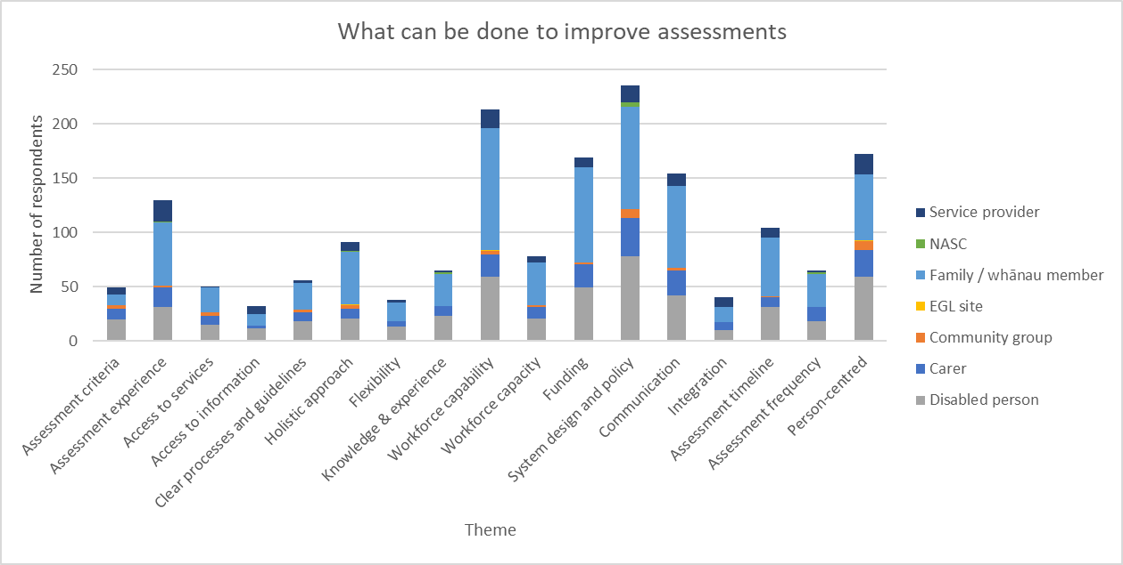

There were 1,131 responses to the question ‘What can be done to improve assessments to establish the support required?’

6% of respondents spoke about the value of disabled knowledge and experience and the importance of consultation in decision making and governance.

21% of respondents shared feedback on the need for better policies and processes across the disability system to simplify, improve consistency, and support greater diversity of needs.

Suggestions included improving workplace standards and assessment processes, having 1 central NASC or inter-NASC peer reviews, and separating assessor and service coordinator roles. 4% of respondents mentioned the need for improved coordination and information sharing between agencies and organisations.

Assessments need to be completely re-designed by disabled people who have experience in disability-led and inclusive research. Assessments should be based on international best practice, the UNCRPD, the NZ Disability Strategy, EGL, and the social/rights model of disability. – Disabled person, Auckland

there needs to be interagency work between ACC, Te Whatu Ora, MOE etc. to make sure that each person's needs are met. So the situation where for example, MOE says DSS is responsible, and DSS says MOE is responsible for a particular need can’t happen. – Disabled person, Canterbury (including Chatham Islands)

Communication to facilitate informed decision making was important to respondents. 5% of respondents mentioned the need for agencies to develop clearer processes and guidelines.

Suggestions included NASCs developing better understanding of different options and supports available, developing clear guidance on assessment processes and next steps, and providing examples and case studies on various processes.

3% of respondents talked about the negative impact of a lack of access to information, particularly where assessors would not have the relevant information or contact details or took inaccurate notes of the assessment. 14% of respondents provided feedback on the impact of insufficient communication affecting assessments.

Communication needed to be accessible. Relational communication was also seen as important with respondents highlighting the need to be listened to, have complaints acknowledged, and not be spoken about in their presence in a demeaning manner.

Simplify processes to reduce stress and delays – Family/Whānau, Canterbury (including Chatham Islands)

don't talk about the disabled person in front of them as though they aren't there. Talk TO them or if talking about them don't do it in their presence. – Family/Whānau, Waikato

19% of respondents shared feedback on the impact of assessors’ capability to understand disabled people and their family/whānau needs. Respondents wanted assessors to have more qualifications or experience, greater understanding of disabilities, empathy, cultural sensitivity, and training to recognise unconscious bias.

7% of respondents mentioned workforce capacity, recommending more staff, especially connectors, better wages, and employing more disabled people.

Our initial assessment was terrible.  The person doing it was very disrespectful to my son and didn't understand anything about his condition and was super condescending. There should be some understanding that we often have to go over this really traumatic story with doctors, specialists, counsellors etc, over and over again.   There is a lack of communication between all these people too. Our next assessment with EGL was amazing. Their attitude towards individualised funding was completely different, and they are really invested in the success and allowing them to thrive and recognise that they are not alone in this journey. – Family/Whānau, Bay of Plenty

Training assessors in disability awareness and cultural competence is essential, as is incorporating feedback from individuals who have undergone assessments to enhance the process – Disabled person, Northland

I would hire more staff to the NASCs with a reasonable case load to ensure that each case is given proper care. – Family/Whānau, Wellington

4% of respondents mentioned their needs not being met because of the services available.

For some this was because of waitlists or language barriers, for others it was because the services were inappropriate, with 15% of respondents requesting greater flexibility and funding to access supports, often requesting the purchasing guidelines prior to March 2024 to be reinstated.

As we had a great assessment no improvement I can see but what was agreed in the assessment can no longer be done now that flexibility purchasing has been stopped, this has created anexity and stress for all of us in this whanau. – Family/Whānau, Nelson/Marlborough/West Coast

Respondents wanted a stronger values base underpinning the assessment process. 3% wanted greater flexibility both in how services are coordinated, and funding allocated, but also in how assessments are carried out and how support should change with the disabled person’s needs.

8% of respondents wanted a more holistic approach, which listened to and assessed the family/whānau as a unit. 15% of respondents wanted a person-centered approach which considered the individual’s needs and preferences in a way that was flexible to changing circumstances.

Involving family members or support people in the process can provide additional insights, especially for those with complex need – Disabled person, Wellington.

I would advocate for a person-centered approach that focuses on individual needs, preferences, and goals, allowing fr structured discussions that gather comprehensive information. Involving multidisciplinary teams of professionals, such as healthcare providers and disability specialists, would also provide a holistic view of each person’s situation. – Disabled person, Northland

Some respondents requested a focus on strengths-based assessment. Respondents also suggested clarifying the criteria, expanding eligibility, and improving transparency in how the assessment criteria are applied.

4% of respondents mentioned assessment criteria, including how vague and strict they were. 11% of respondents shared feedback to improve the assessment experience. Suggestions included:

* prior access to forms, assessment questions, templates, and examples
* self-directing the location of the assessment (in person, in home, online, phone, self-completed)
* assessors asking about and accommodating access needs prior
* allowing more time for assessments
* clarification of timelines, processes, and requirements
* providing a connector who is consistently available
* making the assessments more flexible and less of a tick-box exercise
* greater flexibility around changing circumstances, particularly where needs are expressed differently on a day-to-day basis (particularly behavioural needs)
* flexibility around the presence of children, particularly where children are being assessed and spoken about
* 9% of respondents spoke about assessment timelines, requesting more time to process information and needing shorter waitlists
* 6% of respondents mentioned the frequency of assessments, including whether more or less assessments are required depending on the disability.

Actually get an assessment! I don’t mind and understand a wait list but I’m almost 6 years into this and still not even an assessment. EVERYTIME I ring I’m told you have to just wait your turn… made to feel like I’m supposed to curl up and die! Basically to just go away! – Disabled person, Nelson/Marlborough/West Coast

We had one person visit to carry out an initial admission assessment then waited over a month for that to be reviewed and to be told who would be our key person. The key person kept telling us how busy he was. It took reaching crisis point and calling the manager to get any form of traction. From hospital discharge to start of support took 5 months and a hospital readmission... – Family/ Whānau, Canterbury (including Chatham Islands)

## Making reassessments easier to understand

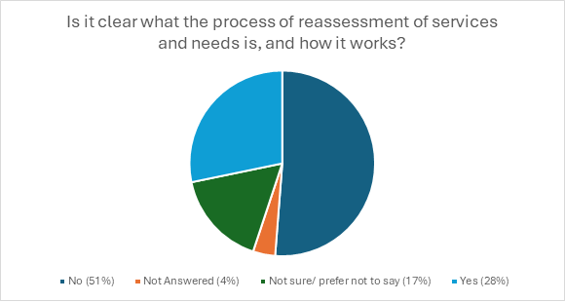

1,193 people responded to the question asking if the reassessment process was clear, and 690 people responded to the follow up question 'What could be done to make it easier to understand?’

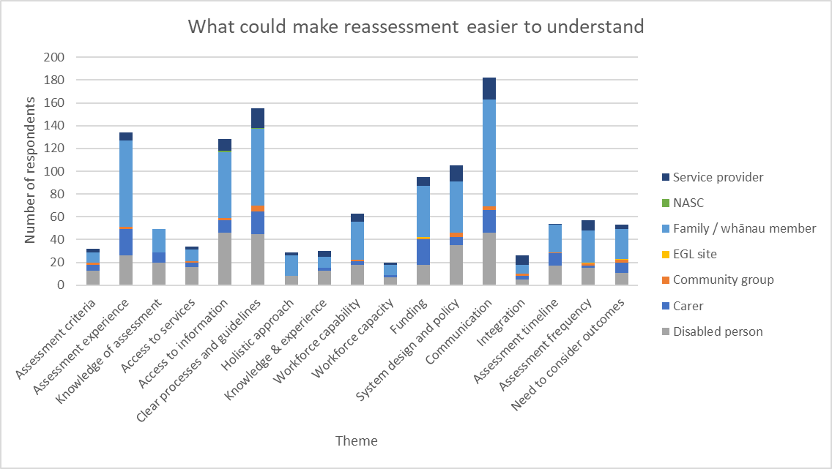

7% of respondents shared they were not aware of reassessments or reviews, or the process involved.

4% of respondents mentioned the importance of lived experience and disability awareness driving any changes to reassessment processes.

I don’t know what this is or how it works which is indicative of how well it’s working – Family/ Whānau, Wellington

15% of respondents shared feedback on the processes and policies required to improve reassessments. These responses requested changes to improve clarity, reduce bureaucracy, improve consistency both regionally and with the rules staying steady, and removing hurdles.

4% of responses also requested further information sharing and collaboration between organisations and agencies.

5% of respondents mentioned not knowing how to begin accessing services, particularly when their situation or needs changed.

This was connected to the purchasing guideline changes, where the March 2024 restrictions prevented respondents from meeting their needs in the ways that had done prior. 14% of respondents mentioned these recent changes and the ongoing need for further flexibility.

Having all government departments on the same page about what disabilities someone has, what help they could get, and an app or website that the disbled could go to and know that all the agencies that they need are connected with them – Disabled person, Wellington

Access to information was seen as an important method to improve the understanding of reassessment processes. 20% of respondents mentioned the importance of interpersonal communication focusing on clarity, timeliness of information access, and listening to disabled people and their families and whānau. 23% of respondents suggested developing transparent reassessment processes and guidelines.

19% of respondents provided feedback on how to improve access to information.

Suggestions included proactively releasing information in plain language and NZSL ahead of rolling out any changes and providing consistent messaging across multiple platforms.

The workforce was also seen as a factor in ensuring better information was made available and understood. 9% of respondents shared feedback on capability, suggesting staff should be more qualified, inclusive, knowledgeable, and culturally sensitive. A further 3% of respondents mentioned the need for hiring more staff.

It's all confusing, there's little communication of who you're interacting with, what processes are happening etc. Disabled person, Waikato

A more culturally responsive approach – Family/Whānau, Taranaki

Like assessments, respondents felt reassessments could be improved.

19% of respondents shared feedback on the reassessment experience, suggesting better follow ups, proactively providing information ahead of time, and addressing power imbalances between NASCs and disabled people and families/whānau.

5% of respondents suggested making criteria more transparent and realistic with greater focus on needs over budget.

4% of respondents mentioned a need for more holistic approaches that consider wider support systems and work alongside family/whānau. Respondents also suggested including conditions such as FASD and long COVID, whilst ensuring autism remained eligible for support.

Focus on care and support, not treating individuals as burdens. Assessments should understand the whole person, their challenges, and needs for thriving – Family/Whānau, Canterbury (including Chatham Islands)

I know it takes time but following up with the people that have these disabilities and really getting to see that they understand what is happening for them or to them or about them rather than them to say yes I understand when that absolutely have no idea I have done that myself on many occasions because I don't want to look like an idiot or that I don't understand sometimes it's hard enough just to read a simple document understand what it is a process of a reassessment May mean – Disabled person, Waikato

8% of respondents mentioned assessment timelines and delays.

Respondents shared the uncertainty this created, particularly when reassessments and plans were not finalized before funding rolled over, resulting in supports being unavailable.

A further 8% shared feedback on the frequency of reassessments. Some respondents suggested that people with permanent disabilities should not require reassessments. Others experienced changing needs before they could be reassessed resulting in unmet needs. Some respondents suggested being able to request a reassessment if or when their needs changed.

My frustration is that we have a daughter with a condition that does not improve and in most cases gets worse. We are frequently faced with re assessments asking us, "has she been able to find work" and stupid questions like that when the previous assessments clearly outline she requires 24 hour care. – Family/Whānau, Bay of Plenty

Explain how they allocate a package. My disabled family members needs changed every year (as he grew) yet it took 6 years for this to be reflected in his budget – Family/Whānau, Wellington

Many disabilities don't "go away" which could be better recognised by the system, which carries a burden of proof. This carries strain on disabled people, whanau, and on the health centre and network of professionals that are required to reconfirm needs – Family/Whānau, Canterbury (including Chatham Islands)

8% of respondents shared the negative outcomes they had experienced due to the reassessment process, such as feeling unheard, confused, frustrated, overwhelmed, uncertain about the future, and sometimes traumatised.

Daily we are seeing hopelessness, desperation and disabled people and whānau in crisis.  There is a lot of fear and mistrust. For this to improve there needs to be a shift from cost management and budget constraint to adequate funding – Service Provider, Auckland

Stop treating it like a test for what can be taken away to save the government sectors money. The goal needs to be to offer support not take it away. These assessments are scary, we are afraid of them and that's sad and unnecessary. – Disabled person, East Coast

# Section 3: flexible funding

Questions in this section focus on flexible funding and purchasing guidelines, including the ways it is used and how to simplify the rules.

## Setting eligibility for flexible funding

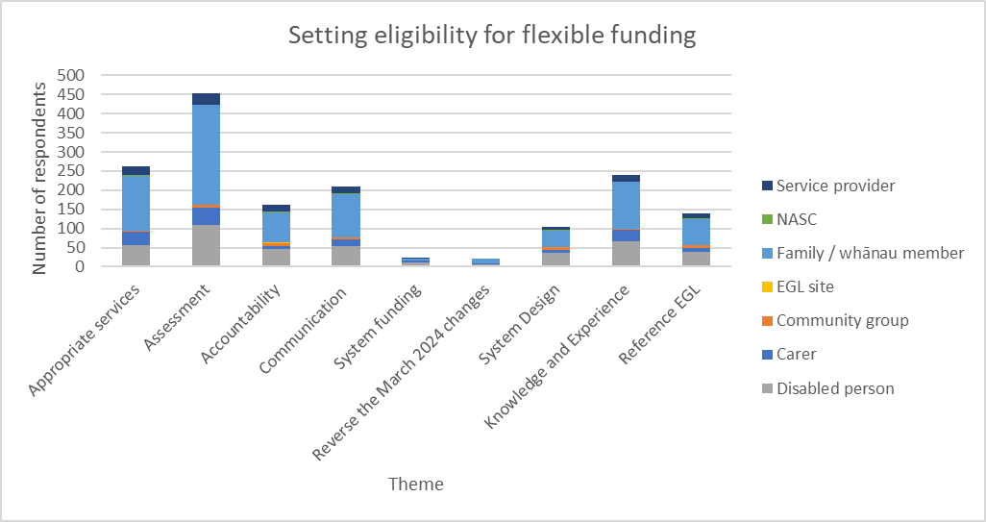

1,036 people responded to the question ‘What things need to be worked through in setting eligibility for flexible funding?’

21% of family/whanāu members who responded to this question felt communication was important.

20% of respondents felt that clearer communication would improve consistency and transparency across all processes and parts of the system.

10% of respondents felt that processes and systems should be simplified, more nationally consistent, and more transparent.

Some felt that the parts of the system (for example, NASCs and hosts) should work together more cohesively, with less bureaucracy. 2% of respondents also felt that further investment was needed to improve DSS.

For families and disabled individuals, this system feels disconnected from the reality they face, and the reliance on government decisions means there’s little room for flexibility or adaptation based on personal circumstances. - Family/Whānau Canterbury (including Chatham Islands)

23% of respondents emphasised the knowledge and experience they held from having a disability (or a family member with a disability), and the inherent knowledge that comes from living through it daily.

Respondents felt there should be greater representation of disabled people as decision makers for DSS, reflecting the mantra “nothing about us, without us”.

A further 13% of respondents highlighted that the principles of EGL and UNCRPD should be pursued and implemented across DSS.

Consultation for starters, not just govt saying what’s going to happen ! - Carer, Wellington

We as disabled people have a better understanding of our needs and requirements than the government. - Disabled person, Wellington

One of the principles of EGL is about giving the disabled person choice and control in their lives. That needs to be a paramount consideration when considering flexible funding. - Carer, Nelson/Marlborough/West Coast

3 key areas were identified to improve access to flexible funding: the purchasing guidelines, assessments and eligibility, and accountability to manage funds. These are explored individually below.

25% of respondents wanted to see changes to the purchasing guidelines, highlighting that flexible funding was often no longer able to be used in a suitable or practical way.

2% of respondents explicitly recommended reversing the March 2024 changes, while many more said these changes had negative outcomes.

I feel the system worked pretty well prior to the changes. We were supported and guided. The carers need to be consulted and actually listened to as we are the ones doing the caring and know what is needed to help support our disabled person.- Family/Whānau Canterbury (including Chatham Islands)

There should be clear information about what flexible funding is and what alternatives are available. -Family/Whānau, Waikato

44% of respondents discussed assessment and allocation mechanisms as critical tools to set flexible funding policies.

Many of the respondents felt a needs-based approach was necessary to understand the diversity of disability and what was required to support disabled people and their families. This included factors such as: the diversity of impairments, income, rurality, permanence of impairment, culture, family contribution and the impact upon the family.

Respondents highlighted the unfairness of current eligibility settings, calling for all disabled people to be eligible for DSS and flexible funding. Others requested impairments such as FASD, ADHD, mental health (such as depression and anxiety) be made eligible for DSS.

Develop a comprehensive framework for assessing individual needs, ensuring it takes into account diverse circumstances and promotes equity. Allowing funds to be used for a variety of purposes, depending on individual circumstances, while ensuring that there are guidelines to prevent misuse. - Carer, Taranaki

16% of respondents focused on accountability mechanisms to improve flexible funding access. These suggestions varied substantially, with several suggestions covering who should be included in the scheme, how disabled people should be set up to succeed in using the scheme, the mechanisms to manage the scheme and protect disabled people and their families, and the values that should underpin all elements of the scheme.

Eligibility for flexible funding should only be removed when past evidence has demonstrated the person does not have the skills or appropriate support to effectively manage flexible funding. - Service Provider, Wellington

## Flexible funding was a critical method to access supports

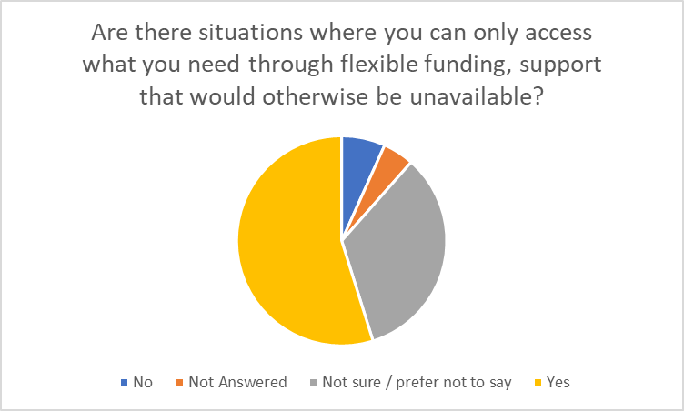

There were 924 responses to the question ‘Are there any situations where you can only access what you need through flexible funding, support that would otherwise be unavailable?’

Responses varied by region. Over 50% of respondents from every region except for 1 responded with ‘Yes’.

29% of respondents from the East Coast responded with Yes. There were 769 responses to the follow up question asking for examples where access to support is only available through flexible funding.

Most respondents (50%) explicitly mentioned the critical value of flexibility that had been provided through the scheme.

This flexibility enabled disabled people and their families to purchase supports that directly benefitted them, reflecting the diversity of disability and accommodating changes to circumstances over time.

2% of respondents indicated they were confused about what funding was allowed to be used for or what was available elsewhere.

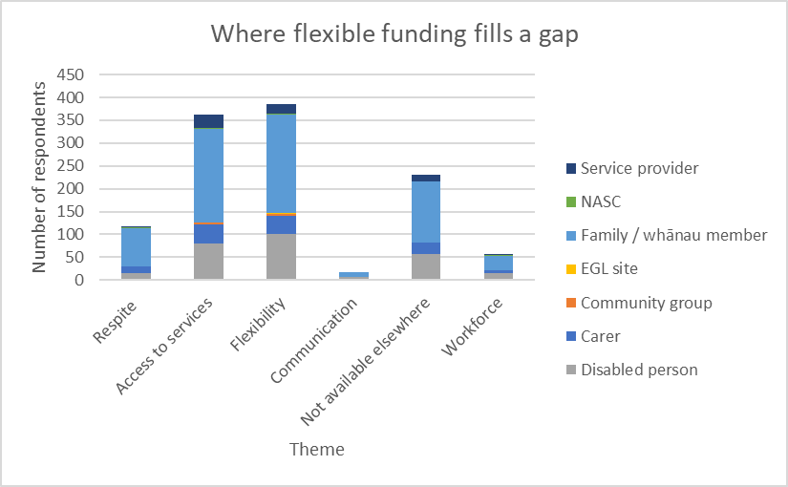

It means we can make decisions based on the needs at the time. It means i can partly pay myself as a carer as it is impossible to work fulltime with a very high needs family member ( many sick days, and hospital visits often at short notice) I have control over choosing the supports and resources he needs as his needs and our circumstances change.  The flexible funding has changed our life, in the past with the layers present to access resources my family has experienced a great deal of stress and the resource has been wasted and sucked up by institutions that did not meet our needs. Our life is very challenging, but having some power over how we access support has been a game changer. - Family/Whānau, Canterbury (including Chatham Islands)

My partner's needs are increasingly complex due to a deteriorating condition - if we were not funded through an EGL agency he would get less support - I would definitely have to leave my job. Family/Whānau, Canterbury (including Chatham Islands)

15% of respondents provided feedback on their use of flexible funding to access respite.

Respondents shared frustration with current purchasing guidelines that they saw as preventing access to practical methods of respite.

Single parents and those without extended family and community support, in particular, pointed to the increased rate of carer burnout and social isolation. Respondents felt the current purchasing guidelines undermined and undervalued the critical work carers provided and the support respite gave them.

I can no longer pay for travel and accommodation for respite from my 11 year old autistic daughter. She can't access respite outside of the home herself, so my only.option is to leave the house myself. I can no longer use the funding for this. - Disabled person, Wellington

When you have a child with complex needs it is so difficult to find a way to have some 'respite', you have to think creatively and work out a way - in an individualised way - what works for one will not work for another. It is generally more expensive and you have to think creatively. That is the way it is. - Family/Whānau, Wellington

8% of respondents highlighted the importance of hiring their own staff, whether these be family members or not.

Choice over staff provided a greater level of trust between the disabled person and their staff, and greater control in setting their schedules.

Some respondents had chosen their support workers because of their specific expertise, or their willingness to coach and upskill the disabled person and their families. Others were able to source support workers in regions where providers were not present.

Unique cultural and language requirements simply cannot be catered for under an inflexible model when residing in a remote location so family and close friends have to step in. - Family/Whānau, Northland

47% of respondents provided feedback on the government funded services they had accessed privately through flexible funding.

This included other DSS supports such as equipment modification services (EMS) or behavioural support, as well as supports that are the responsibility of the Ministry of Education (MoE), MoH, Ministry of Transport (MoT), and MSD.

Flexible funding was used as these supports were not disability inclusive or accessible, were insufficient to meet the needs of disabled people and their families, were not consistently available, or had substantial waitlists.

Yes, flexible funding is often the only way to access the specific support my nephew requires. Without it, I wouldn’t have the option to customise his care to meet his complex needs. For example, flexible funding allows me to hire specialised carers, arrange therapy sessions, and manage his unique behavioural and emotional support—all tailored to what works best for him. Traditional funding doesn’t typically cover these personalised options, leaving families like mine without the vital resources we rely on. Flexible funding gives us the freedom to make decisions based on real needs rather than predefined, limited services, ensuring my nephew receives the right support for his well-being. - Carer, Canterbury (including Chatham Islands)

We used to be able to use funding for private therapy, equipment, housing modifications etc that weren't publicly funded (e.g if didn't meet criteria) or if waitlists were many years long or publicly not avaliable in our region. - Family/Whānau,Taranaki

30% of respondents highlighted the range of supports they did not believe were funded by any government agency.

Support focused in 3 areas:

* consumables for self-regulation, such as sensory items, crafts, and items for special interests
* participation in the community, such as transport to events, and support for the Special Olympics
* supports to build independence or maintain independence for degenerative conditions, including mobility therapies and innovation – including use of new technologies.

Currently I cannot participate fully in society because the only funding for interpreters is health or employment related. How would YOU like to be only able to understand things in the workplace or a health setting but not at a whanau gathering like a wedding, tangihanga, or socially like a movie, party, theatre, community support group, or inspirationally like a night class, hobby group, volunteer work to name but a few. - Disabled person, Wellington

Families who use IF rather than residential providers to provide homes for their sons have so many more opportunities to be innovative, and responsive to their son or daughter’s needs and aspirations. As one example, it allows homes where those with and without disability can live together. - Family/ Whānau, Wellington

## Clarity about what flexible funding can be used for

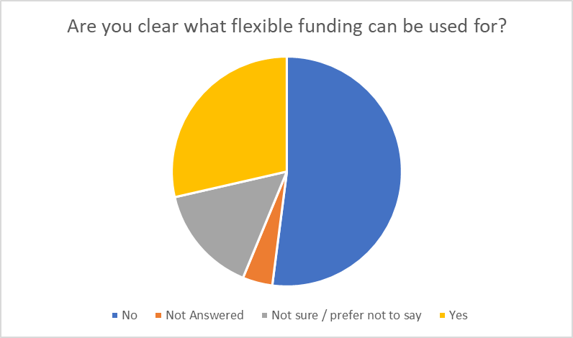

1,210 people responded to the question ‘Are you clear what flexible funding can be used for?’

44% of service providers were not clear what flexible funding could be used for.

Over half of carers, family/whānau, and disabled people also were also not clear. Respondents answered the follow up question ‘What suggestions do you have to make flexible funding simpler?’

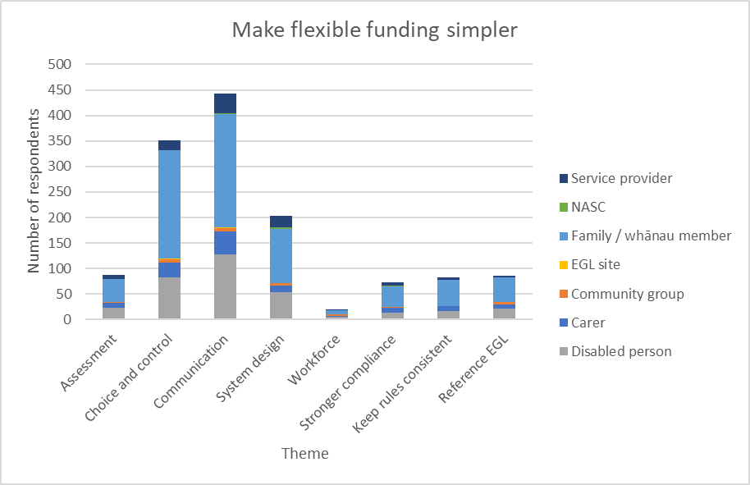

21% of respondents felt the DSS systems were overly complex and bureaucratic with poor transparency in processes and expectations, and poor consistency in the application of processes across the country.

This created additional stress and fatigue for disabled people and their carers and disempowered them in managing their funds with confidence and independence.

9% of respondents felt the system would be better if it reflected the EGL principles.

establish clear guidelines to support disabled people, clinicians and assessors. - Service provider, Central

A streamlined application process with clear guidelines, reducing bureaucracy and making it easier for individuals to understand what info is needed. Providing a user-friendly online portal where individuals can apply for funding, track their applications, and manage their budgets would also enhance the experience. I believe that offering support through dedicated case managers or navigators can help individuals understand their options & assist with the application process. I suggest creating standardised, simple forms that avoid complex jargon, making it easier for applicants to provide the necessary information. Training for staff involved in managing flexible funding programs can improve communication and ensure they are equipped to assist applicants effectively. - Disabled person, Northland

44% of respondents highlighted the impact of inadequate and inaccessible communication. Communication was often inaccessible for different disabilities and language requirements.

The quality of communication had substantially decreased since March 2024 changes. Many respondents did not know what the rules were or where to go to find out.

2% of respondents identified the workforce as a critical method of sharing information, yet sometimes staff did not know the rules or did not have time to share information.

Again a central info hub where you can talk to someone would be extremely helpful. Fully accessible of course with staff committed to disability right approach. - Disabled person, Bay of Plenty

35% of respondents wanted to see greater choice and control in the purchasing rules than was currently allowed. Increased flexibility in purchases would reflect the diversity of disability needs and provide a method to access support that would otherwise be inaccessible.

9% of respondents felt assessments should be needs based, to identify the areas where flexible funding would be beneficial. People thought assessments should consider the needs of the family as well as the disabled person.

Greater autonomy and trust were requested by some respondents. Suggestions included allowing the same degree of autonomy as the benefit or having no rules for under $10,000 allowances.

8% explicitly wanted to reverse the March 2024 changes.

Needs specific. Not just a blanket rule. - Family/Whānau, Canterbury (including Chatham Islands)

Trust the family to know where they need help. Trust the individual to know their needs. - Disabled person, Auckland

Make it goal driven to support disabled people to succeed in their life goals that are on a par with their peers. - Community Group, Wellington

7% of respondents provided feedback on various compliance methods. This included auditing, peer support, providing support to ensure funds last the full year, or enabling disabled people and their families to spend their allocation with the knowledge that there will be no top ups if it is finished before the review.

Give a yearly allocation with some peer support – disabled person, Canterbury (including Chatham Islands)

## Making purchasing rules easier to understand

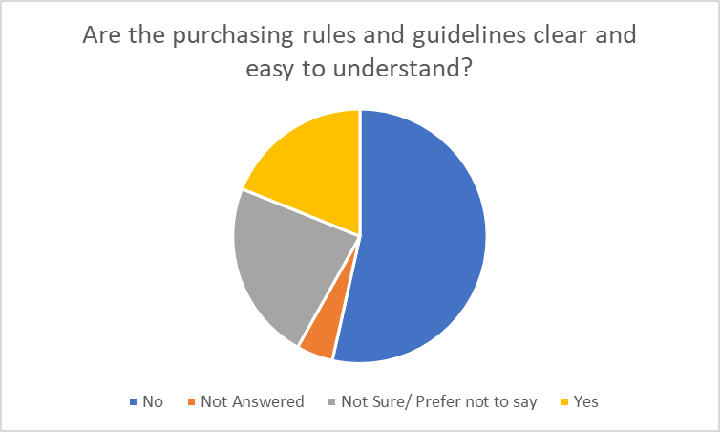

1,087 people responded to the question ‘Are the purchasing rules and guidelines clear and easy to understand?’

1,431people responded to the question ‘What suggestions do you have to make the purchasing rules or guidelines easier to understand?’.

64% of carers and 56% of family members felt the rules were not easy to understand.

665 people responded to the follow up question ‘What suggestions do you have to make the purchasing rules or guidelines easier to understand?’

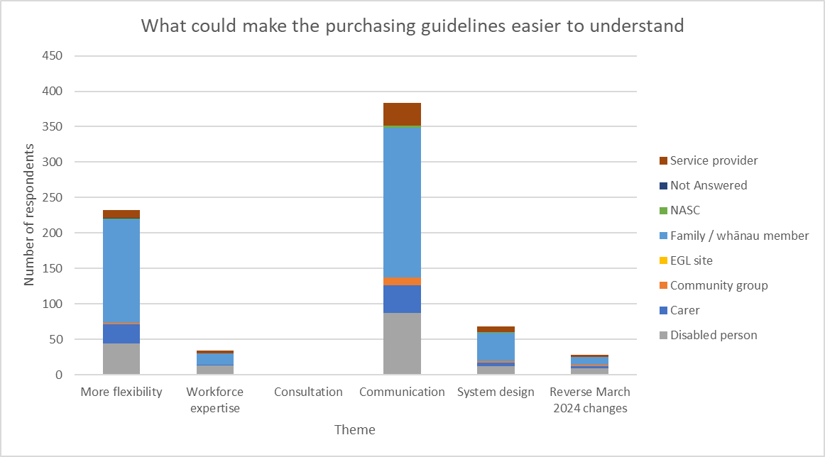

35% of respondents highlighted the importance of flexibility in the rules.

The current purchasing guidelines were seen as hard to understand and this was worsened by frequent changes to these rules.

The rules were seen as too restrictive and do not enable the flexibility to fit disabled people and their family’s/whānau needs.

4% of respondents wanted the March 2024 changes reversed whilst 5% wanted further and improved consultation before any other changes took place.

Fewer restrictions would make it easier to think creatively find something that would work for our family. - Family/Whānau, Auckland

What is cost-effectives differs for each person. What is a disability support differs for each person. What is the point of filling out a purchasing support form and providing evidence that it fits the purchasing criteria if the goal posts are continually being shifted to ensure that it can be rejected as not being "cost-effective" or "a disability support". Disabled person, Auckland

58% of respondents provided feedback on the need for better communication.

Communication needed to be consistent with accessible and alternate formats readily available from initial announcements.

Information needed to be available in many formats such as on websites, live web chats, pamphlets, and hotlines to ensure disabled people and their families/whānau can access information in the ways that work best for them.

Language needed to be plain, with clear examples and answers to common questions. Announcements needed to go through the appropriate channels and be available in multiple languages.

A key part of successful communication was also viewed as being through the workforce.

5% of respondents wanted staff to be knowledgeable and able to answer their questions. They wanted staff to also have the availability to spend time with disabled people and their families.

Some people and I am one of them don't always understand the way a sentence is worded for legality if it could be written in a much simpler form even if it was say twice as long so that again people with the disabilities can understand themselves rather than have someone just say or this is it abcdefg well I I want to understand it and I feel like it crazy idiot because I don't understand some of these huge big words with 20 syllables in. - Disabled Person, Waikato

Again you need to provide information in English, New Zealand Sign Language, and ensure there are face to face meetings that allow anyone to ask the questions they need to. Have regular workshops face to face and online. - Disabled Person, Auckland

10% of respondents highlighted issues across the disability support system, which increased complexity and reduced understanding.

People felt that processes are confusing and time consuming, which added to the barriers disabled people and their families/whānau faced in accessing the support they required.

The system was not applied consistently, either due to staff not following processes, or due to regional unavailability of support. EGL and principles-based approaches were identified as methods of redirecting and improving the system.

They are so complex, requiring considering multiple fund types to determine if I can use the funding. Family/Whānau, Auckland

Redesign the whole system and start from the beginning around defining how each service and rule fits together. - Family/Whānau, Wellington

If you put EGL into place this would almost eradicate the need for these guidelines. Family/Whānau, Southern

# Methodology

Submissions were received and included in the quantitative analysis up until 29 November 2024. Duplicate submissions were removed.

The survey data was curated to isolate all responses to each question separately. The data was quantitatively coded by recurring themes, providing an understanding of the proportion of respondents who mentioned each topic or idea.

This enabled the team to understand the broad responses to each question and iteratively update a rich description of each theme.

The qualitative approach involved reading the written submissions and meeting notes to understand the broad themes and nuances of concepts reflected in the quantitative analysis.

Quotes were taken only from the online survey to ensure word for word reflection of what was shared with us. Quotes with identifiable information were not shared, as quotes were not changed in anyway, including in grammar or spelling.

In some cases, extracts of responses were shared, where the other ideas in the response were distinct and not relevant to the topic being discussed.

Basic identifiers (connection to the disability community and region) were shared with the quote to highlight the breadth of responses and give context to the quote.

## Privacy

The Privacy Act 2020 applies to all submissions. Any personal information supplied to DSS while making a submission will be known only to the team working on this project. Submissions may be requested under the Official Information Act 1982.

Personal information, not deemed to be in the public interest, will be withheld from any information releases and publications.

## Limitations

There were some limitations on the information collected through the consultation process. In some instances, a submitter’s initial answer to a proposal would differ from their following response.

This may result in the statistics not always accurately reflecting the sentiments of submitters.

Analysis recorded the frequency of responses, not the intensity. An idea may have been important to only a small portion, yet this nuance was not captured in our analysis. These statistics should be read considering the contextual comments to ensure a clear understanding.

As submissions were received in a range of formats (including Word, PDF, handwritten, and email), there were some formatting errors in the submissions. Where required, submissions were reformatted to be analysed.

When referring to respondents, the report quantifies support for positions based on the classifications in the table below.

Some questions had larger response uptake than others, yet all were statistically analysed into percentages of respondents who mentioned a topic or idea. Hence whether a question received several hundred responses or less than 100, the same percentages and terms are used relative to the proportion of responses to that question.

**Submission classification**

|  |  |
| --- | --- |
| **Classification** | **Definition** |
| Few | Fewer than 10% of submitters |
| Some | 10% to 25% of submitters |
| Many | 26% to 50% of submitters |
| Most | More than 50% of submitters |